Intro/Review - pH
Go to: phet.colorado.edu. You will also need a scientific calculator (that can do logartithms). Click on…
PhET Simulations > Play With Sims > Chemistry>pH Scale > or click HERE. 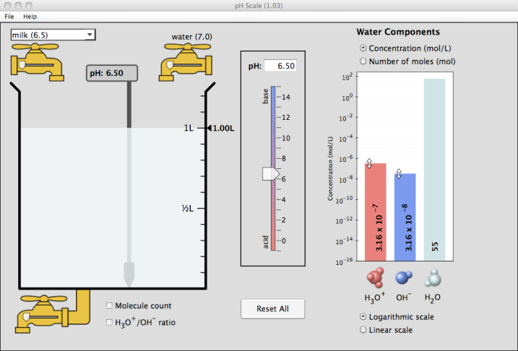
Familiarize yourself with some of the controls of the program (click-and-drag sliders and drop-down menus) and then press “Reset All.”
- Answer the following questions by manipulating variables as specified.
- Check the box entitled “H₃O⁺/OH⁻ ratio. Red dots represent hydronium ions while blue dots represent hydroxide ions. Adjust the pH slider up and down, observing how this changes the number of each type of ion.
- As you raise pH, which type of ion concentration increases? _____________
- As you lower pH, which type of ion concentration increases? _____________
- Based on your observations, what does a high (greater than 7) pH indicate?
______________________________________________________________
- What does a low (lower than 7) pH indicate? __________________________
- Reset the simulation. Check the box entitled “Molecule Count.”
- From the drop down menu in the top right, select “vomit” (pH 2.0) and record the number of hydronium ions. ____
- Select “battery acid” (pH 1.0) and record the number of hydronium ions. ____
- Determine how many times more concentrated battery acid is than vomit. To do this, divide the number of hydronium ions in battery acid by the number of hydronium ions in vomit (use a calculator):
Battery acid is ____times more concentrated than vomit.
- Reset the simulation. Check the box entitled “Molecule Count.”
- From the drop down menu, select “drain cleaner” (pH 13.0) and record the number of hydroxide ions. ______
- Select “hand soap” (pH 10.0) and record the number of hydroxide ions. _____
- Determine how many times more concentrated drain cleaner is than hand soap. In this case, you are dealing with basic solutions. Adjust your calculations accordingly.
Drain cleaner is ____times more concentrated than hand soap.

- For each of the following, manipulate the variables and record the outcomes:

- Using the pull-down menu, change the contents of the beaker to “water”. What is the pH? ________. Compare (record) the H₃O⁺/OH⁻ concentration.

- Fill the beaker with drain cleaner. What is the pH? ________ Compare (record) the H₃O⁺/OH⁻ concentration.

- Fill the beaker with soda. What is the pH? ________ Compare (record) the H₃O⁺/OH⁻ concentration.

- Using “custom liquid”, adjust the pH level to 6.00. How does the H₃O⁺/OH⁻ ratio differ from a pH of 7?

Record and compare (concentration) H₃O⁺/OH⁻ ratio.

- Again, using “custom liquid, adjust the pH level to 8.00. How does the H₃O⁺/OH⁻ ratio differ from a pH of 7?

Record and compare (concentration) H₃O⁺/OH⁻ ratio.
*You need to be familiar with adjusting the amount of liquid in the beaker. Choose water from the pull down menu. Fill and drain the water using the faucet knobs above and below the beaker. Try to get 0.5 L of water in the beaker. Practice until you are accurate.
- Fill the beaker with coffee (pH 5.0). Drain out half, and replace that amount with water. What is the new pH?_______

Record and compare (concentration) H₃O⁺/OH⁻ ratio.
- OK, feeling nauseous? Fill er’ up with Barf!(pH 2.0) Drain out half, and replace it with H₂O! What is the new pH?____ Record (concentration) H₃O⁺/OH⁻ ratio.

- Let’s get back to “basics”. Fill up with hand soap, drain half, and replace with water. What is the new pH? ____ Record (concentration) H₃O⁺/OH⁻ ratio.
5. What do you notice about the H₃O⁺/OH⁻ ratio when you add water to either an acid or a base? (Refer to how the concentration changes.)

6. Calculate: Add anything to the beaker. Using your scientific calculator, find the negative logarithm (-log) of H₃O⁺ mol/L. This should match the pH value given.
Substance ________________ pH ______
negative logarithm (-log) of H₃O⁺ mol/L ____________
Ex: if the concentration is 0.003 mol/L, key in: 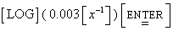
and get a pH of 2.52
*Hint! you may not be able to enter the concentration in scientific notation so you will have to convert first. (This example is for a TI-30XIIS

7. Calculate: Add anything to the beaker. Using your scientific calculator, find the negative logarithm (-log) of OH⁻ mol/L. This should match the pOH value given.
Substance ________________ pH ______
negative logarithm (-log) of OH⁻ mol/L ______________

8. An area of oceanic surface water went from a pH of 8.1 to 7.9. You are given the
task of explaining what this means to a group of your peers. What do you tell them?

