Exploring Model Systems

Go to http://www.g2conline.org/.

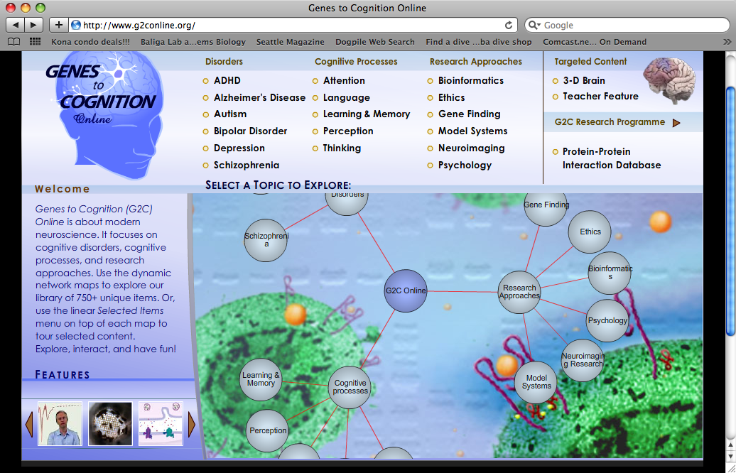

Click on ‘Model Systems’.

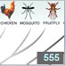
Drag ‘balloons’ so that you can see the model organisms. Click on “Conservation of Function”.

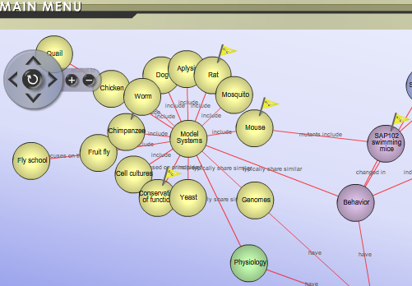

If students would benefit from a review of amino acids > proteins > homologs, click on link 555 first and work through the animation slides.

The screen will show you a brief discussion of the importance of model organisms (Link 548 ). Click on the X (upper left corner) to uncover 10 organisms for comparison.

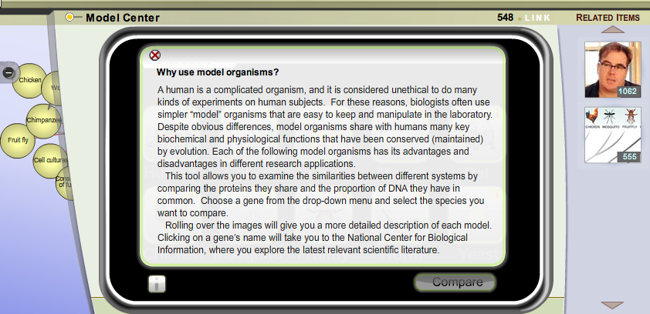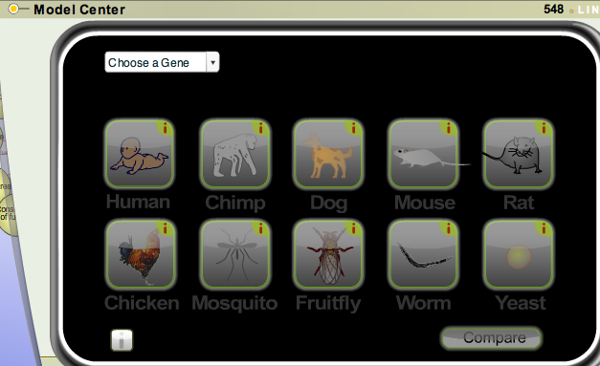

Drop down the ‘Choose a Gene’ menu and pick one. The organisms having that gene will be highlighted.

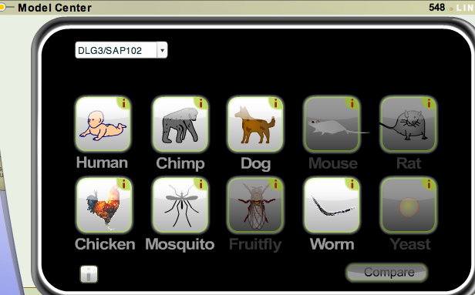

Click on any of the highlighted organisms and then click ‘Compare’.

The amino acid homologs will be shown and then you can click on ‘% Protein the same’.

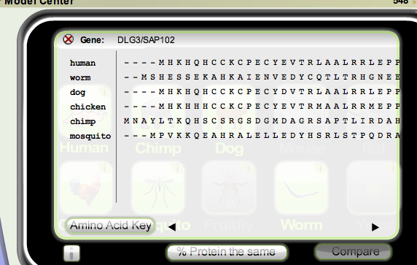
This is similar to the way scientists ‘BLAST’ for information.

