Metabolism Data Sheet
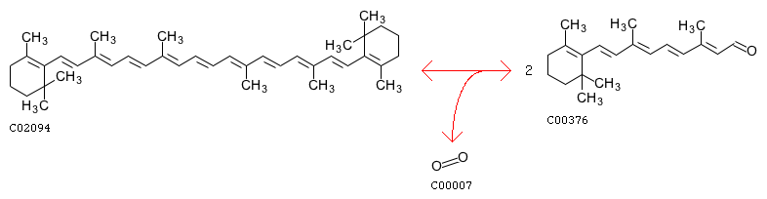
Beta-carotene
Retinal
Substrate: beta-carotene→Product: Retinal
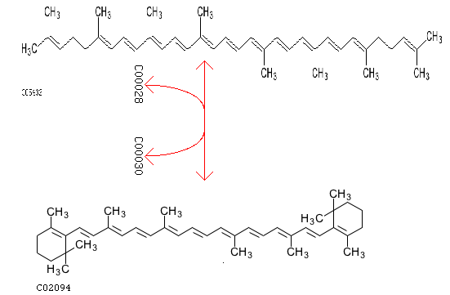
Lycopene
Beta-carotene
Substrate: Lycopene→Product: Beta-carotene
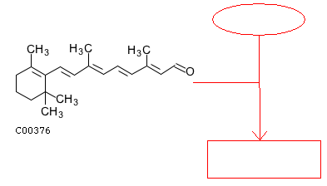
BOP Protein
Bacteriorhodopsin
Retinal
Substrate: Retinal and BOP protein→Product: Bacteriorhodopsin
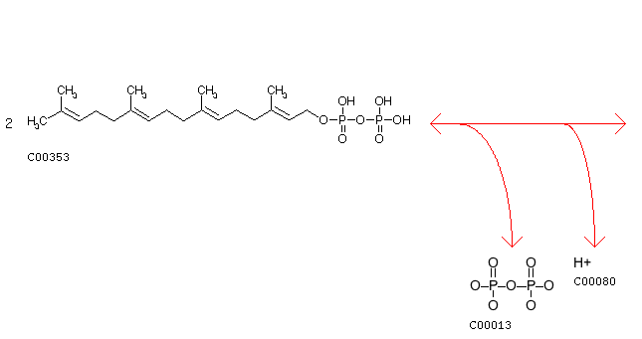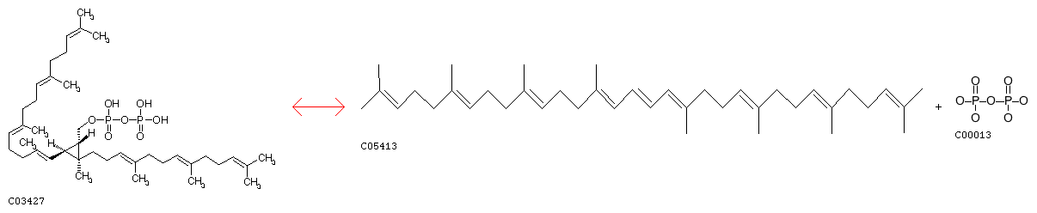
GG-PP
Phytoene
Substrate: GG-PP → Product: Phytoene

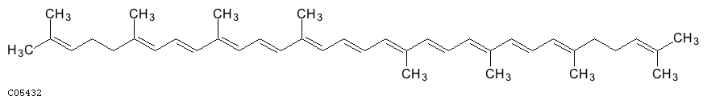
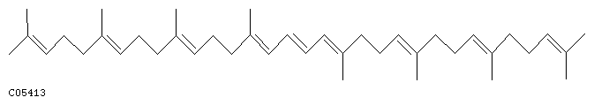
Phytoene
Lycopene
Substrate: Phytoene → Product: Lycopene

