ENVIRONMENTAL IMPACT ON GENE NETWORKS
Lesson 2: Growth and Phenotypic Response of Halobacterium in Different Environmental Conditions

Background

In the image below, taken from Google Earth, you will notice a number of saltwater crystallization ponds adjacent to San Francisco Bay. The most obvious and quite beautiful feature of these ponds is the variety of distinct colors that are found in each. One of the factors influencing the color of these ponds derives from the action of salt loving (halophilic) bacteria. Through a series of experiments and other activities this week, you will become acquainted with the biology of halobacteria. More specifically, you will develop an understanding of the how the environment can influence particular gene expression and the network of proteins that ultimately affect the phenotypic color of these halobacteria. In this initial introduction, you will experimentally manipulate bacterial access to light and oxygen.

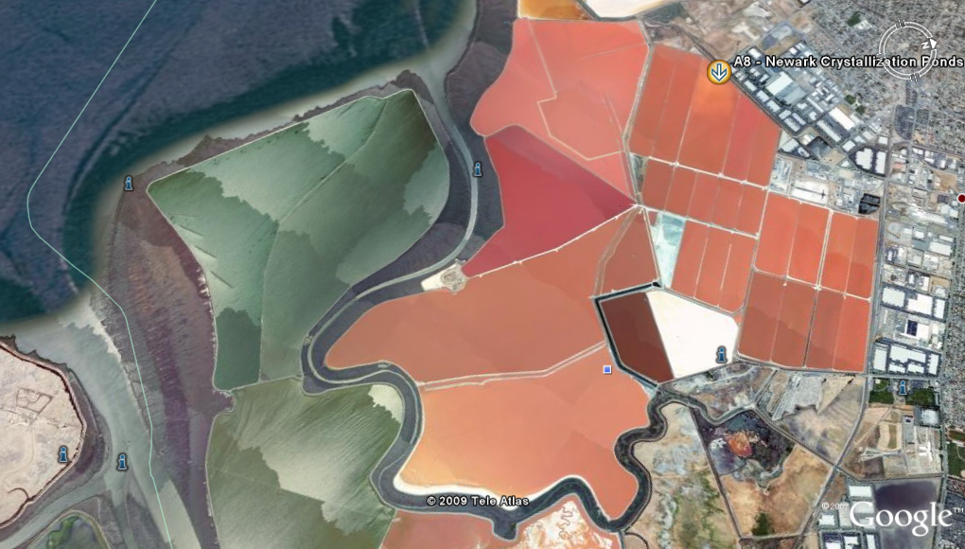

Inspiration for this image came from observations of a Google Earth linked poster of the South Bay Salt Pond Restoration Project at the following website. When you have the time click the KMZ file link to take a Google Earth tour of the images in the poster. It is an impressive visual experience. http://steel.ced.berkeley.edu/research/hidden_ecologies/?page_id=416

Acknowledgements

This lesson was collaboratively written by Eric Kessler in the Blue Valley School District in Kansas and by teachers, scientists and students in the Baliga Lab at the Institute for Systems Biology.
Name: _____________________________

ENVIRONMENTAL IMPACT ON GENE NETWORKS
Lesson 2: Growth and Phenotypic Response of Halobacterium in Different Environmental Conditions

Lab-Preparation Questions

Read the American Scientist article Extreme Microbes by Shiladitya DasSarma, and answer the following questions.

- Explain how halobacteria are unique and discuss how they are related to other forms of life.

- Explain how halobacteria can, as a group, be considered diverse metabolically and ecologically.

- What protein of interest was discovered in these bacteria? Diagram and describe the function of this protein in relationship to ATP synthase.

- What is curious about the characteristics of all the proteins found in halobacteria? How might this unique protein profile be adaptive in the environment in which halobacteria thrive?

Next, read more information about bacteriorhodopsin at David Goodsell’s Molecules of the Month at the Protein Data Bank by surfing the first website below or downloading a pdf of the same information at the second. Also, view the third website for an animation on halophilic cells.

- http://www.pdb.org/pdb/static.do?p=education_discussion/molecule_of_the_month/pdb27_1.html
- http://www.pdb.org/pdb/education_discussion/molecule_of_the_month/download/Bacteriorhodopson.pdf
- http://www.sumanasinc.com/webcontent/animations/content/ionpumps.html

- Describe the structure of bacteriorhodopsin.

- Explain how bacteriorhodopsin used sunlight to generate a proton gradient in general and more specifically after reading to the end of the document.

- Name and describe the other three types of rhodopsins found in halobacteria.

- Do we have any proteins similar to bacteriorhodopsin? Explain.

- Based on the knowledge you have gained about halobacteria, how would you hypothesize the color of your different samples vary?

Post-Lab Questions

- Which Halobacterium culture has the greatest expression of bacteriorhodopsin? Explain your reasoning.

- Does it appear that light affects the expression of the gene coding for bacteriorhodopsin? Explain with reference to specific results.

- Does it appear that oxygen affects the expression of the gene coding for bacteriorhodopsin? Explain with reference to specific results.

- Besides the expression of the gene coding for bacteriorhodopsin, does it appear that light or oxygen influences anything else? Explain.

- Can you now make hypotheses about the different colors of the salt ponds shown in the introductory image? Give an example of a few hypotheses that you think are reasonable.

