Name:________________________ Teacher: ____________Period:___ Date:_______
Pre-Assessment for Ocean Acidification: A Systems Approach to a Global Problem
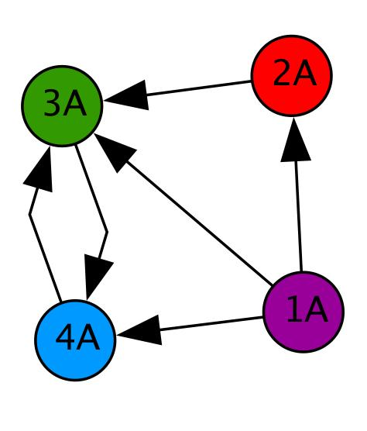
Instructions: This worksheet will be used as a way to assess your understanding before you begin this new set of lessons. Please try your best to give an answer to every question, even if you need to guess. It is important for us to see where your thinking is now, before beginning new learning activities. Thank you!
Use the diagram at the right to answer the following questions. Circle the best answer.
- If the circles (nodes) in the diagram are people, how many people can 1A directly contact?
0 1 2 3 4
- How many people can contact 1A?
0 1 2 3 4
- How many people can directly contact 4A?
0 1 2 3 4
- If 2A sees a funny picture, who else will know about it? (Circle all that apply.)
Nobody 1A 2A 3A 4A
- Explain how/why a network diagram is a useful tool.

- Various things are listed below. Place an X in front of the things that can be thought of as a system.
____aquarium ____bicycle____pile of sand ____ocean ____box of nails
- Explain your thinking. How did you decide whether something is a system?

- What do you think systems thinking is? Describe a time when have you used systems thinking.

- If you were going to do a systems level study, what do you think it would involve?

- Describe an example of an emergent property.

- Give an example of how your actions have a large impact on the environment.

- What are some ways that carbon dioxide gets into our atmosphere?

- Explain the connection between carbon dioxide in the air and carbon dioxide in oceans and lakes.

Students conducted an experiment to determine what causes seeds to germinate the fastest. The students used the same type of seed and water. They placed the six seeds of each test group on a paper towel in a petri dish. The data table below shows the data that they collected over several days on three groups of six seeds.
Test Group | Amount of Water | Temperature | Environmental Condition | Time of germination
1 | 5 ml | 5ºC | Dark | 7 days
2 | 10 ml | 25ºC | Dark | 6 days
3 | 15 ml | 40ºC | Light | 4 days
- What is the best conclusion based on these results? Circle the best answer.
- The amount of water and the temperature affect the germination of the seeds.
- The temperature and the amount of light affect the germination of the seeds.
- The amount of water, the temperature, and the amount of light affect the germination of the seeds.
- No conclusion can be made from this data because too many variables were changed.

- What would your next experimental step be after these results?

- The “amount of light and temperature” are often coupled in the environment. What do you think this means when experimenting with these factors in the lab? Is this a good thing, a bad thing, or just something that must be considered?

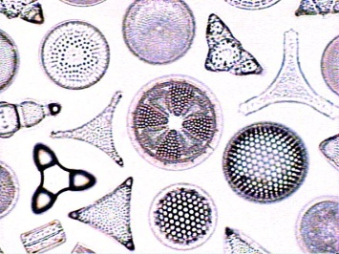
- Why are diatoms a good organism for study?(photo from http://www.ucmp.berkeley.edu)

- How can you assess the reliability (accuracy and trustworthiness) of something that you are reading, such as a newspaper or online article?

- Which of the following comparisons between pH and a centimeter are true? (Circle all that apply.)

- pH tells us how acidic or basic something is; centimeters tell us how long or short something is.
- There are many ways and tools to figure out the pH of something; there are many ways and tools to figure out how many centimeters something is.
- Both pH and centimeters are measured on linear scales. In other words, when a plant grows from 4.0 centimeters tall to 8.0 centimeters tall, it has doubled in height; when the ocean increases in pH from 4.0 to 8.0, it has doubled in alkalinity (how basic it is).
- Both pH and centimeters are measured on logarithmic scales. In other words, a solution with a pH of 8.0 is 10 times more alkaline (basic) than a solution with a pH of 7.0, and a string that is 8.0 centimeters long is 10 times longer than a string that is 7.0 centimeters long.

- Please describe why any of the above is/are NOT true.

- Draw a flow chart or network diagram showing what specifically happens when carbon dioxide (CO₂) is produced by anthropogenic processes and makes its way to the sea. (Side note:Anthropogenic definition = of, relating to, or resulting from the influence of human beings on nature). CO₂ production should be your first step. Next, include as many steps and as much information as you can in your diagram to show where CO₂ goes, any chemical reactions that happen, and what might result. “End” with any effects on various specific sea life and human economies.

- What grade are you? (Circle your answer.)

- 9th grade (Freshman)
- 10th grade (Sophomore)
- 11th grade (Junior)
- 12th grade (Senior)
- College

- In what course or class are you doing these lessons?

- What state is your school in? If your school is outside the USA, please skip this question and go on to the next question.

- If your school is outside the USA, in what country is your school located?

