Name:________________________ Teacher: ____________Period:___ Date:_______
Post-Assessment for
Ocean Acidification: A Systems Approach to a Global Problem

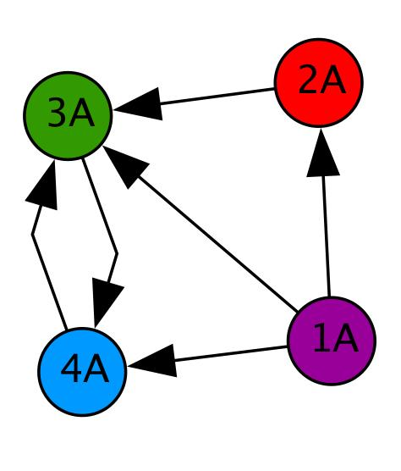
Instructions: This will be used as a way to assess your understanding and the effectiveness of the lessons you just completed. Please try your best to give an answer to every question, even if you need to guess. It is important for us to see where your thinking is. We thank you for your time and thought.
Use the diagram at the right to answer the following questions. Circle the best answer.
- If the circles (nodes) in the diagram are people, how many people can 1A directly contact?
0 1 2 3 4
- How many people can contact 1A?
0 1 2 3 4
- How many people can directly contact 4A?
0 1 2 3 4
- If 2A sees a funny picture, who else will know about it? (Circle all that apply.)
Nobody 1A 2A 3A 4A
- Explain how/why a network diagram is a useful tool.

- Various things are listed below. Place an X in front of the things that can be thought of as a system.
____aquarium ____bicycle____pile of sand ____ocean ____box of nails
- Explain your thinking. How did you decide whether something is a system?

- What do you think systems thinking is? Describe a time when have you used systems thinking.

- If you were going to do a systems level study, what should it involve?

- Describe an example of an emergent property.

- Give an example of how your actions have a large impact on the environment.

- What are some ways that carbon dioxide gets into our atmosphere?

- Explain the connection between carbon dioxide in the air and carbon dioxide in oceans and lakes.

- Describe the experiment(s) you conducted. Include your question, a brief summary of your procedure, materials used, a description of the data that you collected (including a description of any graph(s) that you made), results, and conclusions.

- If you had time, what other experiments would you perform?

- What interest group did you study? What information about your interest group did your experiment(s) give you?

- The “amount of light and temperature” are often coupled in the environment. What did this mean when experimenting with these factors in the lab?

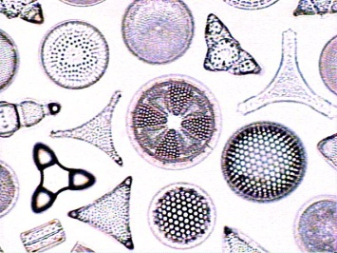
- Why are diatoms a good organism for study?(photo from http://www.ucmp.berkeley.edu)

- Which of the following comparisons between pH and a centimeter are true? (Circle all that apply.)

- pH tells us how acidic or basic something is; centimeters tell us how long or short something is.
- There are many ways and tools to figure out the pH of something; there are many ways and tools to figure out how many centimeters something is.
- Both pH and centimeters are measured on linear scales. In other words, when a plant grows from 4.0 centimeters tall to 8.0 centimeters tall, it has doubled in height; when the ocean increases in pH from 4.0 to 8.0, it has doubled in alkalinity (how basic it is).
- Both pH and centimeters are measured on logarithmic scales. In other words, a solution with a pH of 8.0 is 10 times more alkaline (basic) than a solution with a pH of 7.0, and a string that is 8.0 centimeters long is 10 times longer than a string that is 7.0 centimeters long.

- Please describe why any of the above is/are NOT true.

- How can you assess the reliability (accuracy and trustworthiness) of something that you are reading, such as a newspaper or online article?

- Do you think Ocean Acidification is a hotly debated topic? If so, why? If not, why not?

- Explain how Ocean Acidification is connected to the economy.

- Draw a flow chart or network diagram showing what specifically happens when carbon dioxide (CO₂) is produced by anthropogenic processes and makes its way to the sea. (Side note:Anthropogenic definition = of, relating to, or resulting from the influence of human beings on nature). CO₂ production should be your first step. Next, include as many steps and as much information as you can in your diagram to show where CO₂ goes, any chemical reactions that happen, and what might result. “End” with any effects on various specific sea life and human economies.

- What grade are you? (Circle your answer.)

- 9th grade (Freshman) C. 11th grade (Junior)
- 10th grade (Sophomore) D. 12th grade (Senior)
- College

- In what course or class are you doing these lessons?

- What state is your school in? If your school is outside the USA, please skip this question and go on to the next question.

- If your school is outside the USA, in what country is your school located?

