Name: _______________________ Teacher: ____________Period:___ Date:_______
Post-Assessment for
Ocean Acidification: A Systems Approach to a Global Problem

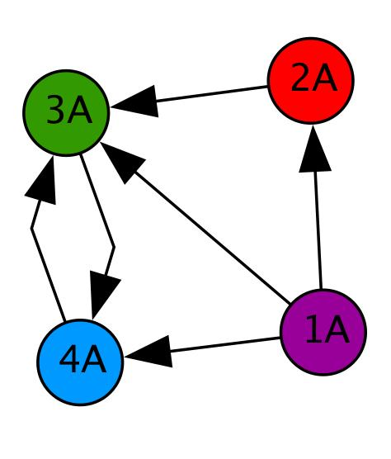
Instructions: This will be used as a way to assess your understanding and the effectiveness of the lessons you just completed. Please try your best to give an answer to every question, even if you need to guess. It is important for us to see where your thinking is. We thank you for your time and thought.
Use the diagram at the right to answer the following questions. Circle the best answer.
- If the circles (nodes) in the diagram are people, how many people can 1A directly contact?
0 1 2 3 4
- How many people can contact 1A?
0 1 2 3 4
- How many people can directly contact 4A?
0 1 2 3 4
- If 2A sees a funny picture, who else will know about it? (Circle all that apply.)
Nobody 1A 2A 3A 4A

- Explain how/why a network diagram is a useful tool.
Students should recognize the diagram shows connections and the direction information flows.
- Various things are listed below. Place an X in front of the things that can be thought of as a system.
_ X__aquarium __ X_bicycle ____pile of sand _ X__ocean ____box of nails
- Explain your thinking. How did you decide whether something is a system?
When there are interacting components, complexity.
- What do you think systems thinking is? Describe a time when have you used systems thinking.
When having to consider several (many) parameters at once; figuring out a class schedule for next year.
- If you were going to do a systems level study, what do you think it would involve?
Consideration of as many factors as possible; collection and analysis of much data; data from many different experiments.
- Describe an example of an emergent property.
Mix blue with yellow and getting green. Anything where the actions of one or more things produce something unforeseen.
- Give an example of how your actions have a large impact on the environment.
Buying bottled water and making lots of trash.
- What are some ways that carbon dioxide gets into our atmosphere?
Breathing out; car exhaust.
- Explain the connection between carbon dioxide in the air and carbon dioxide in oceans and lakes.
CO₂ is a heavy molecule and sinks toward the air/water interface. Air is increasingly composed of CO₂ which increases the likelihood of CO₂ in water as CO₂ is soluble in water.
- Describe the experiment(s) you conducted. Include your question, a brief summary of your procedure, materials used, a description of the data that you collected (including a description of any graph(s) that you made), results, and conclusions.
Answers will vary
- If you had time, what other experiments would you perform?
Answers will vary
- What interest group did you study? What information about your interest group did your experiment(s) give you?
Answers will vary
- The “amount of light and temperature” are often coupled in the environment. What did this mean when experimenting with these factors in the lab?
They can be considered in a lab experiment
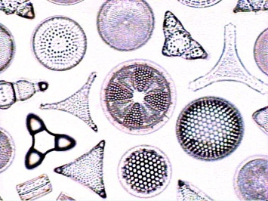
- Why are diatoms a good organism for study?(photo from http://www.ucmp.berkeley.edu)
They are easy to grow, safe to handle, and indicate the health of an ecosystem.
- Which of the following comparisons between pH and a centimeter are true? (Circle all that apply.)

- pH tells us how acidic or basic something is; centimeters tell us how long or short something is.
- There are many ways and tools to figure out the pH of something; there are many ways and tools to figure out how many centimeters something is.
- Both pH and centimeters are measured on linear scales. In other words, when a plant grows from 4.0 centimeters tall to 8.0 centimeters tall, it has doubled in height; when the ocean increases in pH from 4.0 to 8.0, it has doubled in alkalinity (how basic it is).
- Both pH and centimeters are measured on logarithmic scales. In other words, a solution with a pH of 8.0 is 10 times more alkaline (basic) than a solution with a pH of 7.0, and a string that is 8.0 centimeters long is 10 times longer than a string that is 7.0 centimeters long.

- Please describe why any of the above is/are NOT true.
pH is measured on a logarithmic scale; length is measured on a linear scale
- How can you assess the reliability (accuracy and trustworthiness) of something that you are reading, such as a newspaper or online article?
If it is from a peer-reviewed journal, provides evidence to back up claims made by the author, if the author is reputable
- Do you think Ocean Acidification is a hotly debated topic? If so, why? If not, why not?
Answers will vary
- Explain how Ocean Acidification is connected to the economy.
Acidification is harming the shellfish industry, and is impacting tourism (divers and snorkelers) to coral reefs. Fishing is impacted as rookeries are destroyed…

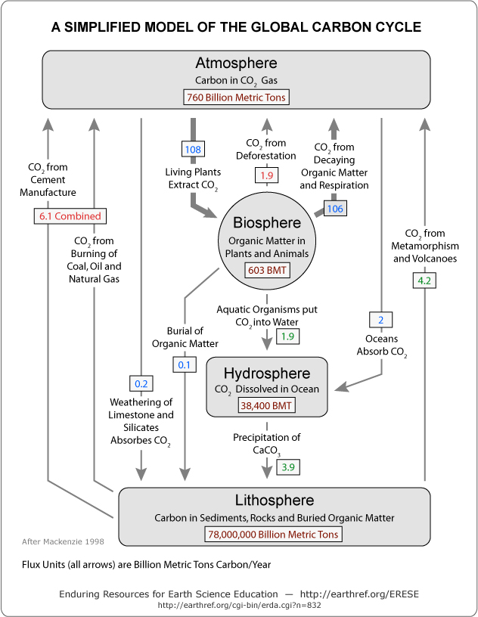
- Draw a flow chart or network diagram showing what specifically happens when carbon dioxide (CO₂) is produced by anthropogenic processes and makes its way to the sea. (Side note:Anthropogenic definition = of, relating to, or resulting from the influence of human beings on nature). CO₂ production should be your first step. Next, include as many steps and as much information as you can in your diagram to show where CO₂ goes, any chemical reactions that happen, and what might result. “End” with any effects on various specific sea life and human economies.

- What grade are you? (Circle your answer.)

- 9th grade (Freshman)
- 10th grade (Sophomore)
- 11th grade (Junior)
- 12th grade (Senior)
- College

- In what course or class are you doing these lessons?

- What state is your school in? If your school is outside the USA, please skip this question and go on to the next question.

- If your school is outside the USA, in what country is your school located?

