Making Test Tube racks

When doing this activity, there is NO substitute for having 10 by 10 grid test racks, so that sample tubes correspond exactly to the maps.

If you use commercial test tube racks, they’ll come in some other numerical arrangement like 4 by 12, and you’ll try to use them by labeling carefully and maybe even taping a couple racks together. Bad idea.

Experience suggests:

you’ll spend twice as much time setting up your samples.

Students will have difficulty
locating samples,
putting samples back in the right place,
correctly associating a measurement with the correct map location

Instead, make some of your own 10 by 10 test tube racks.

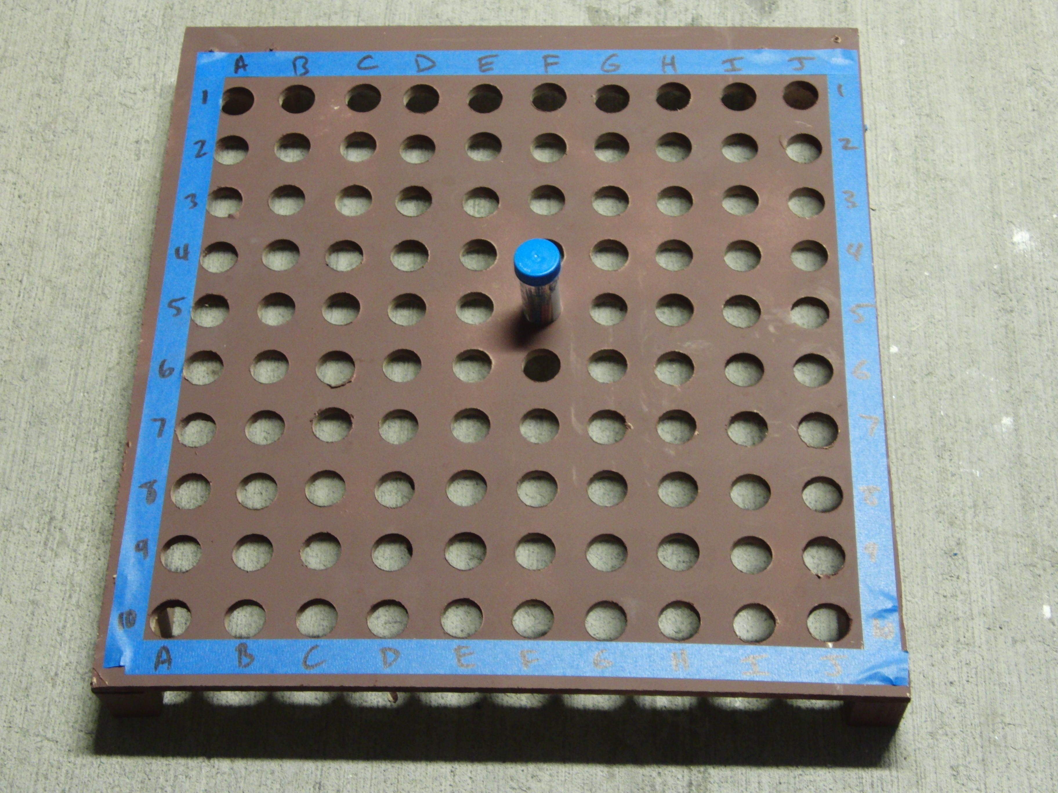
- I wanted to use 50 ml Falcon tubes (4 classes, 2x oversampling, 2ml/ sample). They’re about 1.125 inches in diameter, so I figured out what size board I’d need (24 inches square), cut 4 boards to 24 x24 inches, clamped them together, laid out a 10 x 10 grid (dots 2 inches apart), and drilled 100 holes. To help keep them differentiated, I painted them different colors, and labeled the rows and columns. I added some risers made from scrap 2 by 4 pieces. Kind of heavy, very durable.

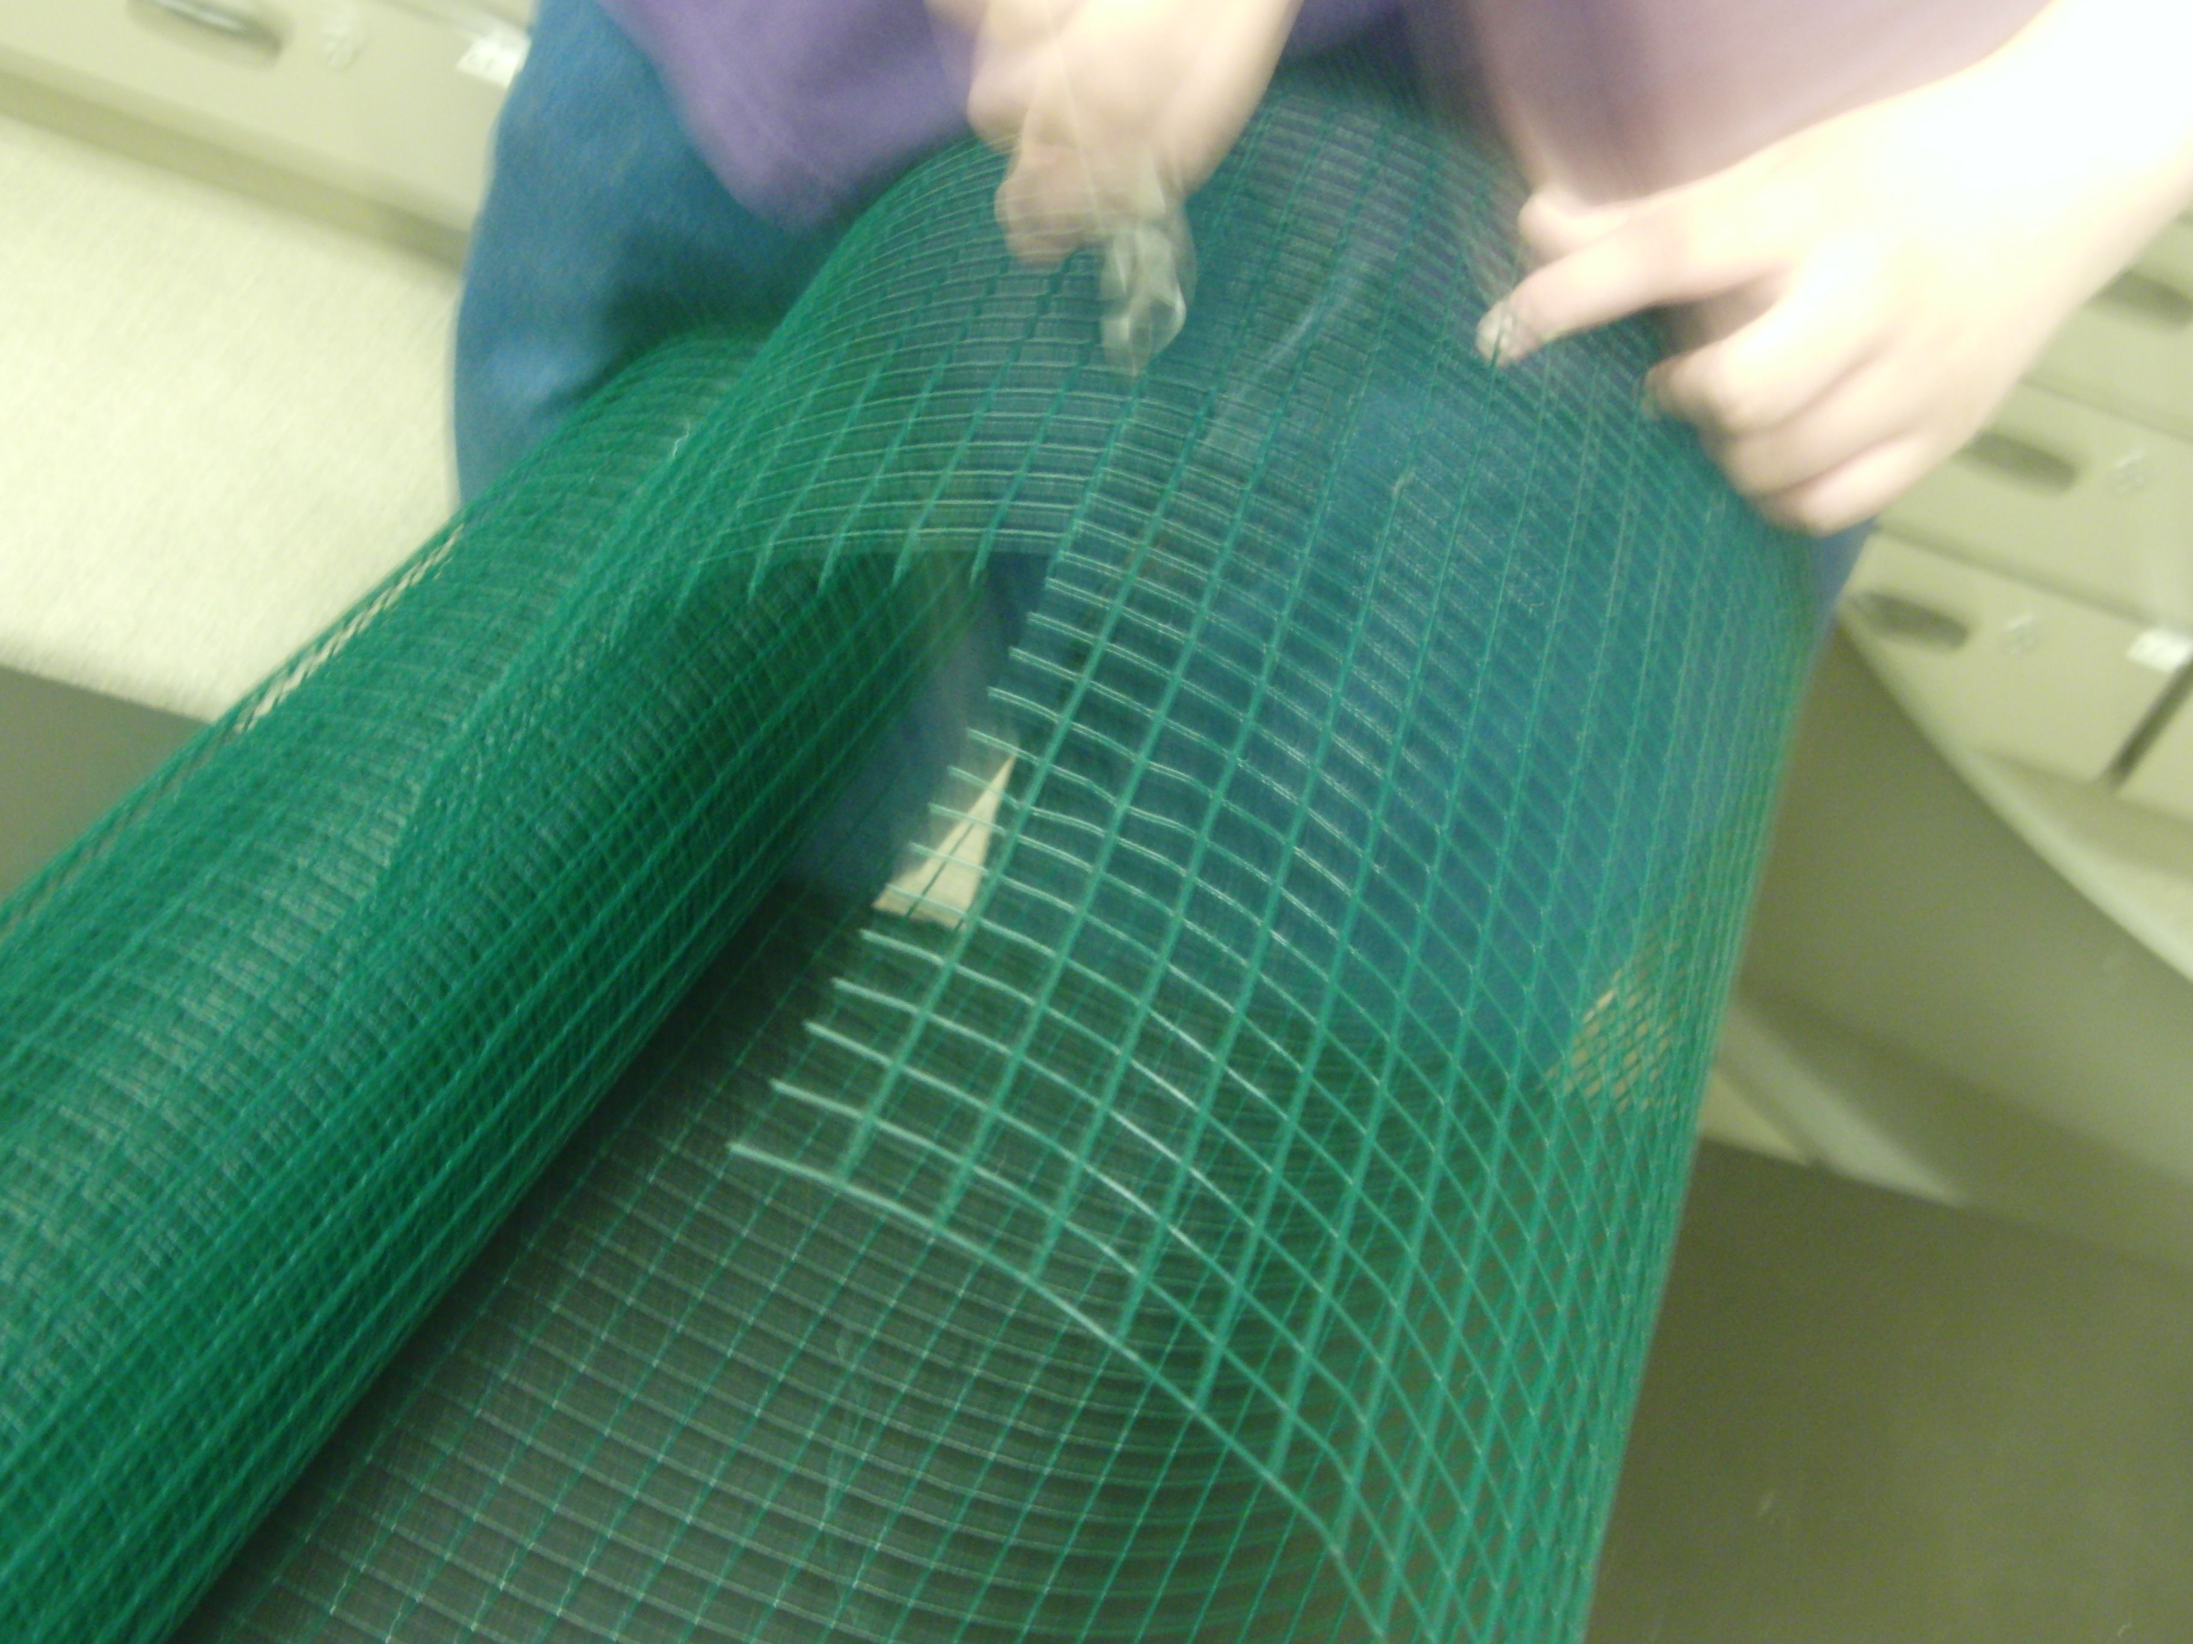
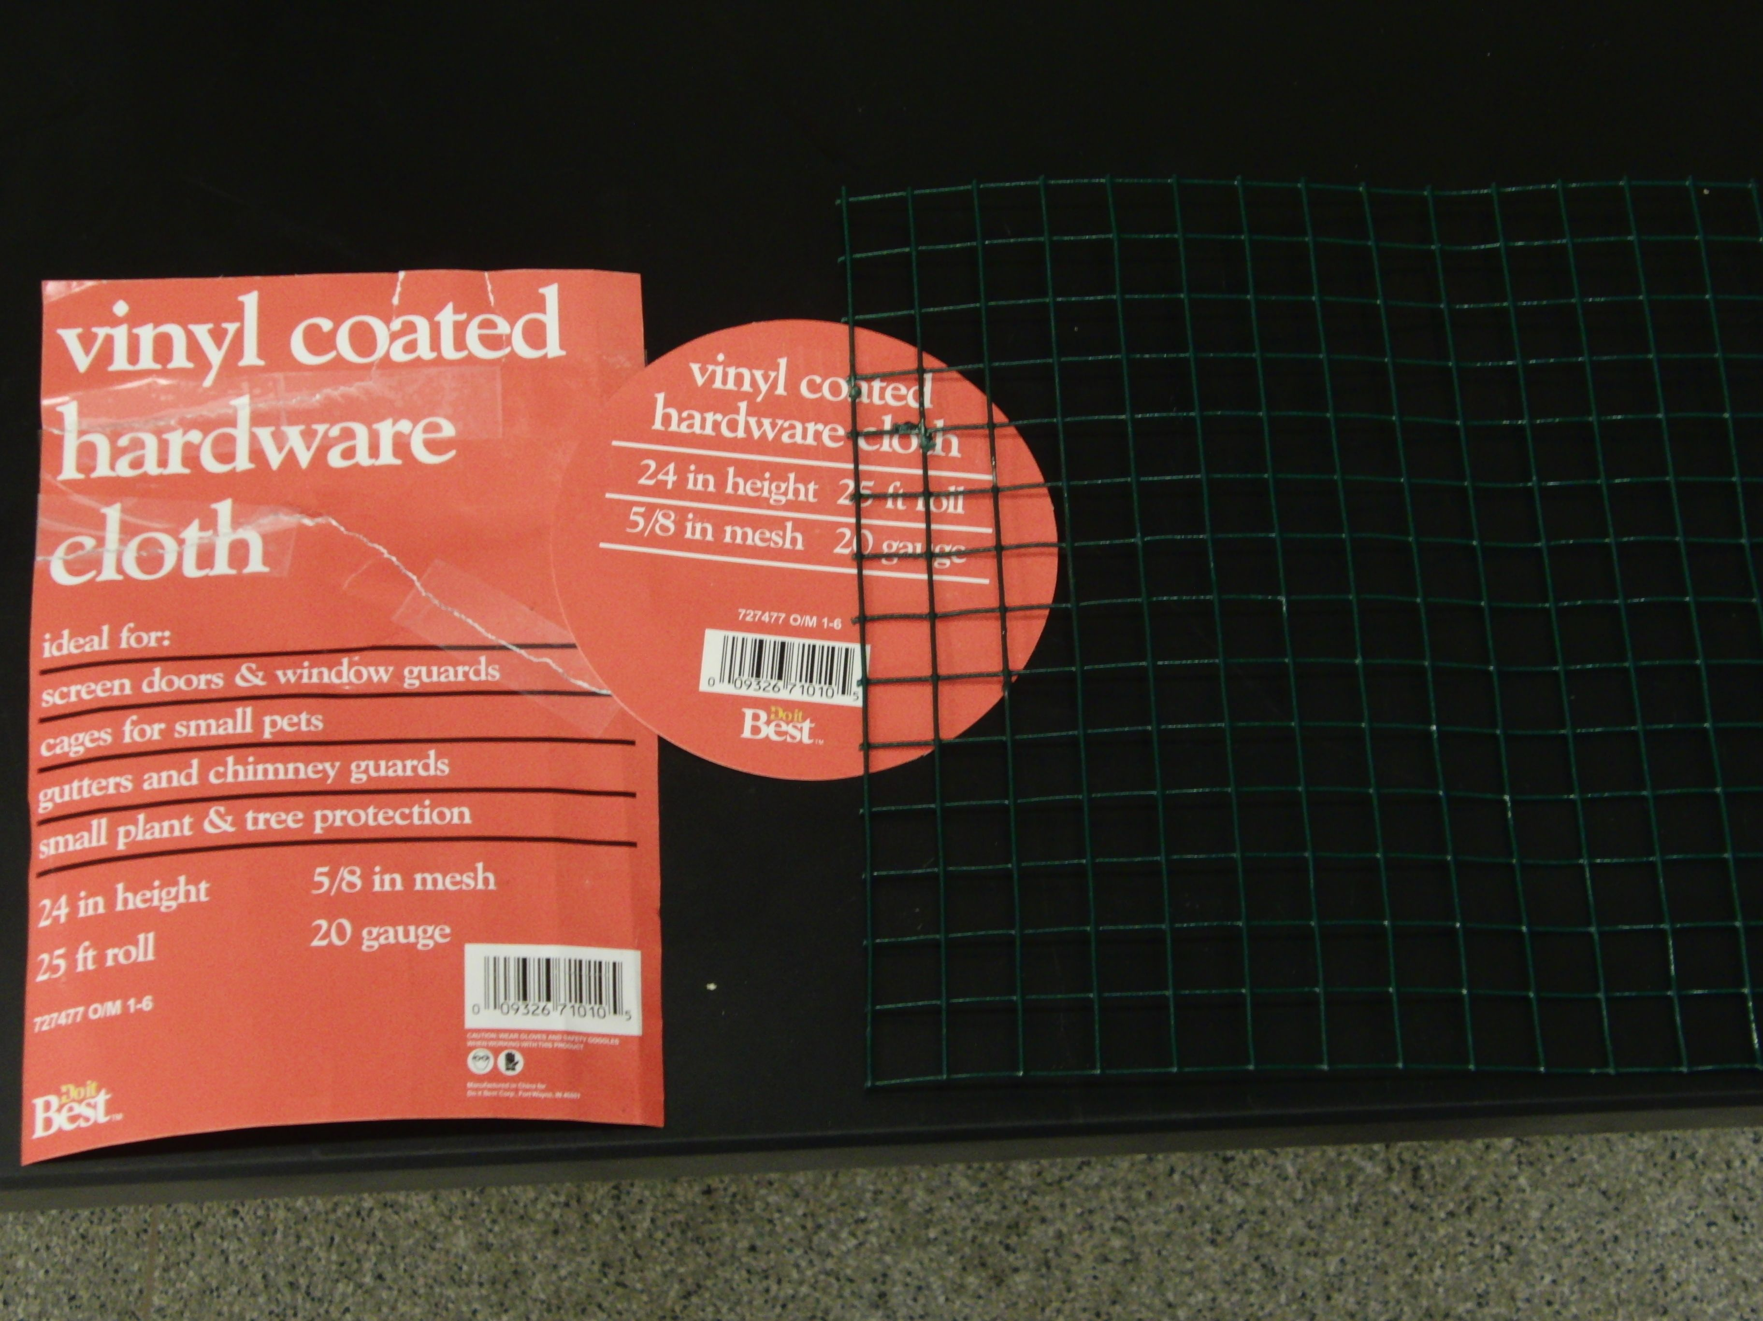
- Here’s another idea: using smaller glass test tubes to hold samples (VWR cat 89000-498: cheap, readily available, but they don’t hold as much, only 10 ml, so you might need to reload between classes or at the end of the day), build racks from hardware cloth. Hardware cloth is sometimes called chicken wire, but real chicken wire has round holes on a diagonal arrangement (you don’t want that) vs hardware cloth, which is arranged into squares (that’s what you want). For this size test tube, we found some hardware cloth with a 5/8 inch mesh size that fit the tube very nicely
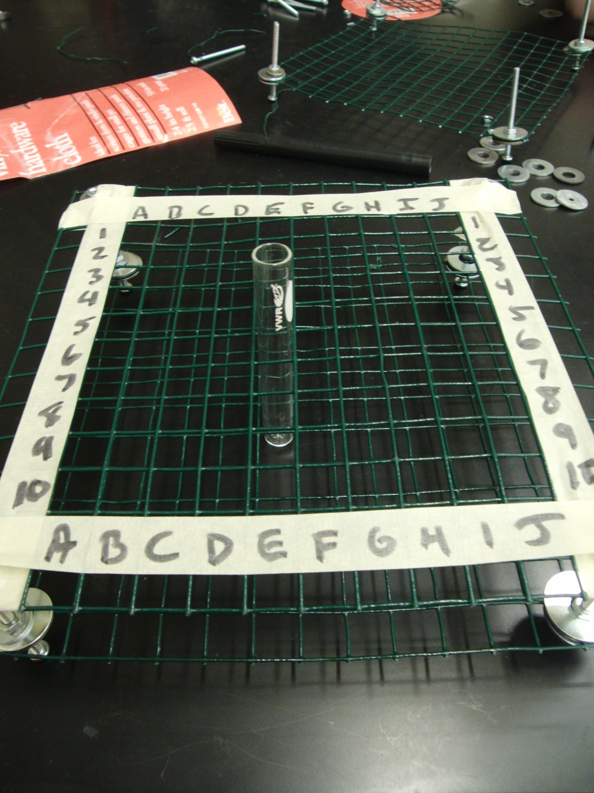
Once you’ve cut 2 14 by 14 squares of the hardware cloth, make some spacers with long bolts . For each spacer, we used one 8-32 bolt 2 ½ inches long, with a nut and washer below and above the cloth, for both the upper and lower cloth.
So, for a finished rack, that’s
2 14 x 14 cloth squares,
4 2 and1/2 inch long 8-32 bolts
16 8/32 nuts
16 washers too big to fit through the cloth mesh

If you have all the materials, it should take about 5 minutes to put a rack together. To do the complete activity, you’ll need 4 racks.

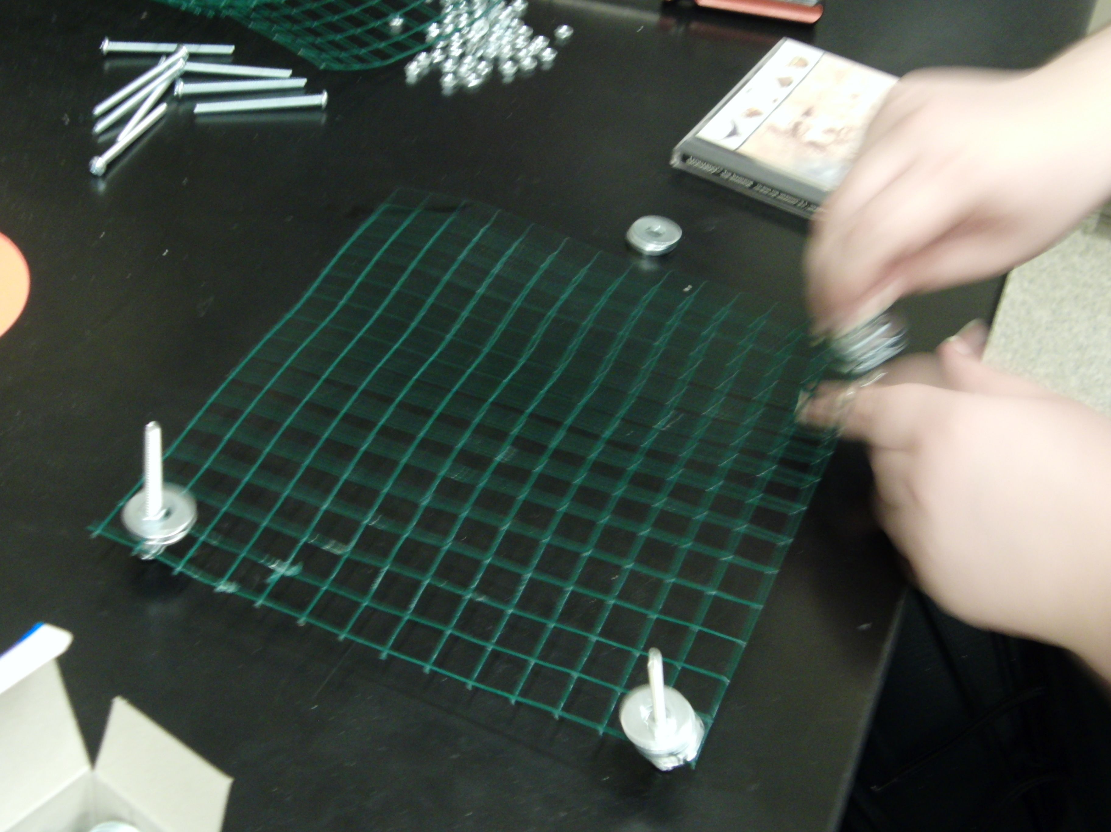

Note: we made a 14 by 14 grid so there would be space for labels and the spacers around the edges.

