Carbon Cycle: Jigsaw Activity
Students explore how biological, physical and geologic processes interact to create equilibrium in the carbon cycle. Each group experiences a simple exploration (hands on activity) along with web-based research that they will use to develop a diagram illustrating the network they are given to investigate. Student(s) from each group then work together to develop a comprehensive network showing the 3 processes acting as a system. ‘Cytoscape’ (see Ecological Networks module) may be used to produce the network or students could draw their proposed network. If students are not familiar with networks, use the cellphone activity from the ‘Ecological Networks’ module.
Objectives: Students will understand that the ocean takes up and releases carbon by…
- Direct solubility of carbon dioxide gas into water.
- Conversion of carbon by phytoplankton into organic material and carbonate shells.
- Settling and lithification of carbonate into limestone.
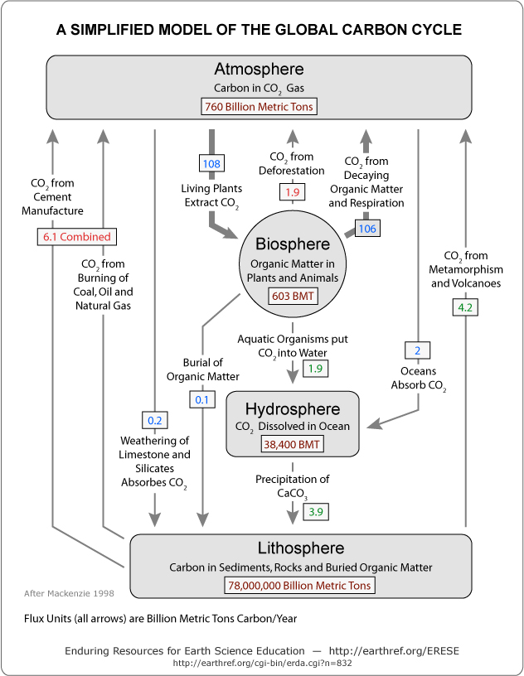
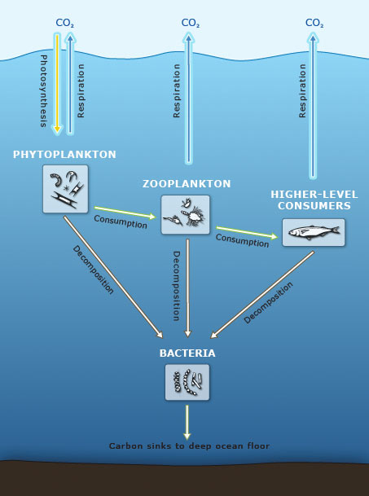

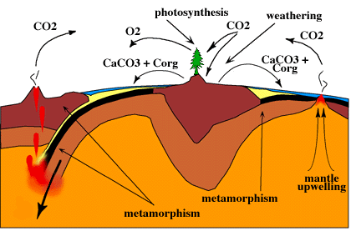

A simplified look at the path of carbon through the
biological pump. http://www.argonautplanet.com/?p=70

Geological processes.
http://www.science.uwaterloo.ca/~cchieh/cact/applychem/ccycle.html
Materials:
- 1 cup clear, cold, carbonated beverage per ‘physical pump’ group and a thermometer (or have students use ‘cold’ versus ‘warm’.)
- Microscope(s) set up with slide(s) of plankton and/or 1 set of plankton pictures per ‘biological pump’ group.
- Samples of carbonate, silicate, calc-silicate, and vesicular lava rocks for each ‘geological processes’ group. If rock samples are not available, use pieces of white chalk (calcium carbonate) and pumice stone.
- 1 dropper of dilute acid (vinegar) per ‘geological processes’ group
- Computers with internet access or printouts of web information
- Student handouts. If you can email or place these documents on a common drive, students can open links without having to type the address in a browser.
Teacher Preparation: Assign students to groups. For the first part of the jig-saw, groups will become “experts” in one of the three background areas. There can be multiple expert groups on the same background topic. For the second part of the jigsaw, assign students in groups of three, including one expert each on the physical pump, the biologic pump, and geologic processes. Each threesome will produce a network (diagram) of the carbon cycle to share with the class.
- Reserve computer lab, if necessary. Bookmark the websites listed; or place student pages on a common drive or email to students so students can click the links; or print and make copies of relevant information.
- Obtain clear soda and a few clear, plastic cups or beakers.
- Set up several microscopes with slides of various types of phytoplankton and zooplankton.
- Collect and label rock samples. Possible carbonates include limestone, dolostone, or marble. Possible calc-silicates include skarn, granite, anorthite, hornblende, wollastonite, and diopside. Silicates include quartz, chert, granite, plagioclase, and obsidian/volcanic glass. If rock samples are not available, use pieces of white chalk (calcium carbonate) and pumice stone.
*See end for useful diagrams.
Jigsaw: Part 1 (Overview of Oceanic Carbon Cycle) Introduce the significance of the ocean to the carbon cycle. Explain that increasing levels of carbon dioxide in the atmosphere contribute to global warming, so we want to know how (and how quickly) natural mechanisms remove carbon dioxide from the atmosphere. The two largest reservoirs of carbon in the carbon cycle are sedimentary rocks and the ocean, and over the next few days the class will focus on learning about the ocean’s capacity to absorb CO2 from the atmosphere.
- Explain that each group will become an expert on one aspect of the ocean’s role in the carbon cycle: solubility of gases (the physical pump), the role of plankton (the biologic pump), or geologic processes.
- Assign groups (3).
- Show the students how to access online resources and clarify procedures for group work and expectations for sharing information with others when data-gathering is complete.
- Group Work Time: Students work as a team to collect data and complete the hand-out on their subtopic.
Jigsaw: Part 2 (Students Share Learning) Students regroup to share their conclusions from Part 1 with 2 students representing the other 2 subtopics. The new groups (of 3) work together to connect the information and diagrams they have designed into a single system that represents a more complete view of the carbon cycle. As students combine ideas, it may help to add labels that clarify the relative rates of different carbon transfers. Cytoscape (see Ecological Networks module) may be used to produce a final, comprehensive diagram (example below).
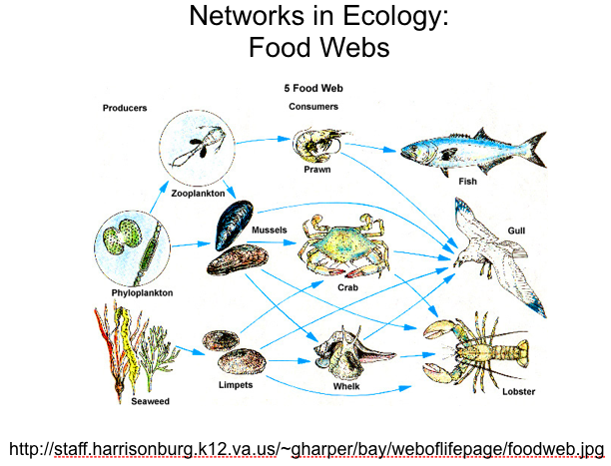
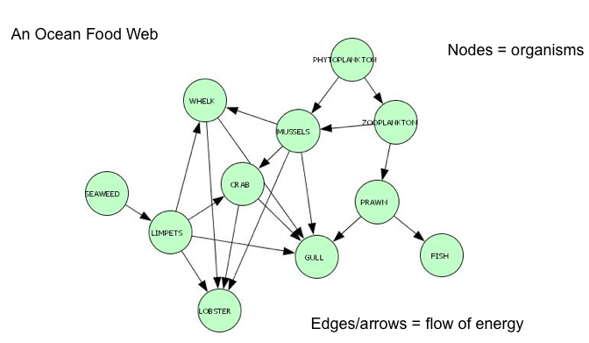

- Once student groups have a network made, have them present their work to the class. Ask students to adjust/revise their network to fully depict the pumps and processes involved in the carbon cycle.
ASSESSMENT: Assign each group or student a question to work on that will require the students to use the completed cycle and apply critical thinking skills. Possible questions include:
- Create a story that describes the motion of a carbon atom through the carbon cycle; include at least one physical/chemical, biological, and geologic change and at least six different reservoirs.
- Oceanographic research shows that the temperature of the oceans is rising. How might warming oceans affect the amount of carbon dioxide in the atmosphere over a long period of time?
- In the Gulf of Mexico, shrimpers complain of a “Dead Zone” where bottom-feeders cannot survive in summer months because of lack of oxygen. Researchers believe that nutrients from Midwest farms that drain into the Mississippi river are to blame. Using what you’ve learned about plankton and the carbon cycle, explain how excessive nutrients in the water could cause oxygen depletion in bottom waters.
- We are currently worried that CO2 sources are out of balance with CO2 sinks. If sources produce more CO2 than sinks can remove, CO2 in the atmosphere increases, possibly leading to global warming. What might happen if the reverse were true and sinks took up more CO2 than sources? Explain.
- Many plants are more productive in CO2-enriched atmospheres than in unenriched atmospheres in the laboratory. Does this mean that the greenhouse effect is likely to help the world food supply, and why or why not?

USEFUL DIAGRAMS
The first 3 charts and information about them may be found at:
http://www.whoi.edu/oceanus/viewArticle.do?id=2386&archives=true
Many more illustrations and images from Oceanus:
http://www.whoi.edu/oceanus/viewIllustrationGallery.do?gType=2&gallery=true&clid=2417
Many useful reports can be downloaded here:
http://www.pewclimate.org/global-warming-basics/climate_change_101

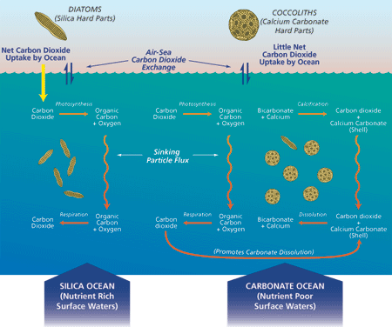

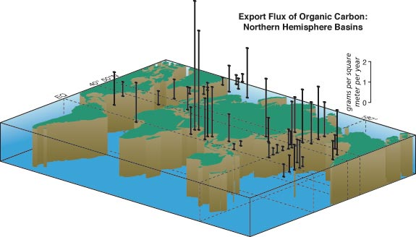

http://www.argonautplanet.com/?p=70

Good explanation (3 pages) of ‘slow carbon cycle’ versus ‘fast carbon cycle’ may be found at: http://earthobservatory.nasa.gov/Features/CarbonCycle/
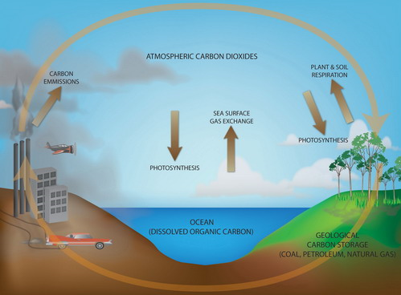
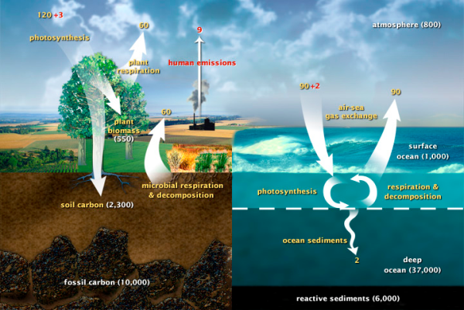

If you need a simple diagram to get students started:
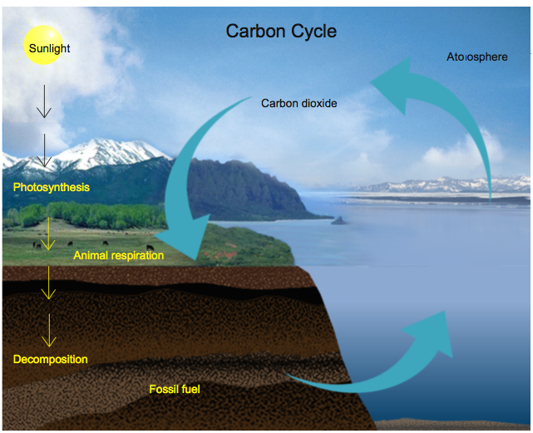
http://tabstart.com/directory/education/carbon-cycle-diagram-worksheet-1367 (4th link down, on left)
or from the powerpoint slides:
