Name:________________________ Teacher: ____________Period:___ Date:_______
Annual Atmospheric CO₂ Patterns from Mauna Loa Observatory, Hawaii
Fully explain the ideas posed in these questions. You may discuss them with others, but your answer must represent your understanding of the ideas. Use the Mauna Loa Observatory website (http://www.esrl.noaa.gov/gmd/obop/mlo/) to answer the following questions.
- Look at the chart online showing the entire Mauna Loa data set from 1958 to 2011. A) Draw the overall trend. B) Describe with words the overall trend.

- If the growing season and the decomposing seasons were in equilibrium, would the trend described in #1 exist? Why or why not?

- Estimate the average CO₂ for 1958. ______________________ Estimate the average CO₂ for 2011. ______________ If the 1958 amount is set equal to 100%, what’s the percent increase in CO₂ since 1958? _____________ show work:

- It is estimated the world needs to keep CO₂ at 350 ppm or less if there is to be climate stability. In what year was the average 350 ppm? ________. Why is this trend happening? Be specific.

- Why was Mauna Loa chosen as a location to measure CO₂ concentrations in the atmosphere?

- Why are carbon dioxide levels in the atmosphere increasing? Be specific.

- How does carbon dioxide cause the pH of the ocean to decrease?

8. Can you find this information on other websites? Are they primary or secondary sources? How do you know whether or not you can trust the site?

9. The following graphs show changes in the levels of atmospheric and oceanic carbon dioxide over the past 20 years, as well as a corresponding change in ocean pH. The x-axis measures time in years, from October 1988 until December 2007. The y-axis of the top graph measures CO2 concentration. This top graph shows how the CO₂ concentration in both the atmosphere (red line) and ocean (blue line) change with time. The actual data collected are shown with dots, and each line is the "best fit" to the data. The y-axis of the bottom graph measures pH of the ocean. Use the graphs to answer the following questions.
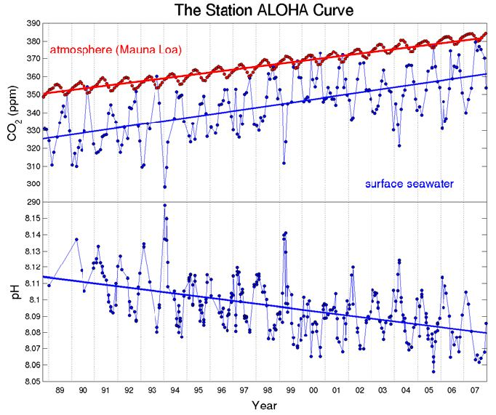
Figure 1: Data from the Hawai‘i Ocean Time Series (HOT) and the Mauna Loa Observatory – Questions 9-10 taken from Uof Hawai’i C-MORE Lesson 1b.
- How much carbon dioxide was in the atmosphere in 1988? ________ 2007? __________
b. How much carbon dioxide was in the ocean in 1988? _________ 2007? ___________
c. What was the pH of the ocean in 1988? _________ 2007? ___________

10. According to these data and the data you collected, how do you think increasing atmospheric CO2 will affect marine organisms? Break marine organisms down into groups to answer this question.

