Scientists look for ways to match changes in Earth’s distant past environmental conditions with the timing and speed of more recent changes. They are trying to understand how sensitive the climate system is to disruption. Various methods and tools are used to gather information.
The chemistry of seafloor sediments full of fossilized microscopic shells can reveal ocean temperatures that existed tens of thousands of years ago. (Photo by Tom Kleindinst, Woods Hole Oceanographic Institution)
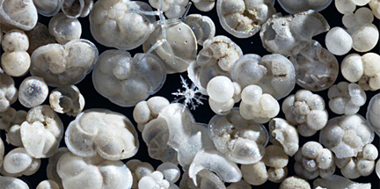
- Click here: http://www.whoi.edu/main/topic/ice-ages-past-climates , and choose
to see what scientists look for in these tiny shells.
- Which 2 elements give scientist’s clues about the nutrients available?
- b)
- Why do scientists look at oxygen?
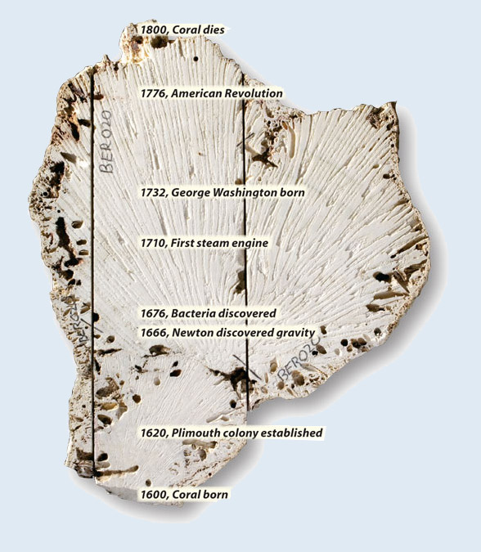
- Coral skeletons can give
scientists another clue.
Examine this photo (by
Tom Kleindinst, Woods
Hole Oceanographic
Institution).

- How long did this coral
live?

- How do you think
scientists know the age
of the places shown in
the picture?

A slice was made through the center of the long-dead brain coral. It is a slice through human and ocean history. This 1,000-pound coral grew near Bermuda during the Little Ice Age. Radiating marks visible in the photo are grooves from the quarry saw that sliced through the coral. The coral changed its growth direction once in about 1650, and marine life eroded its surface, but scientists can analyze the coral's inner skeleton and decipher ocean temperatures during its lifespan.
While a coral is growing it incorporates a lot of uranium (U), but no thorium (Th). This means that as it ages its Th/U ratio increases at a known rate. So, measurements of the Th/U ratio provide a measurement of the coral’s age.
- Change or add to your answer from #4; How do scientists know the age of the places shown in the picture?

- Scientists often come up with new ideas about where to obtain more clues. Click here: http://www.whoi.edu/main/topic/ice-ages-past-climates , and choose
to see how one, young researcher combined her interests in climbing and science to solve a problem.

- What is the problem Ms.Criscitiello wanted to solve?

- Briefly describe 2 techniques she used to obtain data.
a)

- How does she confirm that concentrations of MSA actually can be used?

Scientists determine that the data they collect are actually useful by checking their results with other scientists and by seeing if other types of data lead to the same conclusions. You have explored several ways scientists collect data. Using chemical information collected from ice cores and from shells of organisms preserved in deep-sea sediments, geologists have been able to map out how Earth's climate has changed over time.
- Click on http://carbonconnections.bscs.org/curriculum/unit-01/lesson-02.php#emccc Scroll down to and play the animation. This will help you understand how the following graphs are produced.

- Examine the graph below.
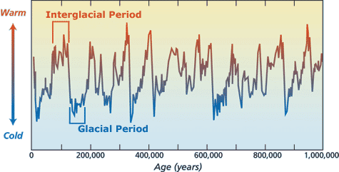

- What span of time does it cover?

- What do the peaks and valleys tell you?
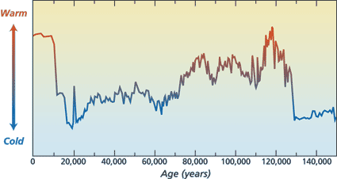
- Examine the graph to the right.
- What is different about this graph
compared to the graph above?

- Which time in history was most like
the current temperature?

- Compare the 10,000 years previous to the 2 warmest times. What is different?

Let’s compare 3 different types of data in more detail. You will need a sheet of tracing paper and colored pencils or a transparency and water-based pens, a ruler, and the graphs for comparison.
- Cut out the 3 graphs and arrange them on your table so that you can easily compare the lines.

- Are all 3 graphs comparable? Explain.

- Place a sheet of transparency film or tracing paper over any graphs you are able to match up. Align them. Use a ruler and pen or pencil to draw a line over the aligned Y axes so you have made an ‘anchoring line’. Label this line.

- What do you need to do to align all of the graphs so that you can compare the data?

- Use a different color to draw a vertical band through each of the lowest points (cold, low CO₂) and if there are similar points to the left and right, include those as well.

Example:

- Explain, in detail what you did to align the data of all three graphs.

- What is different about the information depicted by the oxygen graph compare to the CO₂ and temperature graphs?

- Make a generalization about what is happening to CO₂, temperature and
oxygen isotopes over time.

- Examine the next two graphs. http://cdiac.ornl.gov/trends/co2/lawdome-graphics.html
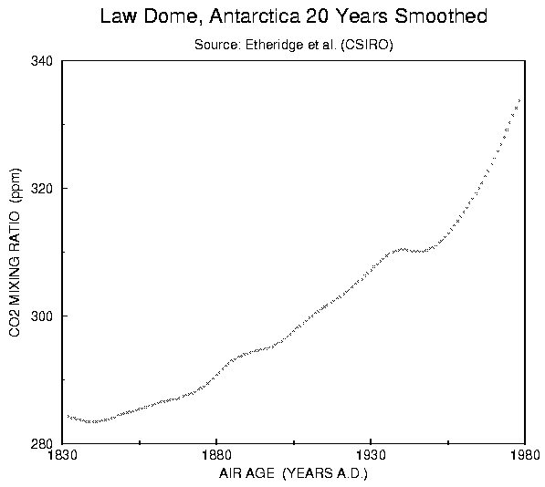
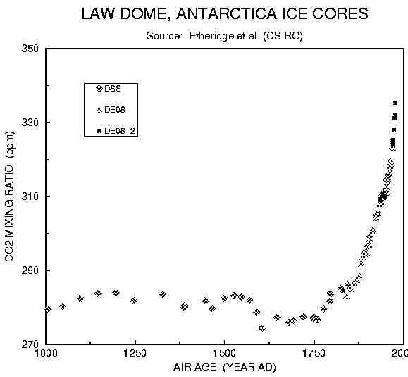
- Draw a vertical line on the 1st graph showing where the data from the 2nd graph
begins.

- Describe what the data from these 2 graphs indicate has happened since 1000AD.

- Calculate the rate of change from 1000AD to 1830AD. (show work)

- Calculate the rate of change from 1830AD to 1980AD. (show work)

- How many times faster is the rate of change from 1830 to 1980 compared to the previous time period shown? (show work)

Fill in the missing information:

- I have examined _____(number) lines of evidence supporting the theory that…

- Scientists are confident in their findings because…

- Which line of evidence do you find most convincing?

Explain:

