Tatoosh Island article http://www.nytimes.com/2012/10/07/us/scientists-in-washington-state-adopt-tiny-island-as-climate-change-bellwether.html?emc=eta1&_r=1&

American Museum Nat. Hist. PETM video: http://www.amnh.org/explore/science-bulletins/(watch)/earth/features/petm-unearthing-ancient-climate-change

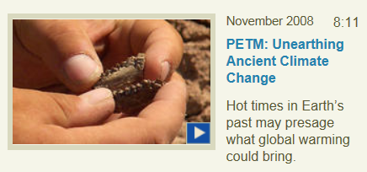
Look for: Alignment of mass extinctions with drastic climate changes:
http://www.skepticalscience.com/Earths-five-mass-extinction-events.html
http://www.environmentalhealthnews.org/ehs/newscience/2011/08/2011-0829-climate-change-extinctions
http://earth.usc.edu/classes/geol150/stott/evolution/paleozoic.html

