3 Graphs for comparison:
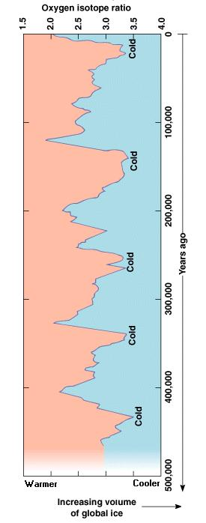

http://higheredbcs.wiley.com/legacy/college/levin/0471697435/chap_tut/chaps/chapter15-06.html
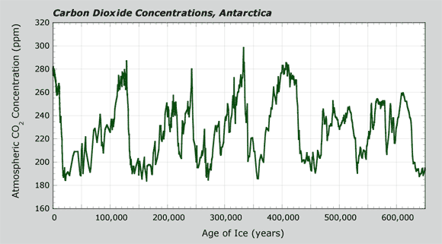

http://carbonconnections.bscs.org/media/images/content/1065.gif
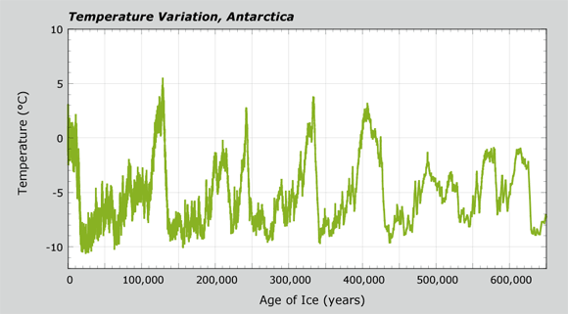

http://carbonconnections.bscs.org/media/images/content/1067.gif

