Ice cores, CO2 concentration, and climate, B. Geerts and E. Linacre, 3/'02

http://www-das.uwyo.edu/~geerts/cwx/notes/chap01/icecore.html

Ice cores have been drilled in Antarctica and Greenland to examine the variation of the composition of air trapped in bubbles in the ice, representing global atmospheric conditions as much as 160,000 years BP (1). The first and deepest ice core was drilled at Vostok in central Antarctica, originally by a French-Russian team (Fig 1). Drilling of the core still continues, and it is expected that, when drilling is completed in a few years time, an age of up to 500,000 years will have been reached. Starting on the right-hand side of the graph at about 140,000 years ago, the climate was about 6ºC colder than it is today. This was an ice age. Then at about 130,000 years ago, there was a quite rapid warming period until about 125,000 years ago, when the climate was, perhaps, 1ºC or 2ºC warmer than today. These short warmer periods are called interglacials.
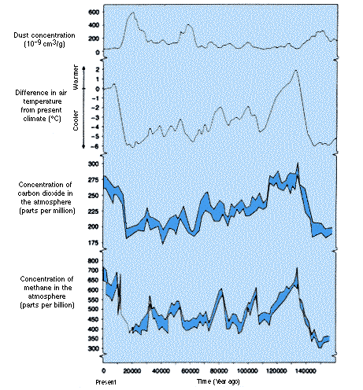
Fig 1. Dust concentration, mean temperature (as estimated from the oxygen isotope ratio), CO₂ and CH₄ concentrations plotted against time, estimated from the analysis of an ice core drilled at the Russian station, Vostok, on the Antarctica plateau (1).

From 120,000 to about 20,000 years ago, there was a long period of cooling temperatures, but with some ups and downs of a degree or two. This was the last Great Ice Age. From about 18,000 or 19,000 years ago to about 15,000 years ago, the climate went through another warming period to the next interglacial, - the current one.
Fig. 1 and Greenland ice cores indicate climate oscillations lasting 7,000 - 15,000 years during the Last Great Ice Age (110-16 kBP). These are known as ‘Heinrich events’ and are also evidenced by ocean sediments. A more detailed ice core analysis shows an occasional abrupt change of climate during the last interglacial (the Eemian, at 120 kBP), changing by as much as 10K during only 10 -30 years. Such changes may be due to switchings of flows in the northern Atlantic. Similar changes have been observed at the end of the last glaciation.
Fig. 1 also shows that carbon dioxide and methane (main greenhouse gases) occur in higher concentrations during warm periods; the two variables, temperature and greenhouse gas concentration, are clearly consistent, yet it is not clear what drives what. The correlation coefficient is 0.81 between CO₂ content and apparent temperature, on the whole. During deglaciation the two varied simultaneously, but during times of cooling the CO₂ changed after the temperature change, by up to 1000 years. This order of events is not what one would expect from the enhanced greenhouse effect.
Finally, Fig. 1 shows that high concentrations of dust occur at the same times as the colder periods. The most likely reason is that the ice sheets were more extensive during colder periods, and therefore the sea level lower, thus there would have been more exposed, bare land.
Fig. 2. Average air bubble CO₂ concentration versus age in three ice cores taken close to the summit of Law Dome at 67ºS, 113ºE, around 1390 m elevation. Law Dome is near the Australian Antarctic station Casey.

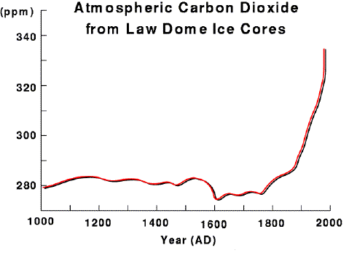
Another study of three much smaller Antarctic ice cores (2) shows the CO₂ concentration for individual years over the last millennium (Fig. 2). The core depths were 234 m, 243 m and 1200 m. The layers of the core were dated by counting the annual layers of oxygen ratio, ice electro-conductivity and hydrogen-peroxide concentration, and then the chronology was verified by detecting the acidic layers due to known volcanic eruptions in 1963, 1815, 1450 and 1255 AD.
Note the slightly lower CO₂ concentration between 1550 - 1800 AD, i.e. during the Little Ice Age. The considerable increase since 1830 was interrupted by a brief stabilisation during 1935 - 1945, probably as a consequence of some natural variation of the carbon cycle. The concentration had risen to 335 ppm by 1980.
Another ice core, taken near MCMurdo Sound (on Taylor Dome) has confirmed the Law Dome temperature estimates.
It appears that the air bubbles trapped in the ice represent the atmospheric composition at the time of snow deposition, in other words, gas diffusion through the ice is negligible. For instance, the CO₂ concentration in air bubbles dated to be from 1958 or later agrees very well with direct free-atmospheric CO2 measurements (Fig. 3), which have been made since then.
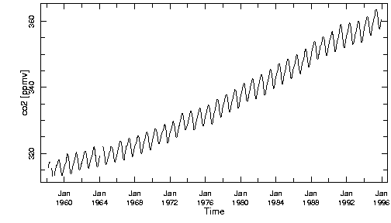
Fig. 3 direct free-atmospheric CO2 measurements
References
- Lorius, C., J. Jouzel and D. Raynaud 1993. The ice core record: past archive of the climate and signpost to the future. In: Antarctica and Environmental Change. Oxford Science Publications. pp 27-34.
- Etheridge, D.M., L.P. Steele, R.L. Langenfelds and R.J. Francey 1996. Natural and anthropogenic changes in atmospheric CO2 over the last 1000 years from air in Arctic ice and firn. J. Geophys. Res. 101, 4115-28.

