Lesson 5A:
Separation of Thaps Pigments using Paper Chromatography

Overview:
After students have completed their counts and experiments with Thaps, the students will collect yet another form of data by evaluating the photosynthetic pigments of their cultures. Thaps grown in different conditions may show different levels of pigments (Chlorophyll a, c2, Carotene, and a variety of Xanthins). Students will extract the Thaps pigments, then run a basic paper chromatography. Students should be able to see differing quantities of pigments according to their lab design when they compare their chromatograms to other groups.

General Protocol Description:
Students concentrate their Thaps by allowing Thaps to “settle” to the bottom corner of the canted flask by tilting the flask (or transferring the culture to a Falcon Tube) over night. The media is carefully removed as much as possible using a transfer pipet. Thaps are transferred to a 2.5µl tube and spun down in a microcentrifuge. The media is decanted off again, and the Thaps are bathed in a few drops of methanol. A chromatography paper strip is dropped into the microtube and allowed to sit undisturbed for up to 10 minutes.

Materials/Supplies {*Alternative (low tech)}
Thaps culture in the canted flask Thaps culture in flask/bottle
2.0 ml microtube and rack Small test tube (5ml) and rack
Disposable transfer pipet Disposable transfer pipet
400µl Methanol 0.4ml Methanol
Microcentrifuge Clinical centrifuge (if possible)
Chromatography paper (heavy) Chromatography paper (heavy)
50ml and 15ml Falcon tubes
Protocol Part 1: Isolate Thaps and extract pigments
•Prop up the flask of Thaps culture so that the cell “settle” into the corner of the flask. Leave the flask overnight (preferably over a weekend). {* Transfer entire culture to 50ml Falcon tube, allow cells to settle}
•Carefully draw off as much of the water as possible using the transfer pipet, trying to not disturb the Thaps that have collected at the bottom of the culture flask.
•When most of the water is removed, resuspend the Thaps in the remaining water and then pipet all of it into the 2.5ml microtube. {*Remove water as described, transfer Thaps to 15ml Falcon tube}.
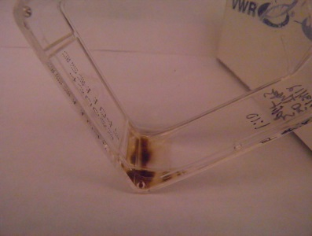
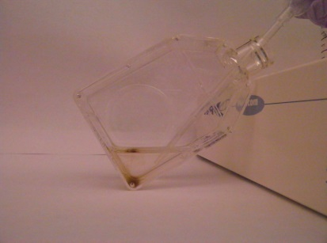
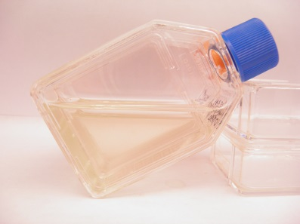

•Centrifuge the tubes at 3000 – 5000 rpm for 5 minutes to “pellet” the Thaps in the bottom of the tube.
•Use a disposable plastic pipet to again draw off as much water as possible. There should only be a couple of drops left, containing all of the Thaps cells. {*At this point, transfer the Thaps to the small test tube}
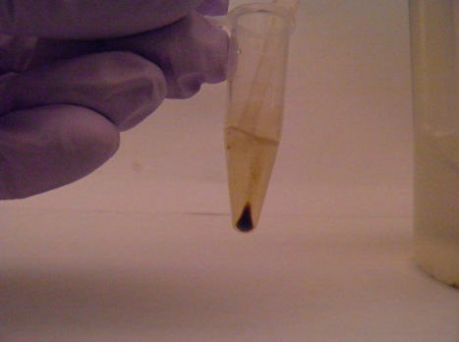
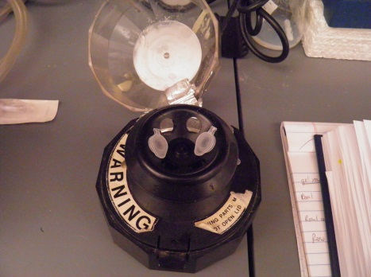
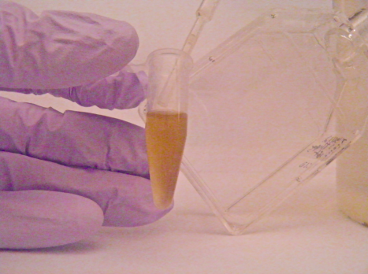

•Add 250µl of Methanol to the Thaps and “flick” the tube several times to suspend the diatoms and extract the chlorophyll. The Thaps silica shells can be seen collecting as a white film at the bottom of the tube.
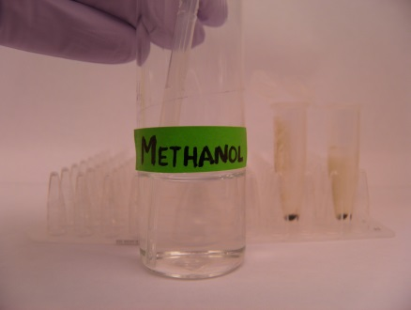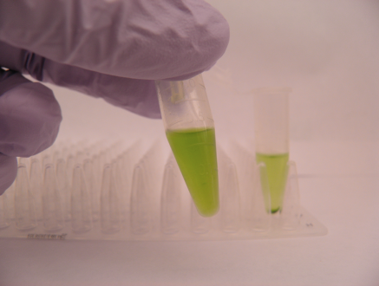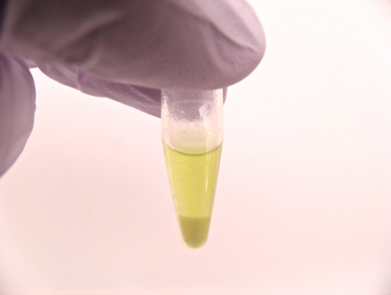
Part 2: Paper Chromatography of Thaps Pigments
•Prepare a strip of heavy chromatograpy paper: 10cm long x 8mm wide and snip one end to make a “point”.
•Drop the chromatography strip into the tube containing the methanol/cholorophyll.
•Allow the chromatography to stand up in a rack UNDISTURBED for 10-20 minutes or until the solvent has nearly reached the top of the paper.
•Tape your chromatography paper to your lab notebook. The pigments will fade as they are exposed to light, so having marked them with pencil and keeping your paper strip away from the light is important.
