Example of results for 3 trials to establish the control: students should let the pH stabilize before starting data collection. The 2 low pH lines are probably due to starting the collection before the probes were down in the solution.
Control: pH of Ocean Water
Time (S) | trial 1 | trial 2 | trial 3
0 | 6.72 | 8.15 | 4.86
10 | 7.21 | 8.2 | 5.48
20 | 7.52 | 8.2 | 6.14
30 | 7.79 | 8.15 | 6.71
40 | 7.92 | 8.15 | 7.13
50 | 7.98 | 8.23 | 7.45
60 | 8.04 | 8.23 | 7.68
70 | 8.09 | 8.24 | 7.93
80 | 8.11 | 8.19 | 7.93
90 | 8.14 | 8.19 | 7.99
ΔpH | 1.42 | 0.04 | 3.13
Δ ⁰C | 0.9 | 1.2 | 0.5

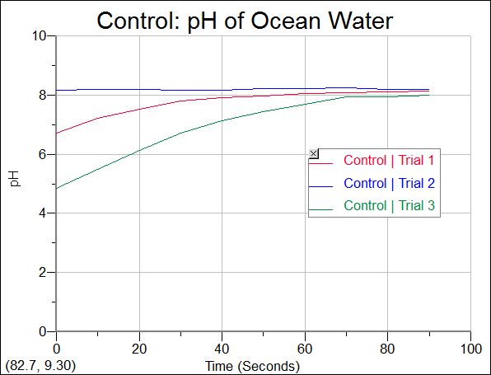
Trial 2 was the most consistent and so should be used for the graph comparison ( see student directions – Analysis).

Students collected data (6 trials) while exhaling through a straw. They were concerned about controlling the temperature of the sample (warming due to their breath) but the data is usable even with a 5ºC increase (R trial 1). See data on the next page.
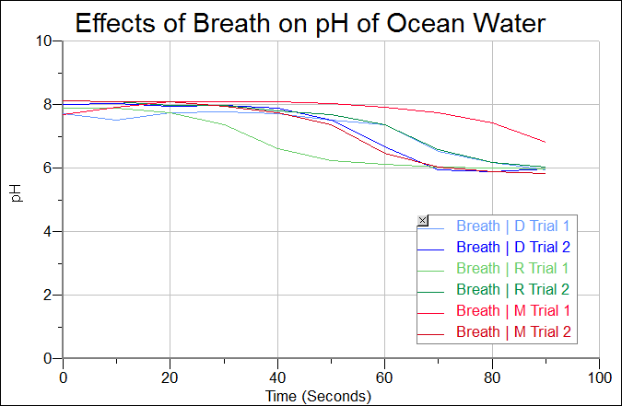

Effects of Breath on pH of Ocean Water
Time (Seconds) | D Breath 1 (pH) | D Breath 2 (pH) | R Breath 1 (pH) | R Breath 2 (pH) | M Breath 1 (pH) | M Breath 2 (pH) w/ice
0 | 5.74 | 6.67 | 7.88 | 4.41 | 7.67 | 8.11
10 | 7.52 | 8.02 | 7.89 | 8.09 | 7.92 | 8.10
20 | 7.73 | 7.93 | 7.75 | 7.98 | 8.08 | 8.09
30 | 7.78 | 7.97 | 7.36 | 7.96 | 8.09 | 7.95
40 | 7.72 | 7.88 | 6.61 | 7.81 | 8.08 | 7.73
50 | 7.51 | 7.52 | 6.23 | 7.69 | 8.03 | 7.37
60 | 7.36 | 6.67 | 6.13 | 7.37 | 7.91 | 6.47
70 | 6.53 | 5.93 | 6.04 | 6.57 | 7.73 | 6.02
80 | 6.17 | 5.89 | 5.99 | 6.17 | 7.42 | 5.89
90 | 5.94 | 5.97 | 5.98 | 6.04 | 6.81 | 5.82
ΔpH | 0.2 | -0.9 | -1.9 | 1.63 | -0.86 | -2.29
Δ⁰C | 0.9 | 2.5 | 5.1 | 1.6 | 2.2 | 0.1

Students collected data (3 trials) using dry ice to generate CO₂ gas. They used pieces close to the same size (1-2g) hoping that they could control the temperature of the sample. Of course, dry ice is very cold so they saw a temperature swing. Collecting CO₂ in a balloon and then attaching a straw to introduce the gas into the sample could control the temperature further. This data was taken using 4.4% salinity which is high. The solution was made following the directions on the box of Instant Ocean®.
Effects of Dry Ice on pH of Ocean Water
Time (S) | pH 1 | pH 2 | pH 3
0 | 8.43 | 8.4 | 7.95
10 | 8.18 | 8.36 | 7.36
20 | 7.79 | 8.3 | 6.89
30 | 5.78 | 8.35 | 7.23
40 | 5.83 | 7.96 | 6.22
50 | 5.82 | 6.91 | 5.9
60 | 5.61 | 6.29 | 5.89
70 | 6.58 | 6.25 | 6.03
80 | 5.55 | 6.1 | 6.03
90 | 5.59 | 6.03 | 6.07
Δ pH | -2.84 | -2.37 | -1.88
Δ (⁰C) | -2.9 | -3.1 | -1.5

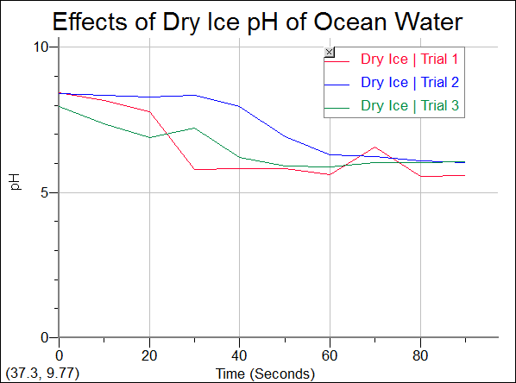

Students made 3 solutions and collected data (7 trials) while exhaling through a straw. They tried to keep the sample at 8⁰C.
Effects of Salinity on pH of Ocean Water (with CO2)
Time (Seconds) | 3.32% sal 1 (pH) | 3.32% sal 2 (pH) | 3.98% sal 1 (pH) | 3.98% sal 2 (pH) | 6.33% sal 1 (pH) | 6.33% sal 2 (pH) | 6.33% sal 3 (pH)
0 | 4.74 | 8.25 | 8.31 | 8.14 | 8.25 | 8.15 | 8.17
10 | 6.66 | 8.22 | 8.34 | 8.32 | 8.25 | 8.1 | 8.18
20 | 8.14 | 8.29 | 8.32 | 8.28 | 8.25 | 8.15 | 8.17
30 | 8.22 | 8.26 | 8.26 | 8.21 | 8.22 | 8.14 | 8.13
40 | 8.22 | 8.2 | 8.19 | 8.09 | 8.17 | 8.13 | 8.1
50 | 8.14 | 8.08 | 8.08 | 7.94 | 8.11 | 8.12 | 8.08
60 | 8.07 | 7.94 | 7.94 | 7.74 | 8.04 | 8.1 | 8.05
70 | 7.98 | 7.75 | 7.73 | 7.29 | 7.98 | 8.1 | 8
80 | 7.85 | 7.37 | 7.33 | 6.61 | 7.88 | 8.08 | 7.95
90 | 7.63 | 6.87 | 6.72 | 6.44 | 7.79 | 8.08 | 7.91
ΔpH | 3.16 | -1.38 | -1.59 | -1.38 | -0.46 | -0.07 | -0.26
Δ ⁰C | 0.5 | 0.4 | -1.4 | 0.4 | -2.2 | 1.1 | 1.1

