Shell Dissolution

We encourage students to choose how they would like to make CO₂. See the examples in lesson 2 for protocols for using chemical reactions, combustion, or cellular respiration. They can also use their breath. They can also use dry ice. Below is an example of a set up using Vernier equipment that can be adapted as needed. For instance, students can use other probes and/or can create chambers using large plastic containers.

Example of experimental set up. 5g of dry ice were used to stabilize CO₂ levels at approximately 2000 ppm. pH of seawater dropped from 8.0 to 6.5 overnight. Shells left in seawater lost 2% of their mass over 3 days.

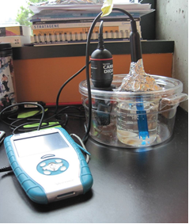

- Dry ice to produce CO₂ (Alka Seltzer or students blowing into the water will add CO₂)
- Seawater with nutrients (ESAW recipe, aquarium salts or actual, filtered sea water)
- A closed, bio-chamber. This can be a home-made set up with an aquarium, or, preferably, the chamber made by vernier shown above (because it seals tightly).
- pH and CO₂ probes, with a LabQuest to record data (or pH paper).
- Seashells, coral, or other calcium carbonate material (the thinner the shell the better – these should lose some mass in a sustained, high CO₂ environment)
Carolina Biological carries crushed coral or a gallon of sea shells:
http://www.carolina.com/tanks-and-accessories/coral-crushed-15-lb/163246.pr?catId=&mCat=&sCat=&ssCat=&question=coral

http://www.carolina.com/animal-habitat-accessories/sea-shell-assortment/261786.pr?catId=&mCat=&sCat=&ssCat=&question=shells

Students should work in groups. The size of these groups is mostly dependent upon the availability of equipment. One set up we have tried and have received some results with is shown above. The teacher should guide the students as they are designing their experiments, but should not just tell them the “correct” way to do it. Science in a lab is a long process of trial and error, in which you learn from your failures and find ways to improve upon your design.

In our trial runs, we have arranged the bio-chamber as follows:
- During one trial, we had a larger aquarium. In this set up, we put the dry ice in a petri dish that was balanced on top of an overturned jar. This allowed the source of the CO₂ to be above the seawater. The CO₂ sunk down into the seawater, much like it does in real life. We found this to be a great visual representation of the process, though it did not fit inside of the sealed chamber venier sells and we could not adequately seal the aquarium (foil, cling-wrap, and parafilm all leak).
- One beaker filled with seawater – we used this to house our seashells. We weighed the shells before and after exposure to the chamber. After around 3 days of exposure, we found an average loss in mass of about 2% per shell. If you can find a way to properly dry the samples (in an oven or the like) this works even better.
- A pH probe resting in the sweater
- A CO₂ probe suspended in the chamber

This is a good chance for your students to engage in a STEM activity as they problem solve how to: produce, contain, and measure CO₂ and how to measure and quantify their results.

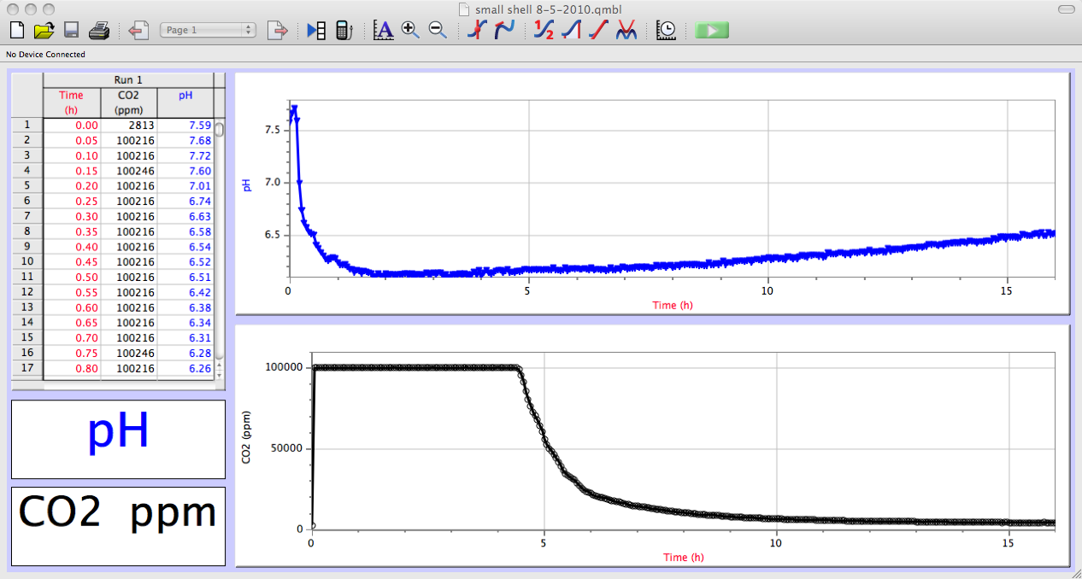
Data from one run in which 8.24g of dry ice was used to create CO₂ within the Vernier biochamber.

