Name:________________________ Teacher: ____________Period:___ Date:_______

**Guidelines for Counting and Analyzing Diatoms**

*Tips for Successful Diatom Use:* If using a 70mL vented flask, 40mL of seawater with 1.5 mL of diatoms works well if counting cells over 7 days. From a diatom stock, using a 1:10 diatom to seawater ratio generally will show peaked growth in 3-4 days.

[*Taking Measurements using a Hemocytometer*](http://baliga.systemsbiology.net/highschool/intern2011/hemocytometer.html)*:* A hemocytometer is a special microscope slide that contains a built in grid. This grid allows you to count cells easily, and with a simple calculation, determine the density of your culture. You could use glass (expensive), plastic disposable, or stick-on grid hemocytometers. Please view our video for more guidelines on using a hemocytometer: <http://baliga.systemsbiology.net/highschool/intern2011/hemocytometer.html>

Below is a picture of a hemocytometer grid. When you use it, you will count the cells in each of the four corners. Figure B shows one of those four corners. Notice that this corner has 16 small squares in it. When you’re using the microscope, you will focus on those small squares.

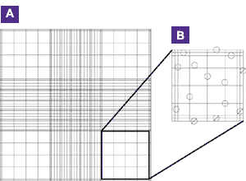To use the plastic hemocytometer, load 10 uL of your culture onto the slide. To do this, it is best to pour a small sample into a container so that you do not contaminate your experiment with a micropipette. Next use a micropipette to transfer the cells to the slide from the small container.

The hemocytometers have two counting grids, meaning they can hold two samples at once. Place the slide under the microscope, first focus on the grid at 4x, then move up to 10x and focus, then move up to 40x magnification and focus until you can see the hemocytometer grid. If you cannot see the diatoms, try dimming the microscope’s light source – viewing cells with low light is easier.

Find the top right corner of the grid. Now, find the bottom left square (of the 16 small squares) within that corner. Using a clicker or your partner, count the number of cells in that square. Using the microscope controls, move the slide so that you are now focused on the square to the right of the one you just counted. Continue using the clicker to count the cells in that square. Continue moving the slide so you can count the cells in all sixteen squares of that corner.

Once you have counted all sixteen squares, write down your total. Reset your clicker, move your field of view to the top left corner and repeat your counting process. Write down this total. Repeat this process for the bottom left and right corners. Below is an example of a typical order for counting cells in squares. Whichever order you decide to count them in, make sure you develop a system that is consistent between all of your countings. Also, make sure to count each cell only once. If one cell is on a grid line, be consistent as to whether or not you record it. (The standard rule is to count cells within the square and if they touch the top or left lines of the square, but not those on the bottom or right line.) This will ensure you count each cell only once. Lastly, you need to count at least 100 total cells for your results to be significant.

Counting Order Example – Use this sequence below to decide where to begin counting cells and where to move next as you count cells in all 64 squares.

Data Table – Use this to record your cell counts.

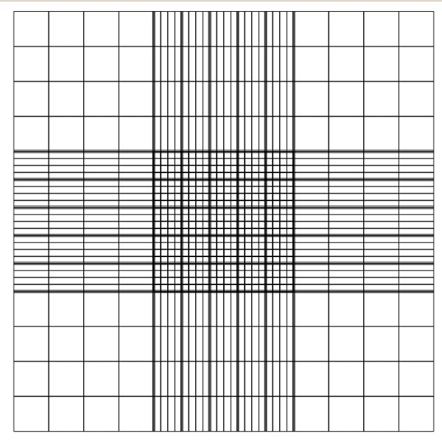

Average the cell counts you recorded for the four corners. Each corner is 1mm by 1mm in size, and has a depth of 0.1 mm. Cell counts are usually recorded in cells/mL. Remember that 1 cm3 is equal to 1 mL. The volume of the area you counted cells for is 1mm x 1mm x 0.1mm = 0.1mm3. In order to convert to cells/mL do the following calculation:

(average number of cells per corner) x (1000 mm3) = cells

0.1 mm3 (1 cm3) mL

*Example calculation*: (50+62+48+58)/4) x (1000 mm3) = 5.45 x 105 cells

0.1 mm3 (1 cm3) mL

Each time you finish counting with a plastic hemocytometer, throw it away.

**General Information on Data Gathering and Analysis:** In systems studies it is very important to have multiple types of data in addition to multiple replicates of one data type. For this experiment, if you are able, we encourage you to determine your cell density using a spectrophotometer on the absorbance setting at 600nm.

Pigment observation is another great way to evaluate diatoms. Though this will not give you a cell count, writing down observations about the color of your cultures is a good way to spot differences between cultures. Your cells will usually settle to the bottom of your flasks. Note how dark the settled cells look. Now, swirl the media in your flask to spread your cells uniformly throughout the media. Write down the color of the homogenized media. Though it may look very clear at first, every day the color will change slightly. Using chromatography is also a great way to see what pigments are present which can tell you about the health and activity level of the diatoms. See Lesson 5a for more information on Chromatography.