Name: ________________________________ Period:_____ Date: _______________
Teacher’s Name: ________________________ Course: ________________________
Chemical Reactions Lab: Baking Soda and Vinegar
Introduction: Many chemical reactions emit ${CO}_{2}$ as a byproduct. You may have seen or even performed the classic science experiment of mixing baking soda and vinegar, but do you know what gas bubbled from the mixture? Consider the following equation for the reaction:
$${NaHCO}_{3}+{CH}_{3}COOH↔{CH}_{3}COO^{-}{Na}^{+}+H_{2}O+CO_{2}$$
$$baking soda+vinegar ↔ sodium acetate+water+carbon dioxide$$
What are the byproducts of baking soda (or sodium bicarbonate- ${NaHCO}_{3}$) and Vinegar (or acetic acid-${CH}_{3}COOH$)? Write your answers here and include whether you think they are solid (s), liquid (l), gas (g) or aqueous (aq): ____________________________
Purpose:
In this lab we will investigate what product is released after baking soda and vinegar are mixed and what results when that product enters water.
Materials (per group):
1 balloon | 200 mL vinegar | 2, 125 mL Erlenmeyer flasks
2 straws | Lime water$(Ca(O{H)}_{2})$ | 1, 500 mL Erlenmeyer flask
BTB in $H_{2}O$ | 5 g baking soda | ${CO}_{2}$ gas probe (if accessible)

- Making Carbon Dioxide (use the right-hand box for notes and observations).
- Obtain a 500mL Erlenmeyer flask and add 200mL of distilled vinegar. | 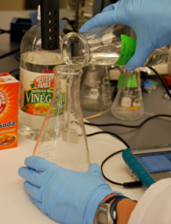
- Mass 5g of baking soda in a small weigh boat. | 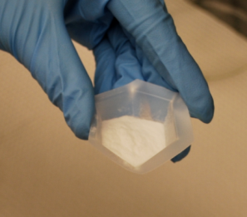
- Stretch a balloon half way over the opening of the Erlenmeyer flask, leaving an opening large enough to pour in the baking soda. | 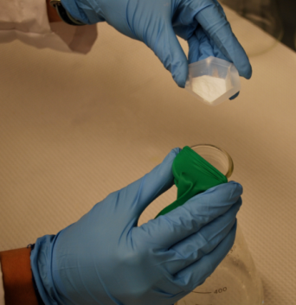
- Pour in the five grams of baking soda and quickly stretch the balloon completely over the over the Erlenmeyer flask. | 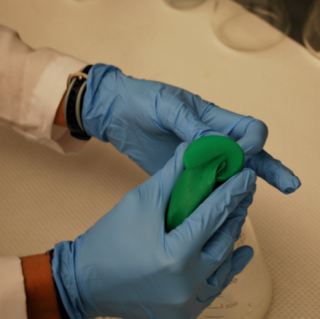
- The balloon will begin to blow up. As the balloon blows up, secure the balloon around the lip of the Erlenmeyer flask with one hand. | 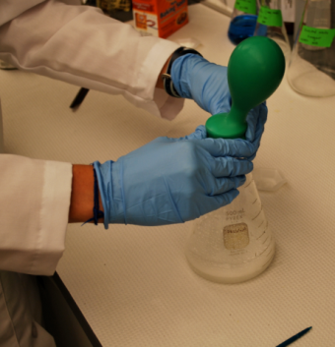
- Once the balloon ceases to increase in volume use your other hand to twist the balloon two to three times. | 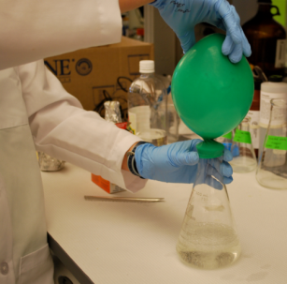
- Hold the balloon at the twist and carefully slide the lip of the balloon off of the flask. Clean up your space and then take your balloon to lab station B to identify the substance in your balloon. | 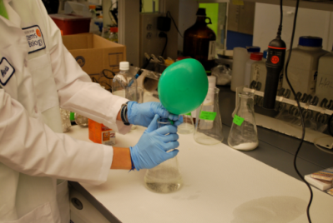
- Answer questions 8 and 9 in your lab notebook. Do you think a chemical reaction has occurred? Why or why not – give evidence to defend your answer.
- What do you think has been captured in the balloon? Be specific and explain your answer.

