How to Detect Carbon Dioxide

- Prepare BTB solution and Limewater solution prior to producing carbon dioxide. To prepare, obtain two 125mL Erlenmeyer flasks. Pour approximately 75mL of limewater into the first flask. In the second flask, add about 2 drops of BTB indicator to approximately 100mL of water. If BTB is yellow or green, titrate the solution with a strong base until it is pale blue. | 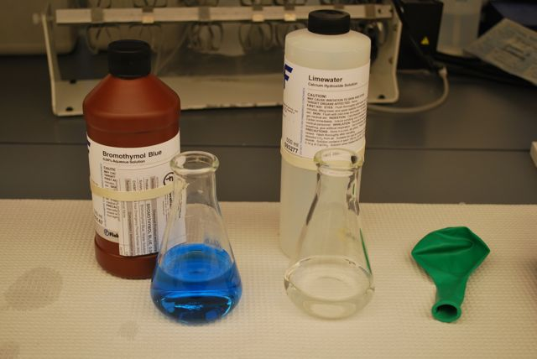
- Carry out cellular respiration or chemical reaction lab.
- Place the lip of the balloon around the straw. Gently release your grip on the balloon, allowing some gas to escape through the straw and into the BTB solution. | 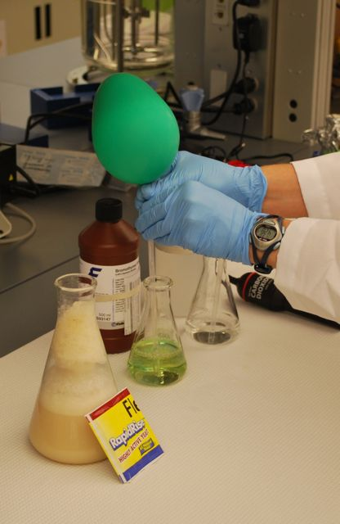
- Once the reaction with BTB has taken place seal your grip on the balloon again, saving the rest of the gas for the limewater indicator. | 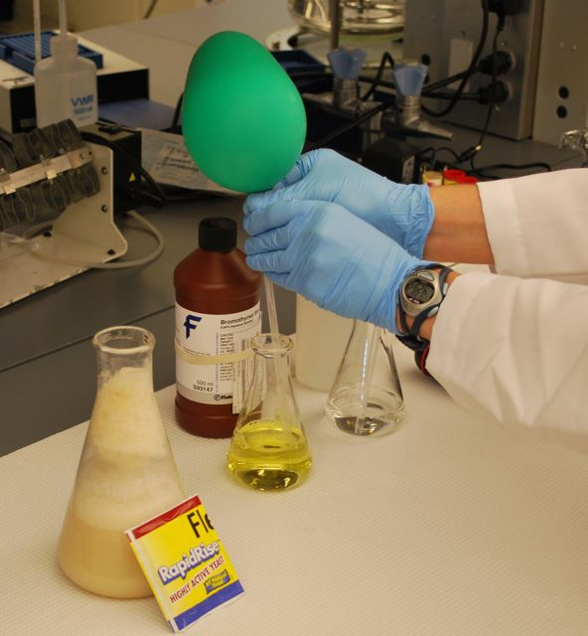
- Once again, place the lip of the balloon around the straw. Gently release your grip on the balloon, allowing some gas to escape through the straw and into the limewater solution. | 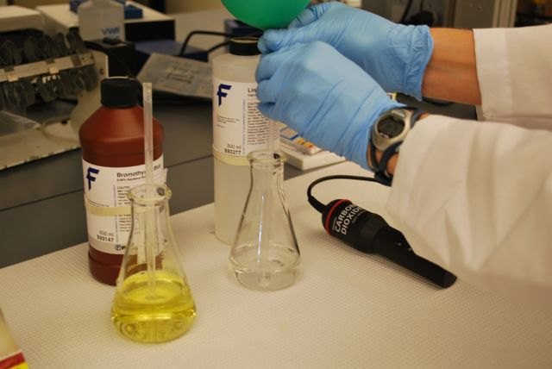
4. Record your observations from bubbling the gas in the balloon into the BTB indicator and the limewater. What reactions took place? What gas did you capture in the balloon? | 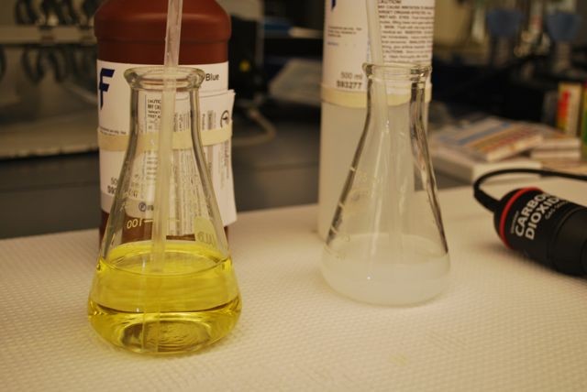
5. If you have a carbon dioxide probe, release the last bit of gas into the probe, graphing the release using Logger Pro. | 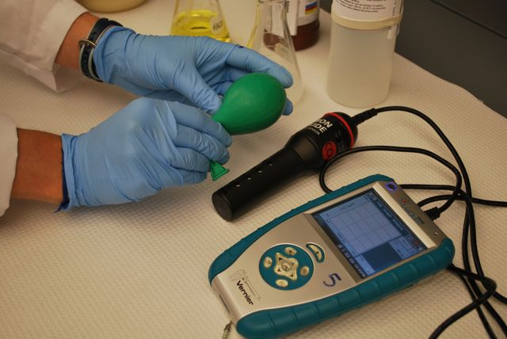

For a good source for more ideas on CO₂ collection see: www.ucar.edu/learn/1_4_2_17t.htm

