Name: ________________________________ Period:_____ Date: _______________
Teacher’s Name: ________________________ Course: ________________________
Combustion Lab
Introduction: Combustion is the process of burning organic material in the presence of oxygen to produce heat energy, carbon dioxide and water. Examples of some organic materials include wood, paper, and fossil fuels (natural gas, oil, or coal). These organic materials, and other organic materials that combust, all consist of at carbon and hydrogen. They may include oxygen as well and some other elements. When the organic material is burned in a complete reaction the carbon is released in the form of carbon dioxide. See the chemical equation below as an example of combustion. What other chemical equation from the lab rotation does this remind you of?
$C_{6}H_{12}O_{6}+ 6O_{2 }→ {6CO}_{2 }+6H_{2}O$ + Energy (heat)
$Glucose+Oxygen →Carbon Dioxide+Water$ + Energy (heat)
$CH_{4}+ O_{2 }→ {CO}_{2 }+H_{2}O$ + Energy (heat)
$Methane (natural gas)+Oxygen →Carbon Dioxide+Water$ + Energy (heat)
Purpose:
As has been demonstrated in other labs, bromothymol blue (BTB) indicates changes in pH and the presence of carbon dioxide. We will use BTB to indicate if we have captured carbon dioxide gas from our combustion experiment.
Materials (per group):
- Dilute BTB
- Two test tubes with stoppers
- A candle
- A match or other device to light the candle
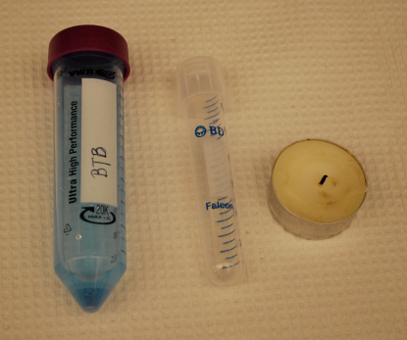

Procedure (use the right-hand box for notes and observations).
- Label your two test tubes, “air” and “combustion”.
- Pour approximately 5mL of dilute BTB into the test tube labeled “air”. Cap the test tube and shake for approximately 10 seconds. Observe the BTB solution, do you notice any color change?
- Set the first test tube aside and record observations in your lab notebook.
- Now, light the candle.  - Uncap the test tube labeled “combustion” and hold it upside down above the flame for 10 seconds. Be sure to use a glass test tube or a plastic test tube that will not melt when held close to a flame.  - While the test tube is still upside down, cap the test tube. | 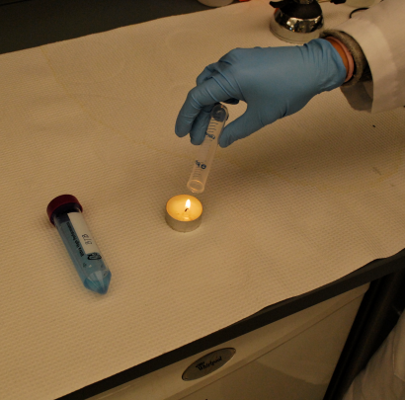
- Once capped, the carbon dioxide test tube may be inverted. Uncap the BTB solution. | 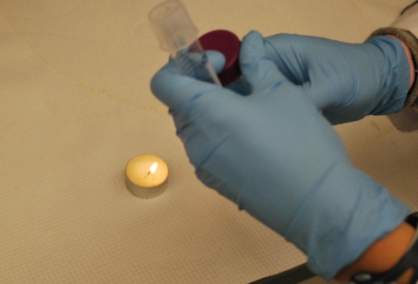
- Carefully uncap the carbon dioxide test tube and replace the cap with your thumb. Roll your thumb to create a very small opening and quickly pour approximately 5mL of dilute BTB solution into the test tube.  - Recap the carbon dioxide test tube and shake for approximately 10 seconds. | 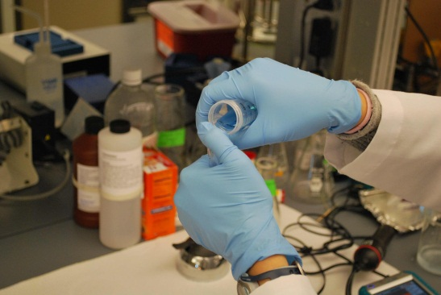
- Compare the BTB in the test tube labeled “air” to the BTB in the test tube labeled “carbon dioxide”. Record your observations in your lab notebook. | 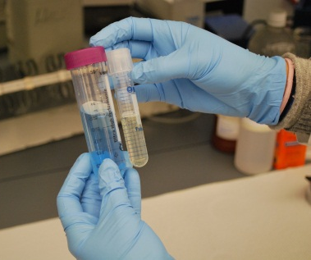
Please answer these questions in your lab book:

- What does a change from blue to yellow in the bromothymol blue and water solution indicate?
- What gas was captured in the “combustion” test tube?
- List five examples of combustion.
- Can you conclude what this experiment might validate about byproducts of combustion and their affect on rain and natural bodies of water?

