Observing Beyond Our Senses Pre-Test: Circle (T)rue or (F)alse

- T F All life flourishes best in the same environmental conditions that are best for humans.

- T F In terms of measurement in science, noise is not just a sound.

- T F Without calibrating your measuring device, it’s hard to know just what you’re measuring.

- T F There is always uncertainty in any measurement.

- T F A measurement can be perfectly exact if you have good equipment.

- T F A lot of scientific measurement is done by measuring a substitute for what you’re really interested in

- T F There is plenty of water for humans, so water is the least of our problems.

- T F Wherever we’ve looked on Earth, whether in the deepest mines or coldest glaciers or hottest hot springs, we’ve found life.

- T F All life on Earth needs food and oxygen.

- T F The Earth’s sky is blue because oxygen (at least if you have enough of it) is blue.

- T F Water absorbs red light better than blue light.

- T F An Atomic Force microscope can be used to map the location of individual atoms in a molecule.

- T F An amplifier makes a signal louder, without adding noise.

- T F Once an investigation is underway, good scientists stick with it until all the data they’d planned to collect is finally collected.

- T F Scientists often work with incomplete data.

- T F It’s possible for 2 scientists working with similar experiments to arrive at different conclusions.

- T F A graph communicates more information than 999 words.

- T F There are places on Earth that closely resemble places on Mars.

- T F At two very different levels of precision, a newspaper might look completely different.

- T F Eyes are just one tool in a scientist’s measurement toolbox.

- T F New technology produces new measurement tools, creating new ways to understand the world.

- T F If there’s no communication, there’s no science.

- T F Ocean water is salty enough to kill most bacteria.

24) Examine the graph and respond to the prompts in question 25. 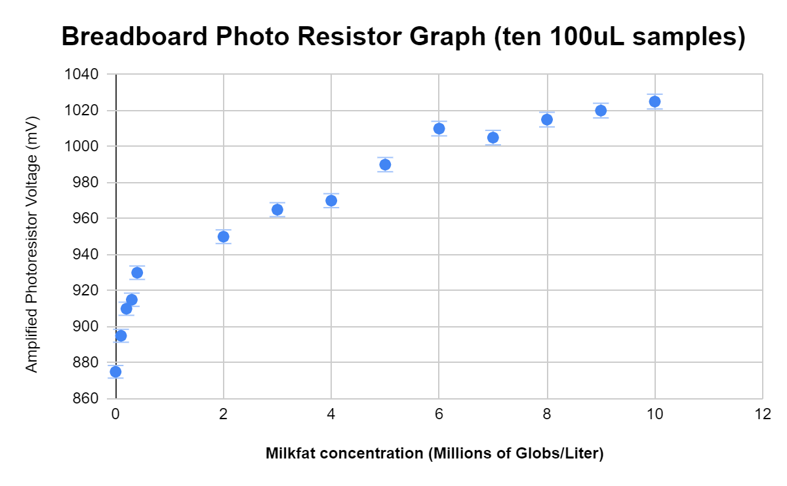

25) As the concentration of milkfat goes up, what happens to the photoresistor voltage?

If this was the readout from the light measuring device that you built, and you used it to measure an unknown, and got a voltage of 970, about how much milk was in the water?

- List 2 measurements for which you can be reasonably confident that they are, in fact, different.

- List 2 measurements for which you can’t be reasonably confident that they are, in fact, different.

26) Imagine you get to design a probe to land on Mars and look for life. Complete the table. Use drawings, flowcharts, cartoons, numbers, and words to describe what you see as the crucial steps to getting a message back by radio that your robotic probe has found life. Don’t worry about getting to Mars – NASA will get you there.

TASK/PROBLEM | SOLUTION
WHERE to look for life

HOW to find life (how will you know it when you find it?
Instrument(s) to use or design and build

Way to know your instruments are accurate

Probe able to get around on Mars.

