Mock AFM (Atomic Force Microscope) PowerPoint

1) Slide 3: What’s the OBSERVATION? What’s the INFERENCE ?

2) Slide 4: What’s the OBSERVATION? What’s the INFERENCE ?
Offer a less likely explanation for the observation

- Slide 8: When you measured wind speed, you probably didn’t
measure wind speed. What did you actually measure?

- Define “proxy variable” as you understand it.

- Describe another common situation where a proxy variable is used.

- Describe 3 ways using a proxy variable can create problems or
limitations.
a) b) c)

7) Describe 2 different situations (examples) in which scientists MUST use a proxy variable, because what needs to be measured is completely beyond the capabilities of human senses.
a) b)

8) Slide 18: Briefly describe how an ‘AFM’ works.

9) Slide 20: You’ll probe to discover and map an unknown and unseen shape in
a box Before you start, describe 2 possible problems you anticipate.
a) b)

- After you started, you probably (I hope!) had at least one good idea, and changed your method. Describe what you changed, and why.

11) Slide 21: What would be the benefits of increasing your sampling resolution?

12) What would be one drawback to increasing your sampling resolution?

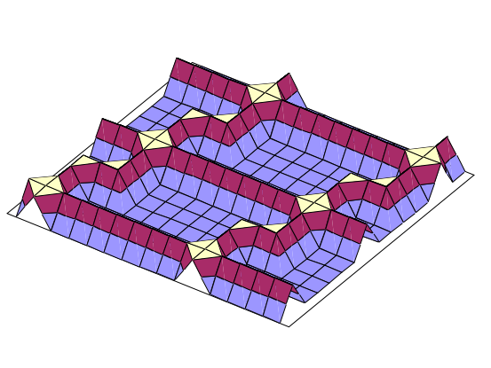
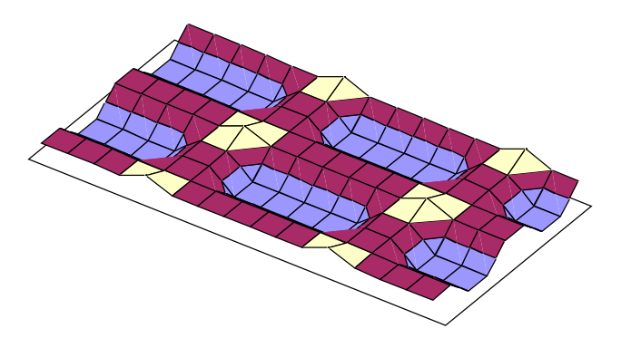
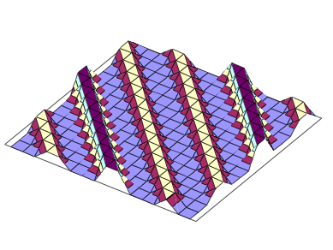

- Make a quick sketch (underneath) of what the bottom of a ‘black box’ would look like for each graph:
