Lesson One PowerPoint: Introduction to a Saline Environment

- Why are some parts of the ocean not as salty as other parts? (2 reasons).
a) b)

- Why is the GSL (Great Salt Lake) 9 times saltier than the ocean?

- The north end of the lake is quite shallow, and mostly isolated from the south end by a railroad causeway. Why is it a different color?

- And why are those smaller areas in the south also light blue?

- How has the GSL changed recently?

- How has the GSL changed in the distant past?

- Aside from NaCl (Sodium chloride, common table salt), what other salts are present in seawater evaporites?

- Why are some evaporation ponds reddish?

- What mineral evidence suggests that Mars once had oceans, rivers, and lakes?

- Why are saline lakes in the Western US interesting and important?
a)

b)

c)

d)

- Why would we measure populations of extremophile organisms in saline lakes of the western US? (What does the population size tell us about the environment?)

- Mark 5 places (on the map) where you would expect to find high numbers of salt-loving extremophiles in this saline lake.
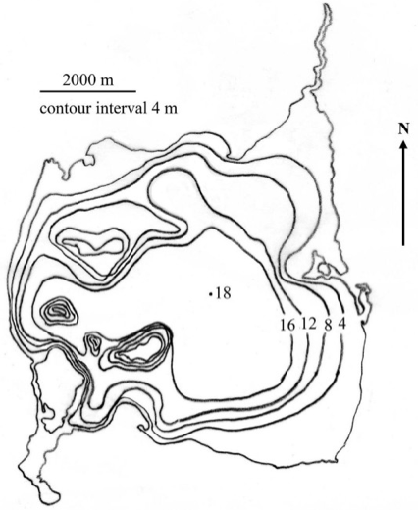
- Explain why you expect them to be in those particular spots.

- How might you measure populations of extremophile organisms if someone brought you samples from this saline lake? (Write down at least 3 ideas.) For each way to measure the population(s), describe challenges/limitations you may encounter.
Idea | Measurement technique | Challenge/limitation
a)
b)
c)

