Lesson One PowerPoint: Introduction to a Saline Environment

- Why are some parts of the ocean not as salty as other parts? (2 reasons).
- different inflow b) more evaporation

- Why is the GSL (Great Salt Lake) 9 times saltier than the ocean?
No outflow, so evaporation leaves minerals behind

- The north end of the lake is quite shallow, and mostly isolated from the south end by a railroad causeway. Why is it a different color?
Less inflow, so it’s saltier

- And why are those smaller areas in the south also light blue?
They are man-made evaporation ponds, and thus are very salty

- How has the GSL changed recently?
Inflows have increased, so the level has gone up (and it’s somewhat less salty)

- How has the GSL changed in the distant past?
At one time, it was part of a much more extensive lake system, and may have even drained to the ocean

- Aside from NaCl (Sodium chloride, common table salt), what other salts are present in seawater evaporites?
Potassium sulfate, a common fertilizer

- Why are some evaporation ponds reddish?
Halobacterium, a salt-tolerant microorganism

- What mineral evidence suggests that Mars once had oceans, rivers, and lakes?
The presence of evaporites

- Why are saline lakes in the Western US interesting and important?
- See slide 17: answers may vary

b)

c)

d)

- Why would we measure populations of extremophile organisms in saline lakes of the western US? (What does the population size tell us about the environment?)
Water quality and quantity, including pollutants

- Mark 5 places (on the map) where you would expect to find high numbers of salt-loving extremophiles in this saline lake.
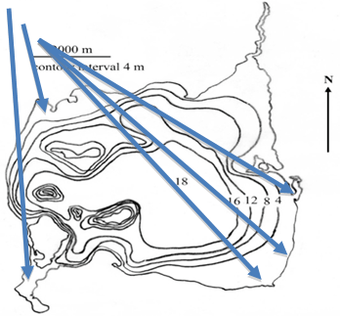
- Explain why you expect them to be in those particular spots.
Shallow, limited circulation, no inflow, high evaporation

- How might you measure populations of extremophile organisms if someone brought you samples from this saline lake? (Write down at least 3 ideas.) For each way to measure the population(s), describe challenges/limitations you may encounter.
Idea | Measurement technique | Challenge/limitation
a) | Microscope | Many options for each – accept any logical answers
b) | Visual Inspection
c) | Measuring Light

