Open the model: Nutrients and Light
Note: If you have not downloaded NetLogo prior to this lesson, follow the guide provided on the Lesson 6 webpage for free download.
Part 1: Getting to Know the Simulation:
- On the left hand side of the screen, you will see various controls. To get to know the simulation, we will change these parameters, click on “setup," and see what this changes in the world.
- Start by hitting “Setup”. Then toggle the light “off”, and hit “Setup” again. How does the “world” change?
The yellow patches in the middle of the world turn to black.
- Lower the values on the sliders for nitrogen, silicon, and phosphorous, then hit “Setup” again. How does the “world” change?
There are less colored patches in the “water” at the bottom of the world. These colored patches are the nutrients.

- Change the value of carbon dioxide between 400ppm and 800ppm, hitting “Setup” after changing. How does the “world” change?
When the value is 400ppm, there are less yellow dots in the “water” at the bottom of the world. The dots are carbon dioxide molecules.
- Summarize your understanding of the “world” by labelling the picture below with the words “light”, “nutrients”, “CO2”, and “diatoms”. 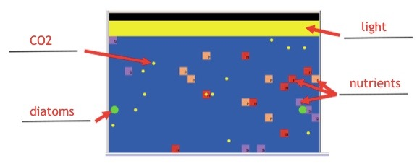
Part 2: Effects of Environmental Conditions on Diatom Populations:
- For each of the following conditions, predict how the population will respond based upon your prior knowledge as well as the experiments you have run. Write your predictions in the column titled “Predictions”. Run a series of experiments to test the effect of nutrients and light on diatom population. You may want to run the simulation a couple times for each condition, since the random nature of a simulation means that the results are not the same every time. Summarize the shape of the graph called “Diatom population” or capture a screen shot of it and paste into the last column.
 | CO₂ Level | Light | Nitrogen Amount | Phosphorous Amount | Silicon Amount | Predictions  Will depend based on their experimental results. See picture below. | Results of Simulation
Condition 1 | 400ppm | ON | 20 | 20 | 20 | Grows rapidly to 70 cells, then remains there. | 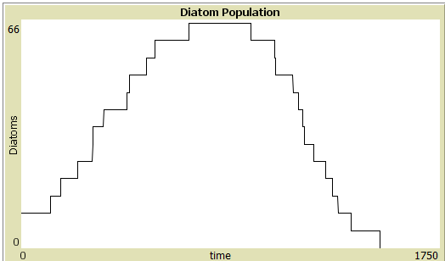
Condition 2 | 800ppm | ON | 20 | 20 | 20 |  | 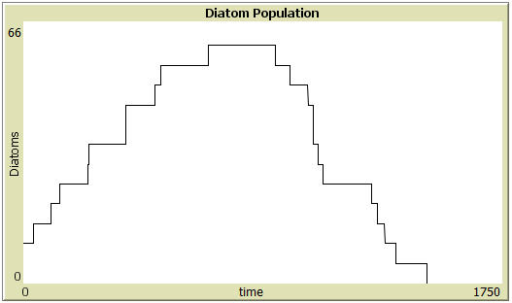
Condition 3 | 400ppm | OFF | 20 | 20 | 20 |  | 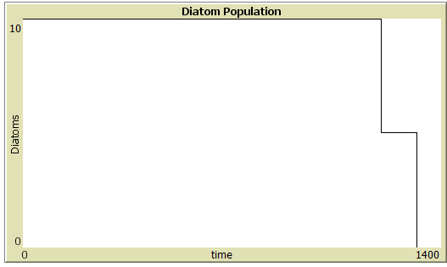
Condition 4 | 800ppm | OFF | 20 | 20 | 20 |  | 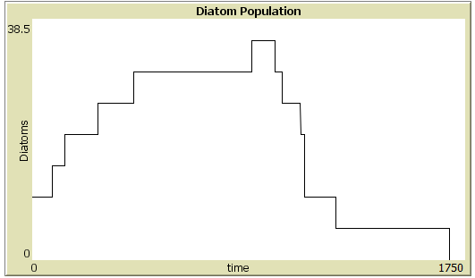
Condition 5 | 400 ppm | ON | 1 | 20 | 20 | Grows to about 40, slower than condition 1
Condition 6 | 800 ppm | ON | 1 | 20 | 20 |  | 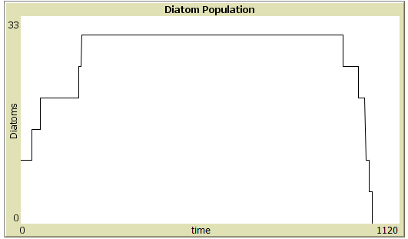
Condition 7 | 400 ppm | ON | 20 | 1 | 20 | Very similar to condition 1 | 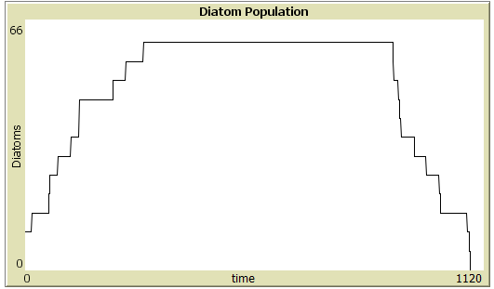
Condition 8 | 800 ppm | ON | 20 | 1 | 20 |  | 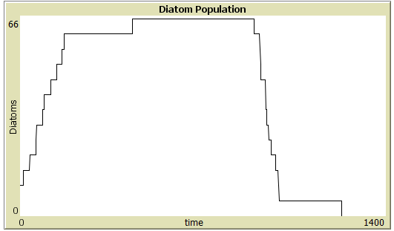
Condition 9 | 400 ppm | ON | 20 | 20 | 1 | No growth: cell count remains just under 10 | 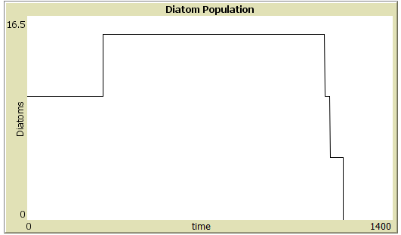
Condition 10 | 800 ppm | ON | 20 | 20 | 1 |  | 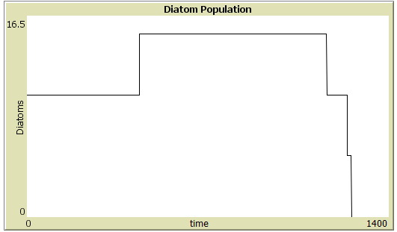

The graph below shows data collected at ISB in the summer of 2014:
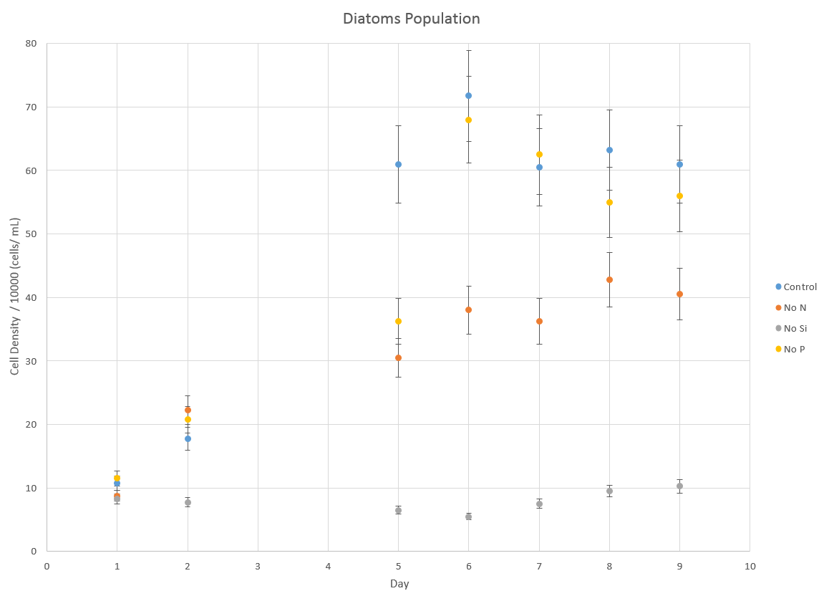

- If you collected experimental data on diatoms under any of the conditions listed above, explain how your experimental results compared to the results from the simulation. Use the table format below.
Conditions 1, 5, 7, and 9 should match up fairly closely, because the model was tweaked to match these conditions.
Condition Number | Experimental Results | Simulation Results | What might account for the difference between the experimental and the simulation results?

- Based on the simulations, which environmental conditions (CO₂, light, nitrogen amount, phosphorous amount, silicon amount) seem to be important for the growth of the diatom population?
Light, silicon amount, and nitrogen amount are all important to the growth. In the absence of light or silicon, no growth occurs at all. In low nitrogen levels, growth occurs but it is slower and to a lower population compared with condition 1

- Based on the simulations, are there any environmental conditions (CO₂, light, nitrogen amount, phosphorous amount, silicon amount) which seem to be unimportant for the growth of the diatom population?
Phosphorous does not seem to play a significant role. Actually, surprisingly (I don’t know why this is), the diatom population growth rate seems to be higher in the model when there is limited phosphorous. It shouldn’t be that way.
Also, CO₂ does not play a significant role. This is because it hasn’t been coded as a factor in the model. I was hoping to get some real data from Thaps to show the effect of CO₂, but did not get to that this summer.
Part 3: Gene Expression in Diatoms under Varying Environmental Conditions
The top of the world (pictured here) shows three columns related to gene expression in diatoms. The columns are transcription factors, genes, and cellular functions. Review your previous learning, fill in the definition Upregulated means _________________________. Downregulated means___________________________.

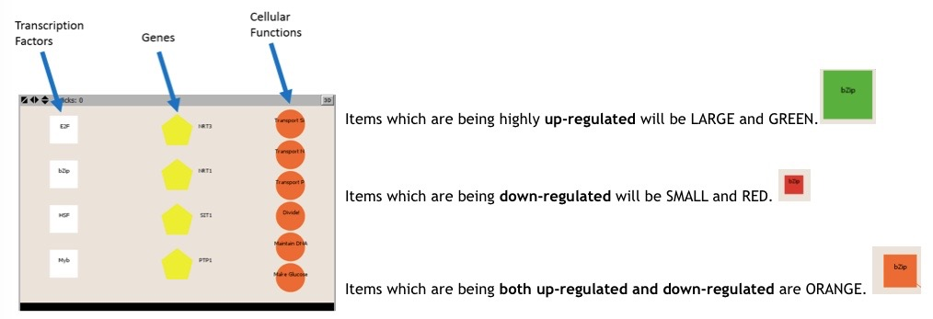
- Setup Condition 1 again, click on “Setup,” then “Go.” Toggle “Go” off by clicking it again. Take a look at the top of the “World”. And answer the following questions:
- Which cellular functions are being up-regulated?
Divide, Maintain DNA, Make Glucose
- Why would diatoms in conditions of high light and high nutrients be up-regulating dividing and making glucose?
Making glucose and dividing makes sense to do under “prosperous” conditions as they increase the population and the energy reserves of the population
- Why might diatoms in conditions of high nutrients not be up-regulating uptake of nutrients (transport of Si, N and P)?
Multiple answers are possible. It may be that they don’t need to actively transport when the nutrients are this high… perhaps enough diffuses into the cell that the cell doesn’t need to waste energy on active transport
- Click “Go” again. Allow the simulation to run until the nutrients are almost gone.
- Which cellular functions are being up-regulated now?
Transport Si, Transport P, Maintain DNA
- Why might diatoms in conditions of low nutrients be up-regulating uptake of nutrients (transport of Si and P)?
The diatom is (perhaps) competing against other sea creatures to procure the small supply of these nutrients. Hence it makes sense to devote some energy to capturing the necessary nutrients so it can stay alive.
- Which cellular functions are up-regulated in conditions of low light and high nutrients?
Nothing actually is. Making glucose, divide, and Transport N are being up-regulated by the low light, but down –regulated by the high nutrient levels.

- Transcription factors control the expression of genes, which code for proteins which affect cellular functions. The next picture shows families of transcription factors which are linked to genes expressed under various different circumstances, as shown in the legend called “Expression States”.
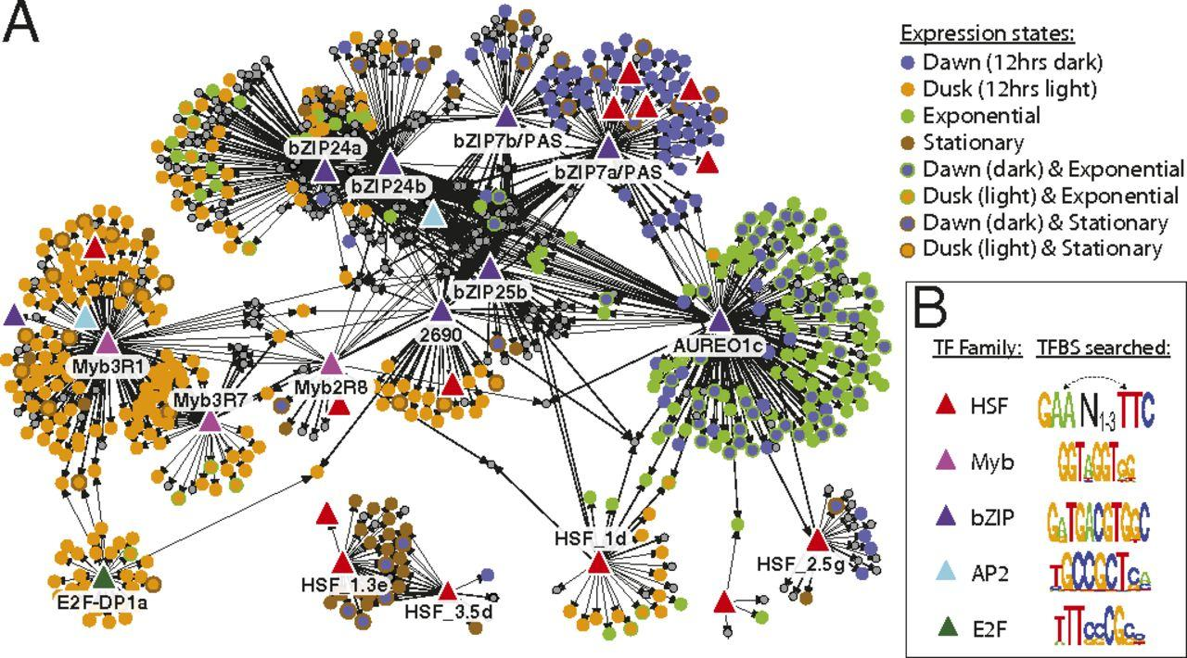

Verify that the simulation is consistent with this picture by checking the following:
- Which of the transcription factors (HSF, Myb, bZIP, AP2, E2F) seems to be associated with the diatoms’ genes expressed at dawn?
HSF, bZIP

- In the simulation, dawn is associated with no light, because dawn is the period after an extended duration of no light. Which transcription factors are up-regulated when no light is present? Based on your answer to letter a, is the simulation in Condition 1 and 2 consistent with the picture?
high nutrient levels: 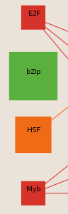 low nutrients levels: 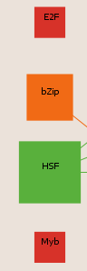
So they are arguably consistent.
- Which of the transcription factors (HSF, Myb, bZIP, AP2, E2F) seems to be associated with the genes expressed at dusk?
HSF, E2F

- In the simulation, dusk is associated with light, because dusk is the period after an extended duration of light. Which transcription factors are up-regulated when light is present? Based on your answer to letter c, is the simulation consistent with the picture?
high nutrient levels :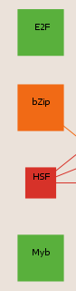 low nutrients levels: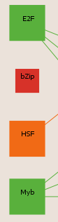
They are partially consistent. Certainly Myb and E2F, but bZIP and HSF are not being consistently upregulated.
- The stationary phase occurs when nutrients levels are low and diatoms no longer reproduce (and may even die). Which of the transcription factors (HSF, Myb, bZIP, AP2, E2F) seems to be associated with the genes expressed in the stationary phase?
HSF
- Let the simulation run until nutrients are low with the light off. Based on your answer to letter e, is the simulation consistent with the picture?
Yes
- All simulations or models have aspects which are consistent with the real world, and aspects which are flawed. What are some of the realistic aspects of this model? What are some of the flaws with this model?
Realistic aspects: diatoms would in fact reduce the concentration of CO₂ and of nutrients in a closed system, such as those that students are using to conduct experiments. The pH of these systems can be seen to decrease as CO₂ is used up. Diatoms do in fact reproduce in these conditions.
There are lots of issues with this model: It does not take into account real biological “rules” associated with diatom reproduction. For example, I don’t know that light or nutrients are actually required for diatom reproduction. The numbers for nutrients are not correlated with anything in the real world (such as uM concentrations). The transitions between gene expression under low and high nutrient/light conditions are unlikely to be as abrupt/instantaneous as they are in the model.

