ID # _____
- Gender
- Race
- At this time, do you plan on pursuing a career in one of the STEM (Science, Technology, Engineering, Mathematics) fields?

- Do either of your parents work in the field of math, science or engineering?

- At this time, what is the highest level of education you plan to achieve?

- When you think about systems biology, what comes to mind?

- Use the diagram below to answer the following questions. Choose the best answer.
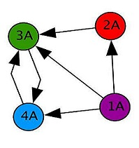
Answer each of the questions by selecting one of the choices provided.
  - If the circles (nodes), and the arrows (edges) show who can call whom, how many people can 1A contact?

  - How many people can contact 1A?

  - How many people can contact 4A?

  - If 2A sees a funny picture, who else will know about it?

- Explain how/why a network diagram is a useful tool in scientific research.

- Various things are listed below.

Aquarium Bicycle Pile of Sand Ocean Box of Nails

- Select all of the things that can be thought of as a system.
- Explain your thinking. How did you decide whether or not something is a system?

- Students conducted an experiment to determine what causes seeds to germinate the fastest. The students used the same type of seed and water. They placed the six seeds of each test group on a paper towel in a petri dish. The data table below shows the data that they collected over several days on three groups of six seeds.
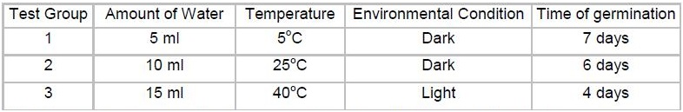
  - What is the best conclusion based on these results? Select the best answer.
    - The amount of water and the temperature affect the germination of the seeds.
    - The temperature and the amount of light affect the germination of the seeds.
    - The amount of water, the temperature and the amount of light affect the germination of the seeds.
    - No conclusion can be made from this data because too many variables were changed.
  - What would your next experimental step be after these results?

- Do plants respire? Explain.

- What is photosynthesis?

- Is bacteria good or bad? Why?

- Why might there be different bacterial communities in different agricultural systems?

- Could you engineer a bacterial colony for specific environments, plants, fish, etc?

- How do you inoculate an aquaponic system with bacteria? Name two sources of bacteria that could be used.

- What major natural process do bacteria facilitate in aquaponics? How?

- What are two bacterial species primarily responsible for the Nitrogen cycle in aquaponics?

- Your plants continually contract diseases and you want to find a way to keep them healthy and resistant to diseases. What is one natural way you could protect them?

- Aquaponics combines which two farming techniques?

- List and describe two parts of an aquaponics system.

- What are the roles of plants, fish and bacteria in an aquaponics system?

- Give two examples of a type of plant, fish, or bacteria that are commonly used in aquaponic systems.

- What is nitrification?

- Name two of the main inputs to an aquaponics system.

- What are some of the benefits of aquaponic systems?

- Give a brief overview of how an aquaponics system works.

- Describe the nitrogen cycle and how it functions in an aquaponic system.

- What happens if you add chlorine to your aquaponic system?

- What is food insecurity?

- What are the 3 pillars of food security? Describe what each means.

- Can we solve the global food crisis by simply growing more food? Explain why or why not.

- What are some issues we are facing with our current food production system?

- What is a scientist in your opinion?

- What excites you about science?

- Do you want to participate in science at the next level (i.e. undergraduate, graduate)?

- Is science fun (1-10, with 10 being high)?

- What is the scientific method?

