Teacher Guide for the NEW Introduction to Systems, Lesson 2
Cytoscape Cell Phone Network

Please note: These instructions should be used with the browser-based cell phone simulation found here – http://cellphonesim.systemsbiology.net. Also, please note that this is a draft and is being updated as we update the simulation. Please always download the current version from our website.

- Connect the teacher computer or device to a projector in order to demonstrate how to use the Cell Phone Simulator. Use Chrome, Safari, or Firefox to access this simulator at this page: http://cellphonesim.systemsbiology.net.
- Once the network is loaded onto the screen, click the “Fit” button at the top of the screen.

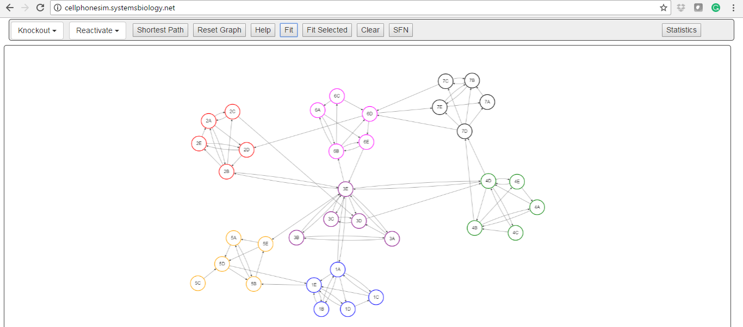

- Ask students what they notice about the structure of this network as compared to the hand-drawn network they created?

- Remind students that this system has 35 nodes, but other systems can have thousands or even millions of nodes. Ask them how they think computer programs such as this be used to study systems? (Examples include, tracking how disease is predicted to move through a population, how cancer can be combated by targeting certain genes, etc.)

- Demonstrate some of the features of the cell phone cytoscape simulation program. The most important features for today’s lesson are all located in buttons at the top of the screen.
    - It is up to the comfort level of the teacher to decide how much time to spend on the “how-to”.
    - Selecting nodes: if you click on a node (remember: each node represents a cell phone), it will turn grey. This indicates that you have “selected” that node.
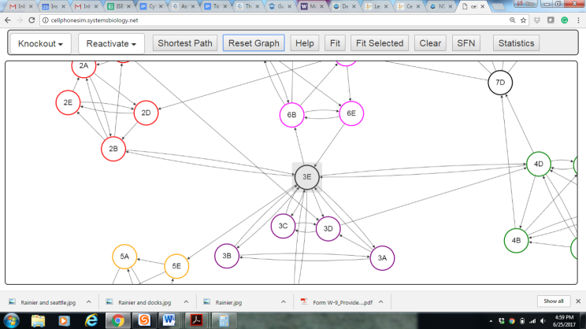
    - Knockout and reactivate selected nodes: selecting nodes is useful if you would like to “knock out” that node from your system. In order to do this, select a node (see above) and then under the “Knockout” menu, click “Selected” to knock out the highlighted node. The node will still appear on the screen, but all the arrows connecting it to the network will disappear. You have removed the node from the network: it can no longer make or receive phone calls. You can reinstate the node into the network by selecting reactivate selected.

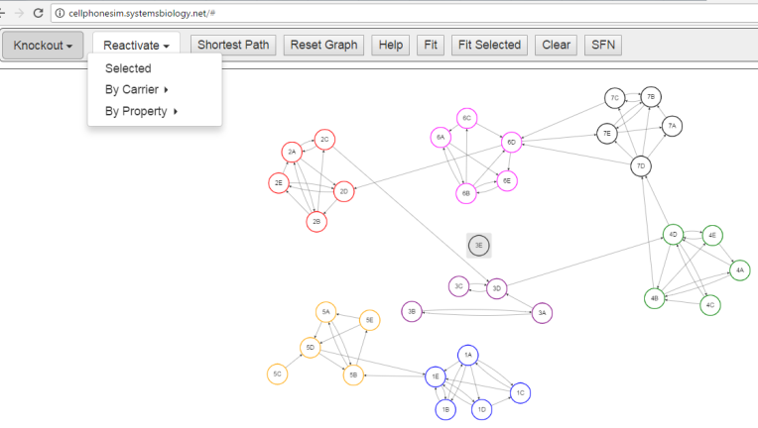
    - Knockout & Reactivate nodes based on carrier: Remember from day 1 that the cell phone information cards had extra information on them about what cell phone carrier you were using, whether or not the phone had email capability, etc. These properties are programmed into the Cytoscape simulation version of the cell phone network. Therefore, we can use this information to knockout groups of cell phones based on their properties.

    - Knockout by carrier: each phone has been assigned to one of seven carriers (note: these correspond to the numbered groups they originally met in while making the network). You can select to knockout a carrier, such as Verizon, and then all of the phones serviced by Verizon will be knocked out of your network.

    - Knockout & Reactivate nodes based on property:
      - Each phone can be put into a category of either phones with or phones without for each of the three properties email, roaming, picture.
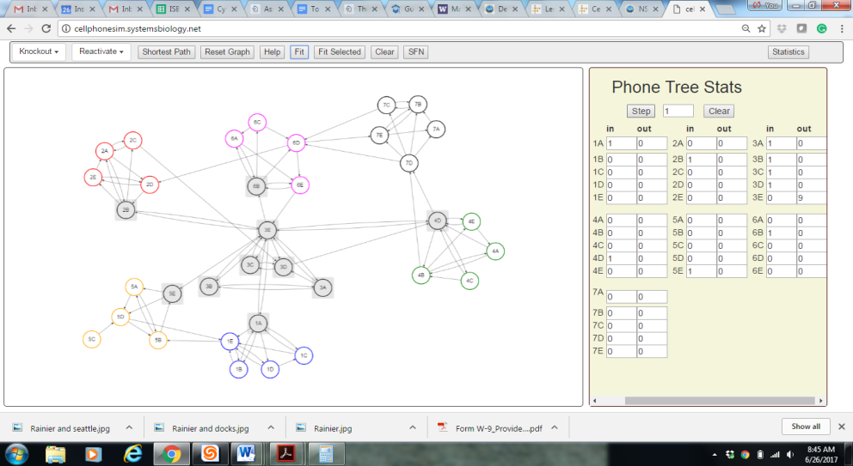
    - Phone Tree: Open the “Statistics” window by clicking the “Statistics” button. You can use this function to answer questions about how information will be passed through the entire system. We call this a phone tree function. A separate window will show up for the phone tree function that displays statistics.
      - After selecting a start node, hit the “Step” button and watch as the info moves through your cell phone network. Click the button again to advance info again through the network.
      - When a person receives a phone call, their node turns grey. When 1A is selected as a start node, all everyone except 5C gets a call, so 34 nodes turn grey. The statistics window gives some great information that they might be able to use to answer their questions.

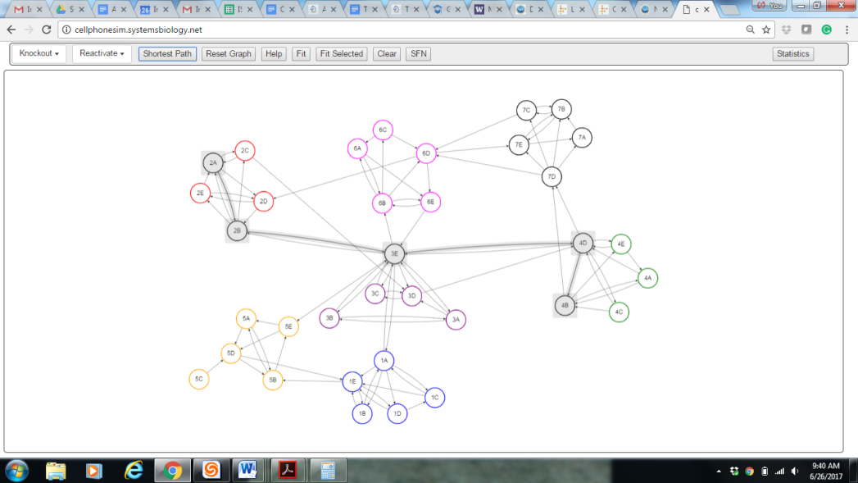
    - Shortest Path: This feature is useful if you would like to determine the shortest path of information flow (i.e. least number of phone calls) between person A and person B. You must select the node you want the message to begin at first. Next select the node you want to find the shortest path to. Once both nodes are selected, you will see they will both be highlighted in grey. Then click the Shortest Path button.

    - SFN (Select First Neighbors): This feature is useful to show what node can directly affect another node. A node’s neighbor is any node directly connected to it by an edge. We are currently working on this feature. For now, you can click any node and then click the SFN button to see how information would move through this network. Click the SFN button again to watch the next set of first neighbors receive information. This information does not currently show in the statistics window but will in upcoming updates.

    - Reset Graph: This is a very important button because it will reset anything you have done; the knockouts, the phone tree, etc. If students think that they messed up, tell them to hit the reset button and try it again. It is also important to reset in between questions.

    - Help: This will soon be populated with helpful links and instructions similar to those given above. May be helpful for students looking for help while on their computers.

  - You are now ready to have the students explore the simulation in order to before familiar with systems structures and properties.

  - Pass out the CytoscapeSim_Student_Handout_2017. We have also prepared for you a CytoscapeSim Teachers Guide. To introduce the activity, remind students’ of the lesson’s purpose of providing an opportunity to use the power of computers to quickly answer more complex network questions using the large 35-node cell phone network. Important notes:
    - Students should be using the computer tools to answer these questions, rather than just using the screen as a neater paper version of their network.
    - Encourage the students to fool around with the various options in the software. If it seems to get “messed up,” they can always reset the graph or close the program and re-open it by following the instructions again.
  - Students should each have their own computer, chomebook, or other device if possible. If not, then there should be no more than 2 people to a machine.
  - Wander the room and monitor student progress. Things to look for:
    - Look for the cell phone network screen to be open on their computer. They should NOT have a blank Cytoscape screen or a version that looks different than the screenshots displayed above.
    - Looking for the grey, highlighted nodes, and an open statistics window is an easy way to determine whether students are actually using the software.
    - If a student seems to have “messed up” their network, and if you can’t figure out what they’ve done, DON’T PANIC! Simply click the Reset Graph then Fit buttons. Or close the program and then reopen.
  - For students who finish earlier than others, encourage them to try to create their own network and try to run the simulation on it. (See extension activities.)
ASSESSMENT –
How will I know they know?
- Did they complete the Cytoscape Questions? Student should be able to answer questions by manipulating the cell phone simulation.
- Monitor student progress in computer lab. You should see nodes changing color from white to grey as messages are passed through the network.
- Discuss the purpose of this lesson and the application of technology such as this. This lesson results in students more thoroughly understanding how and why technology is used to understand complex networks and it also highlights many important aspects of biological networks (importance of redundancy, the variation in node importance, etc.). You can offer biological examples to illustrate this, but you can also encourage students to connect this further to their daily life. The conceptual thinking behind this is what is important, not the specific examples. This may also help when students become confused or intimidated by vocabulary. In this case, the vocabulary words (Cytoscape, simulation, knock out, etc.) are not required to master the needed content and ideas.
EXTENSION ACTIVITIES –

Have students create their own networks using the actual Cytoscape program (http://www.cytoscape.org). This is free, open-source software used by research labs throughout the world. Based on what they learned in this lesson, they should be able to use Cytoscape. However, for more information, here is a manual (based on Cytoscape version 3.2.0 and written in January 2015) that can help guide students through using this program based on the content in this lesson. The newer version may have slightly different protocols, but instead of preparing a new manual, allow students to work towards figuring out how to use any slightly updated functions. Figuring out how to use slight variations in programs is an important skill in the technological workplace.

- In order to do this, they will need you to pass out the following guides:
  - From the 2017 “Making your own food web” packet, pass out Page 1 and one of the half sheets. These half sheets describe possible networks to research, such as the African Savannah, Arctic Tundra, or Australian Grassland, etc. Allow students to choose their network from the three biomes or, if suitable, allow them to be creative about what network they would like to research.
  - Pass out the entire Cytoscape 3.2.0 Manual, or have two students one guide.

For more on these types of activities, see Lesson 6’s Activity 1.

Also, the Extension Activity document listed in Lesson 1 can be completed after this lesson, instead of after Lesson 1 if more information on Bioinformatics is desired.

