Diatom acclimation to elevated CO2 via cAMP signalling and coordinated gene expression
LETTERS
PUBLISHED ONLINE: 15 JUNE 2015 |
DOI:
10.1038
/NCLIMATE
268
3
Gwenn M. M. Hennon¹, Justin Ashworth², Ryan D. Groussman¹, Chris Berthiaume¹,
Rhonda L. Morales¹, Nitin S. Baliga², Mónica V. Orellana^{2,3} and E. V. Armbrust¹
School of Oceanography, University of Washington, Seattle, Washington 98105, USA. ²Institute for Systems Biology, Seattle, Washington 98109, USA. ³Polar Science Center, University of Washington, Seattle, Washington 98105, USA. *e-mail: gwennm@uw.edu; armbrust@uw.edu

Collaborate with your jig-saw group to complete the following:

1. Why is it “energetically expensive” for CCMs to fix carbon at modern levels (400+ppm)?

2. How does the cell regulate how much CO₂ is in the plastid (stroma/Calvin cycle) at any given
time?

3. Put these major components in order: cAMP, CCM, transcription factors, CO₂

4. Draw arrows where you think the pathway of carbon goes from outside the cell to the Calvin
cycle.

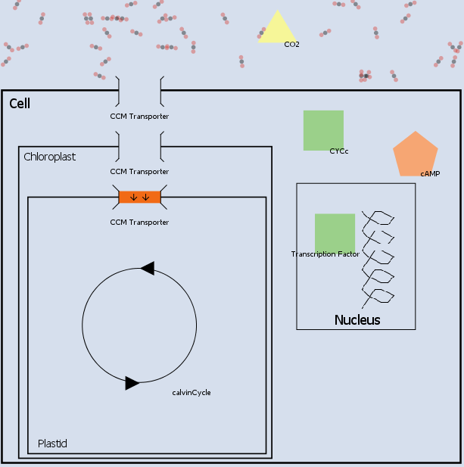
5. The following graph shows gene expression at zero ppm CO₂. Use arrows to show which genes are upregulated and which are downregulated for the

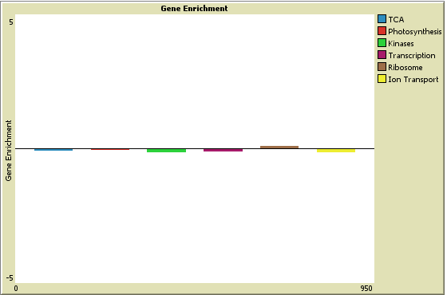

6. People might predict that photosynthesizing organisms (such as diatoms) will produce sugar
(G3P) and oxygen at an accelerated rate. Why is this unlikely to be true?

7. Make a prediction: how will diatoms such as Thalassiosira pseudonana respond to high
levels of CO₂ (climate change)?

