Name:________________________ Teacher: ____________Period:___ Date:_______

Objectives:
- Discover some effects of increasing CO₂ in the atmosphere.
- Determine the environmental factors that impact populations of coccolithophores and silica-shelled algae.
- Discover the role methane hydrate reservoirs play in ocean pH.

Description:
As learned throughout this module, Phytoplankton are organisms responsible for about 40 percent of the total photosynthesis that occurs in our planet and play a critical role in the global carbon cycle and ultimately in global climate. This model simulates the effects of varying amounts of CO2 on the population of the primary producer coccolithophore and a silica-shelled algae that provides carbohydrates to the food chain. The amount of CO2 affects the nodes in this simulation without detailing the various mechanisms in the system that cause the changes in populations. Both are affected in different ways. In Lesson 6 there are continued opportunities to research and explore how what is seen in the simulated Ocean Acidification model might come about. This simulation model and the additional research closely follow the experiences scientists go through as they search for deeper understanding of something observable in the laboratory.

Answer the following questions to assess your prior knowledge: Then check your responses by referring to links provided.
- Where is carbon stored in the earth system? (Hint: Carbon Cycle)
- How is carbon used by phytoplankton such as coccolithophores or Thap?
- Where is carbon stored in the ocean system? (Hint: Carbon Cycle)
- What process is transferring carbon from atmosphere to living ocean organisms?
- What are examples of sources for the CO2 that contributes to ocean water acidification?
- How does CO2 transfer into the ocean water? (Hint: Carbon Cycle)
- What are methane hydrate reservoirs ?
- What are coccolithophores? What role do they play in the ocean system?

Check in: Draw a system diagram to show the interactions among the various nodes that you will be exploring in the following model (use the information from above to help you):

Instructions: How to set-up the Ocean Acidification Netlogo Simulation model

Step 1. Open the NetLogo program using the NetLogo website. Download this Ocean Acidification.nlogo file by right clicking the link and selecting "Save As” or “Download As." Save it to a NetLogo folder on your Desktop. Or find the .nlogo file saved in a public folder by your teacher. On the Netlogo website link click “Go to Netlogo Web” When the window opens click on “Choose File”. Browse and choose Ocean Acidification.nlogo file (saved to your Netlogo folder). Go to Step 2, and follow instructions to start investigating with the model.

Step 2. Click ‘Setup’. Click on “Add CO₂” as many times as it takes to increase the Atmospheric CO₂ (ppm) to 400 or a bit more (current concentration). Use the slider to set the methane hydrate reservoir size to around 800. Click “Go” and let the time (based on ‘ticks’) run to about 1400 and then press the “Go” button again to stop the simulation.
Example below:
Parameters  (Time at 1400) | Carbonic Acid in Ocean | Methane Hydrates | pH in ocean | Cocco-  lithophore  count | Algae  count
CO₂ at 400; methane hydrate reservoir at 806 | 83 | 74 | 8.212 | 61 | 46

Hint:
Drag cursor over the pink section of the Marine life graph to obtain a precise count.
Step 3. Change only your CO₂ and keep your methane hydrate reservoir around 800 to fill in the following table:
Response to Changing Atmospheric CO₂
Parameters  (Time at 1400) | Carbonic Acid in Ocean | Methane Hydrates | pH in ocean | Cocco-  lithophore  count | Algae  count
CO₂ at ____; methane hydrate reservoir at _____
CO₂ at ____; methane hydrate reservoir at _____
CO₂ at ____; methane hydrate reservoir at _____
CO₂ at ____; methane hydrate reservoir at _____
CO₂ at ____; methane hydrate reservoir at _____

Step 4. After recording your last row of data. Lower the methane hydrate reservoir to 50 (use slider) and click ‘Go’. What happens?

Step 5. Experiment with the parameters until you find the set that results in coccolithophore and algae counts reversing (looking opposite). Describe the ‘environment’.
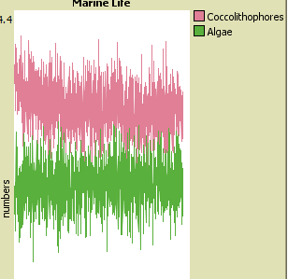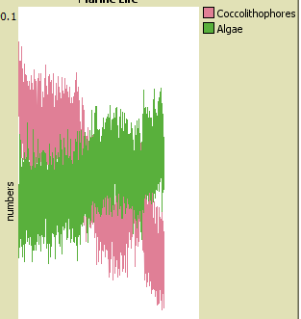

Step 6. What claims can you make about the relationship between the amount of CO₂ and the methane hydrate reservoir?
Provide evidence for your claims:

Step 7. What claims can you make about the relationship between the amount of CO₂ and the ocean pH?
Provide evidence for your claims:
Step 8: What are the consequences you can predict from the model as CO₂ increases? What will this do to populations of coccolithophores? And algae? How will this affect the other nodes in the system? Explain your answer, naming at least three specific nodes.
9. What type of data do you think was used to create the network module this simulation is based on?

