Lesson 5C-Animation Teacher information
Introduce students to reading scientific papers by using the animation from Purdue Libraries
https://www.lib.purdue.edu/help/tutorials/scientific-paper. Essential screen shots are provided below and could be used if you can’t access the animation. Transitional slides are not included here. Ask students to work through the slides individually or project for class discussion.

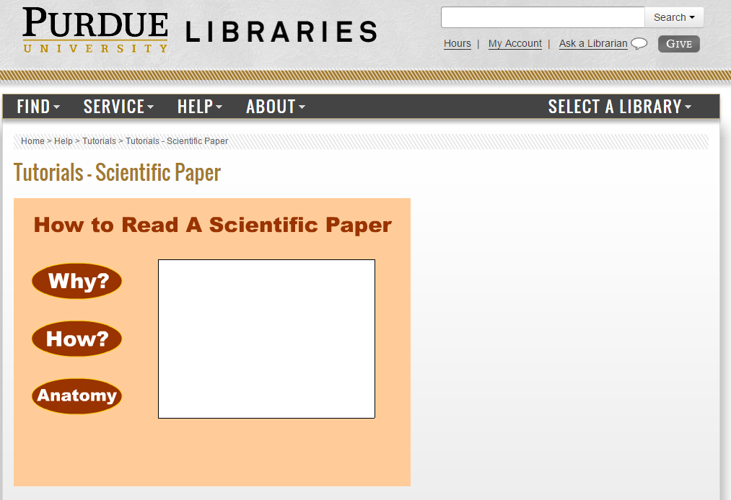
Click on the “Why?” button for a quick explanation on why it is important for students to expend the time and energy needed to understand a scientific paper rather than read a review of the paper.

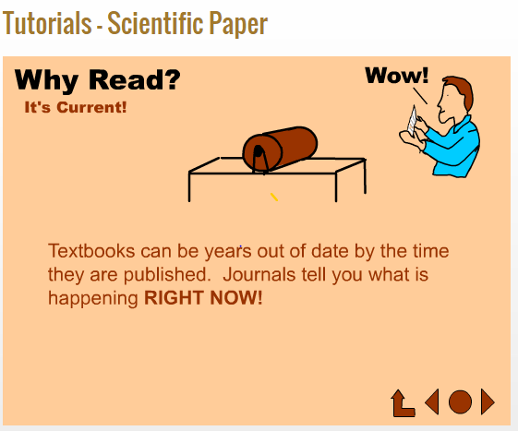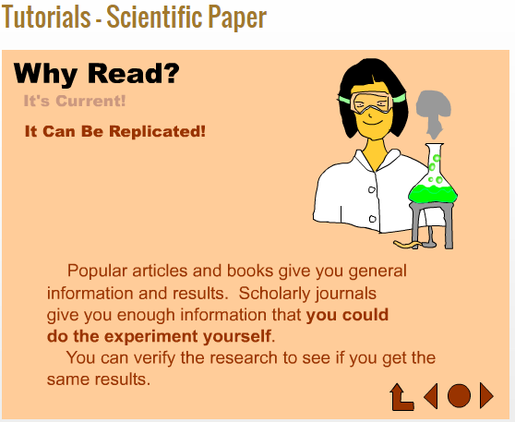
1 2
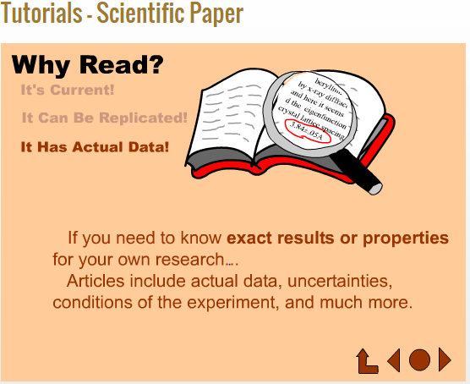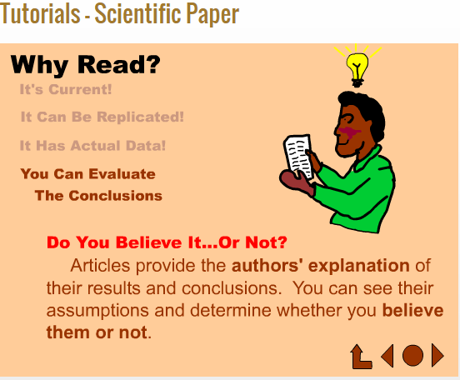
3 4
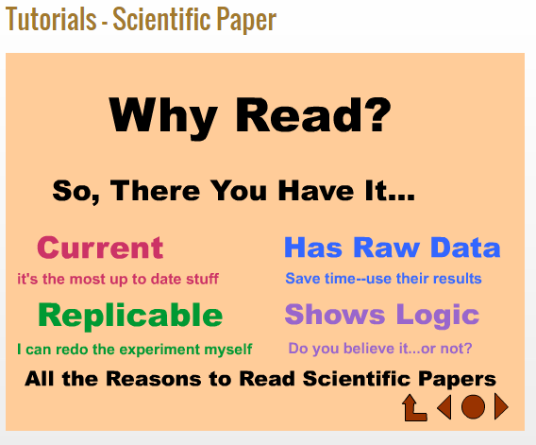
5

Next, click on the “How?” button. Section headings and context are explained; also the reading order recommended for gaining comprehension is included.

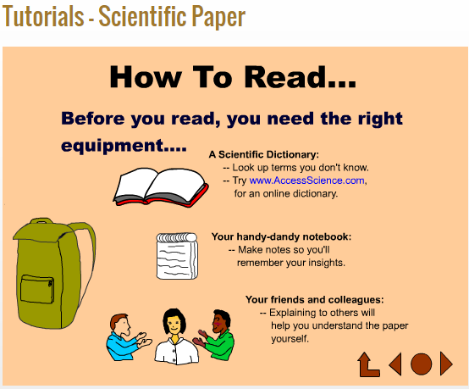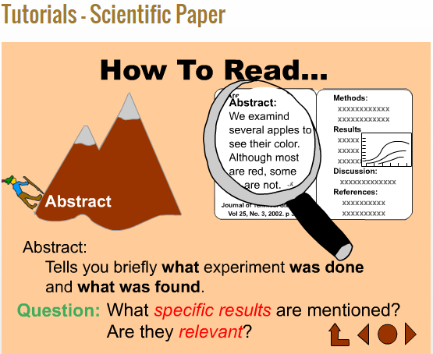
1 2

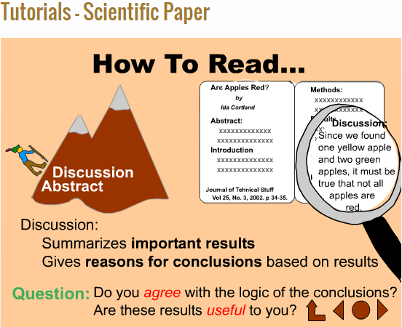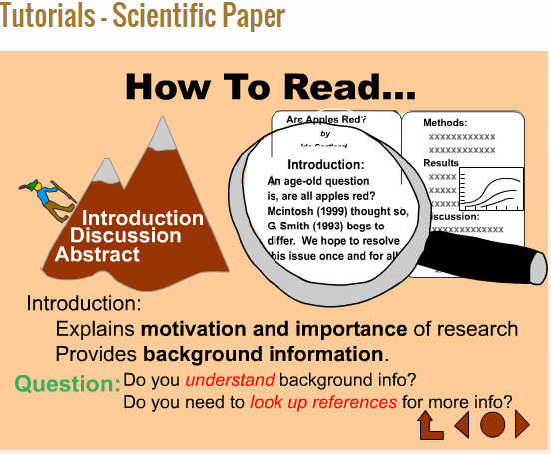
3 4
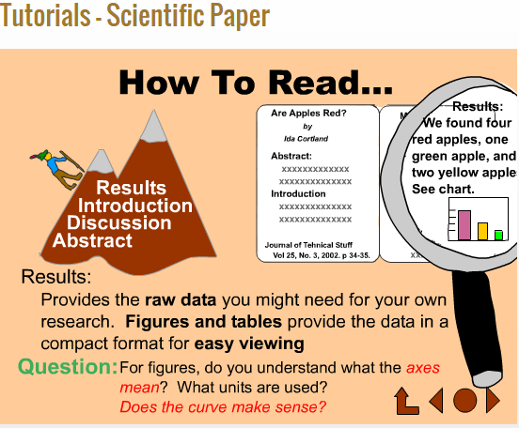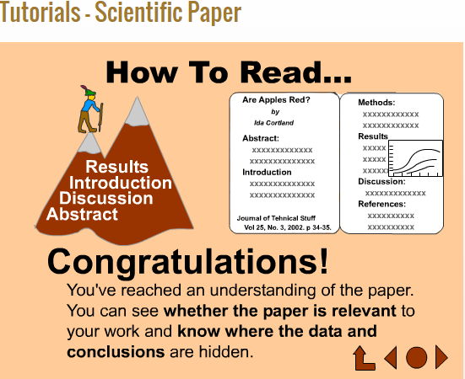
5 6
Need more information about a particular section? The last button, “Anatomy”, gives a more detailed look at each part of a paper.

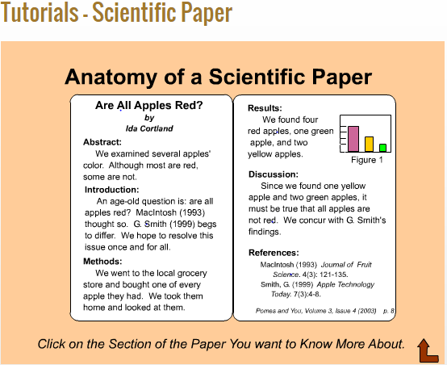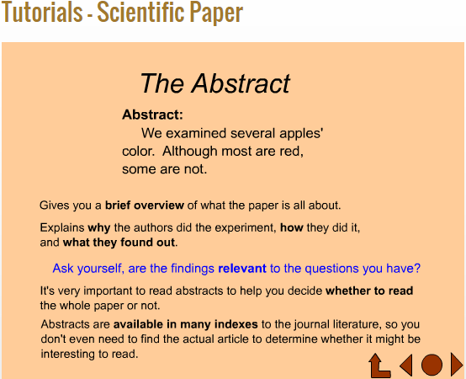
1 2

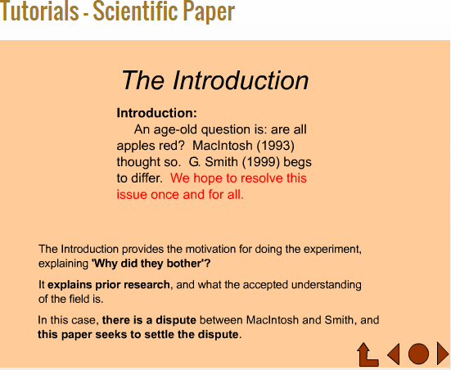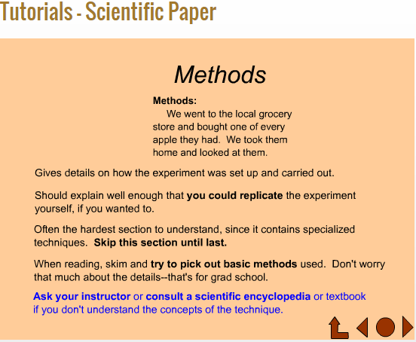
3 4
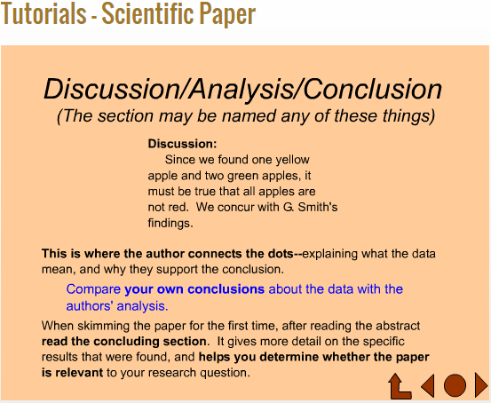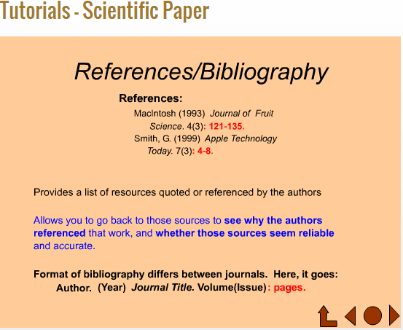
5 6

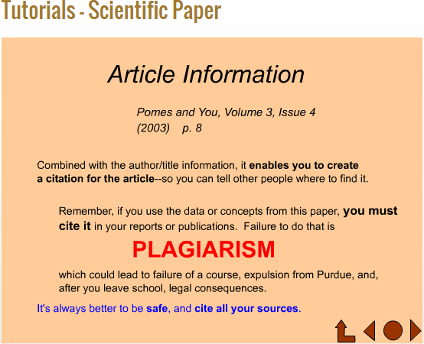
7

How to Read a Scientific Paper by Michael Fosmire is licensed under a Creative Commons Attribution-NonCommercial-ShareAlike 4.0 International License.

