Open the model: Nutrients and LIght NetLogo
Note: If you have not downloaded Netlogo 6.0 prior to this lesson, follow the guide provided for free download.
Part 1: Getting to Know the Simulation
- On the left hand side of the screen, you will see controls for nodes found in the system. To get to know the simulation, we will change these nodes (carbon dioxide, nutrients and light), and see what this changes in the world.
- Start by hitting “Setup”. Then toggle the light “off”, and hit “Setup” again. How does the “world” change?

- Lower the values on the sliders for nitrogen, silicon, and phosphorus, then hit “Setup” again. How does the “world” change?

- Change the value of carbon dioxide between 400 ppm and 800 ppm, hitting “Setup” after changing each time. How does the “world” change?

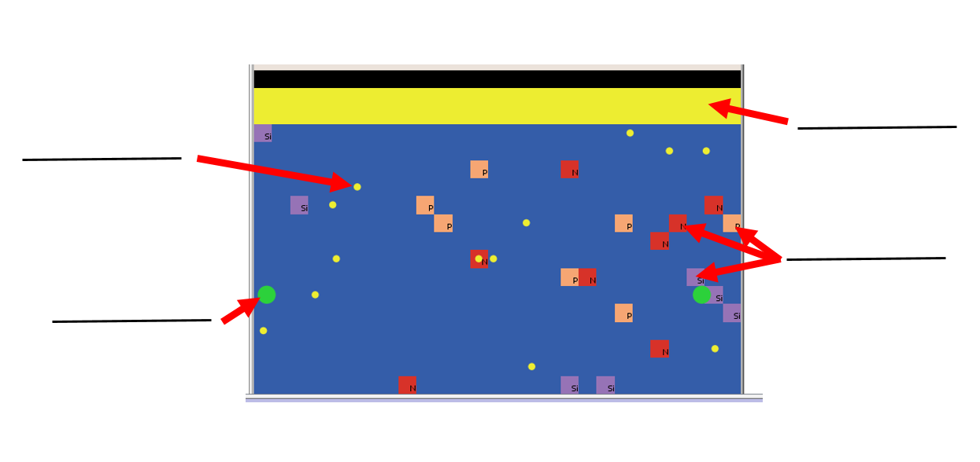
- Summarize your understanding of the “world” by labelling the picture below with the words “light”, “nutrients”, “CO2”, and “diatoms”.

Part 2: Effects of Environmental Conditions on Diatom Populations
- For each of the following conditions, predict how the population will respond based upon prior knowledge as well as the experiments you have run. Write your predictions in the “Predictions” column. un a series of experiments to test the effect of nutrients and light on diatom population. First set the sliders to the conditions, then click the “GO” button to run. Click “GO” to stop a run. You may want to run the simulation a couple times for each condition, since the random nature of a simulation can lead to varied results... Summarize the shape of the graph called “Diatom population”, or capture a screenshot of it and paste this into the last column.
 | CO₂ Level | Light | Nitrogen Amount | Phosphorous Amount | Silicon Amount | Predictions | Summary Results of Simulation
Condition 1 | 400ppm | ON | 20 | 20 | 20
Condition 2 | 800ppm | ON | 20 | 20 | 20
Condition 3 | 400ppm | OFF | 20 | 20 | 20
Condition 4 | 800ppm | OFF | 20 | 20 | 20
Condition 5 | 400 ppm | ON | 1 | 20 | 20
Condition 6 | 800 ppm | ON | 1 | 20 | 20
Condition 7 | 400 ppm | ON | 20 | 1 | 20
Condition 8 | 800 ppm | ON | 20 | 1 | 20
Condition 9 | 400 ppm | ON | 20 | 20 | 1
Condition 10 | 800 ppm | ON | 20 | 20 | 1

The graph below shows data collected at ISB in the summer of 2014:
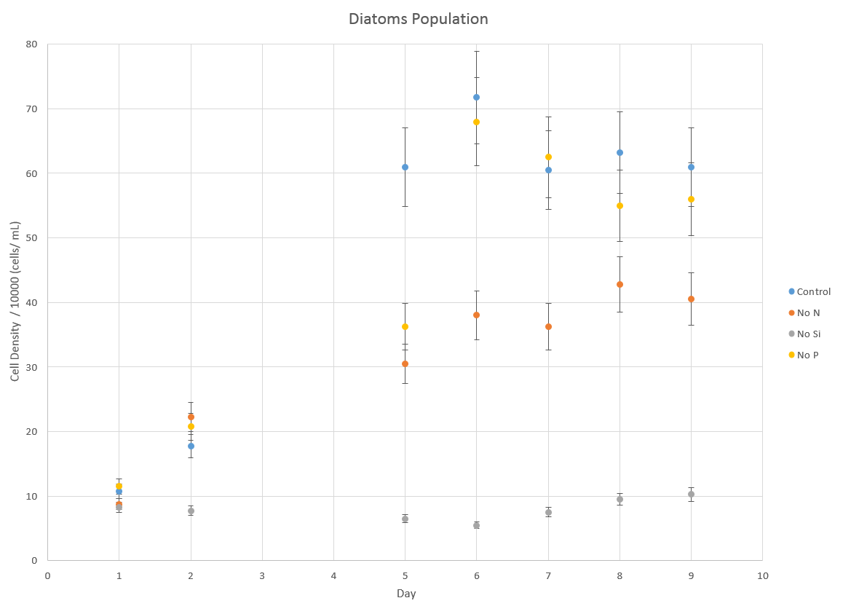

- If you collected experimental data on diatoms under any of the conditions listed above, explain how your experimental results compared to the results from the simulation. Use the table format below.
Condition Number | Experimental Results | Simulation Results | What might account for the difference between the experimental and the simulation results?

- Based on the simulations, which environmental conditions (CO₂, light, nitrogen amount, phosphorous amount, silicon amount) seem to be important for the growth of the diatom population?

- Based on the simulations, are there any environmental conditions (CO₂, light, nitrogen amount, phosphorous amount, silicon amount) which seem to be unimportant for the growth of the diatom population?

Part 3: Gene Expression in Diatoms under Varying Environmental Conditions
The top of the world (pictured here) shows three columns related to gene expression in diatoms. The columns are transcription factors, genes, and cellular functions. Review previous learning, fill in the definition Upregulated means _________________________. Downregulated means___________________________.
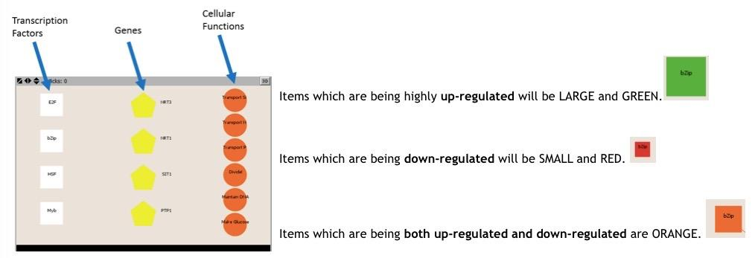
- Setup Condition 1 again, click on “Setup,” then “Go.” Turn off by clicking itagain. Look at the changes in the top of the “world” and answer the following questions:
- Which cellular functions are being up-regulated?

- Why would diatoms in conditions of high light and high nutrients be up-regulating dividing and making glucose?

- Why might diatoms in conditions of high nutrients not be up-regulating uptake of nutrients (transport of Si, N and P)?

- Click “Go” again. Allow the simulation to run until the nutrients are almost gone.
- Which cellular functions are being up-regulated now?

- Why might diatoms in conditions of low nutrients be up-regulating uptake of nutrients (transport of Si and P)?

- Which cellular functions are up-regulated in conditions of low light and high nutrients?

- Transcription factors control the expression of genes, which code for proteins which affect cellular functions. The next picture shows families of transcription factors which are linked to genes expressed under various different circumstances, as shown in the legend called “Expression States”.
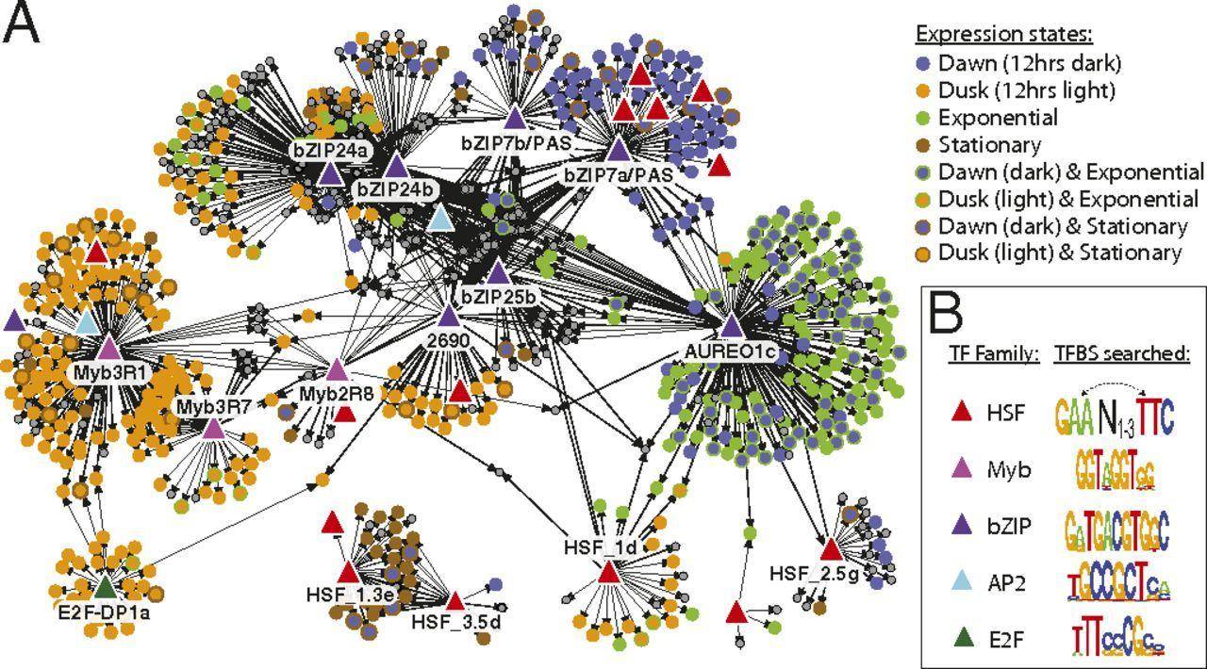

Verify that the simulation is consistent with this picture by checking the following:
- Which of the transcription factors (HSF, Myb, bZIP, AP2, E2F) seems to be associated with the diatoms’ genes expressed at dawn?

- In the simulation, dawn is associated with no light, because dawn is the period after an extended duration of no light. Which transcription factors are up-regulated when no light is present? Based on your answer to letter a, is the simulation consistent with the picture?

- Which of the transcription factors (HSF, Myb, bZIP, AP2, E2F) seems to be associated with the genes expressed at dusk? __________
- In the simulation, dusk is associated with light, because dusk is the period after an extended duration of light. Which transcription factors are up-regulated when light is present? Based on your answer to letter c, is the simulation consistent with the picture?

- The stationary phase occurs when nutrients levels are low and diatoms no longer reproduce (and may even die). Which of the transcription factors (HSF, Myb, bZIP, AP2, E2F) seems to be associated with the genes expressed in the stationary phase?

- Let the simulation run until nutrients are low with the light off. Based on your answer to letter e, is the simulation consistent with the picture?

- All simulations or models have aspects which are consistent with the real world, and aspects which are flawed. What are some of the realistic aspects of this model? What are some of the flaws with this model?

