VISUALIZING GRAPHS NAME__________________________________Per_____

The following graphs give the height of water vs. the volume of water for four differently shaped containers that are sketched at the bottom of the page. Study the graphs and predict which graph matches each container.
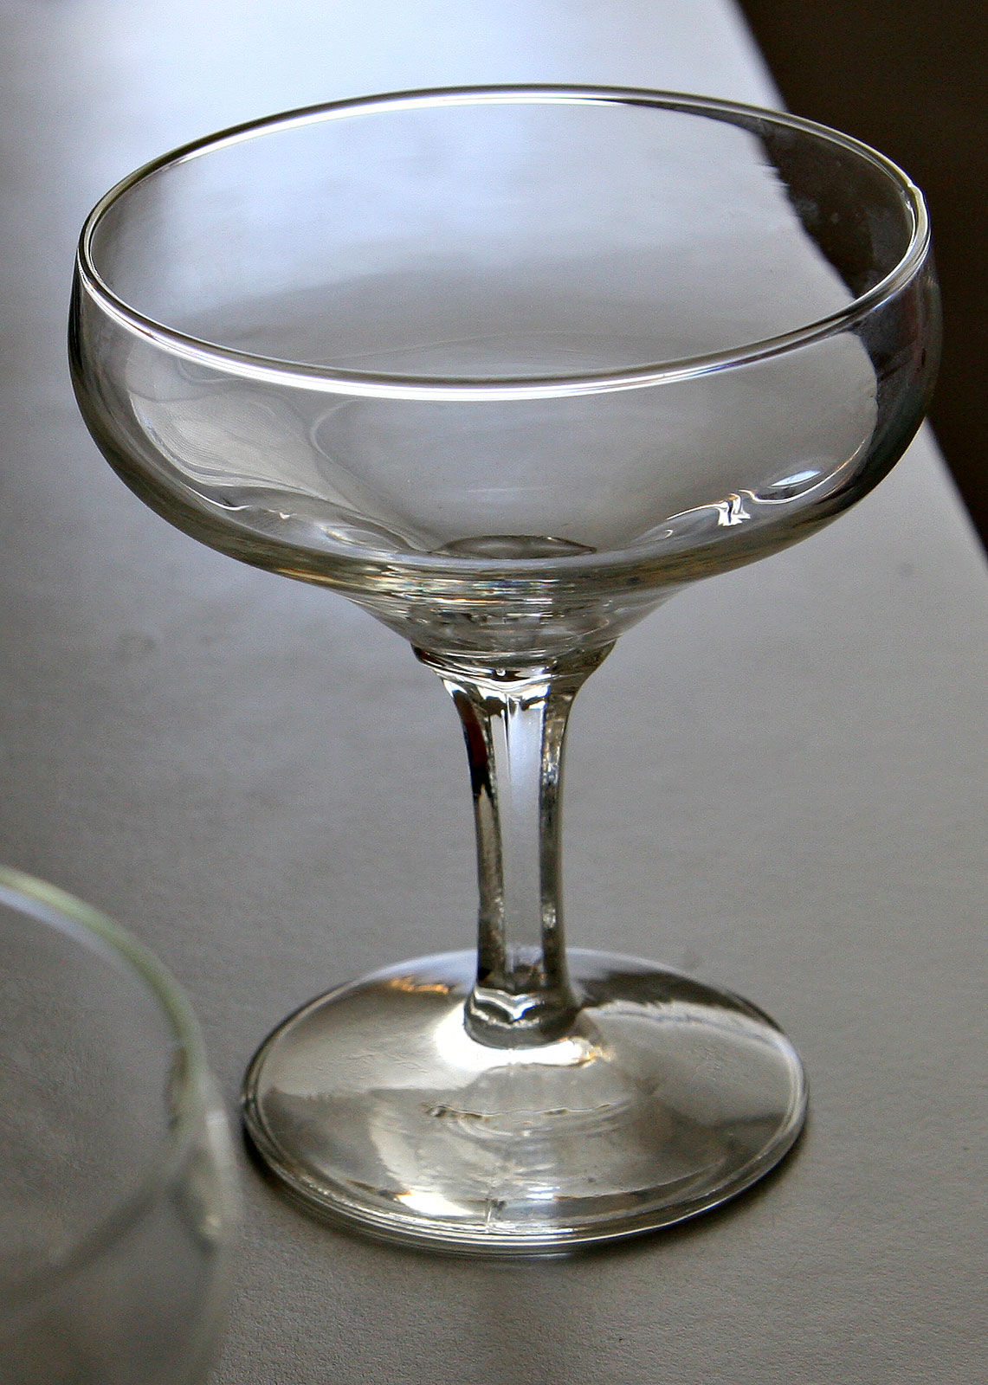
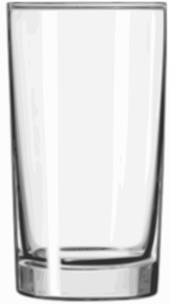
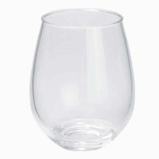

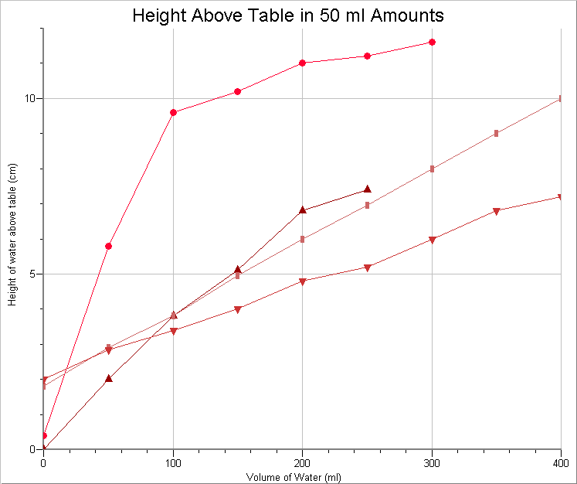

1 2 3 4 5

For your group, collect 2 glasses having unique shapes and add them to those in your bin. (Be careful...you break it, you buy it.) You will also require a container (beaker) of water, a couple of graduated cylinders, a ruler, and your lab books.

In your lab book:
title
objective/focus
procedure
data
analysis
conclusion

General Procedure:
- Sketch each of the glasses which you will fill. Set up a data table to record amount (ml) vs. height (cm or mm). Start with 0 mL of water and measure how far above the table the water would sta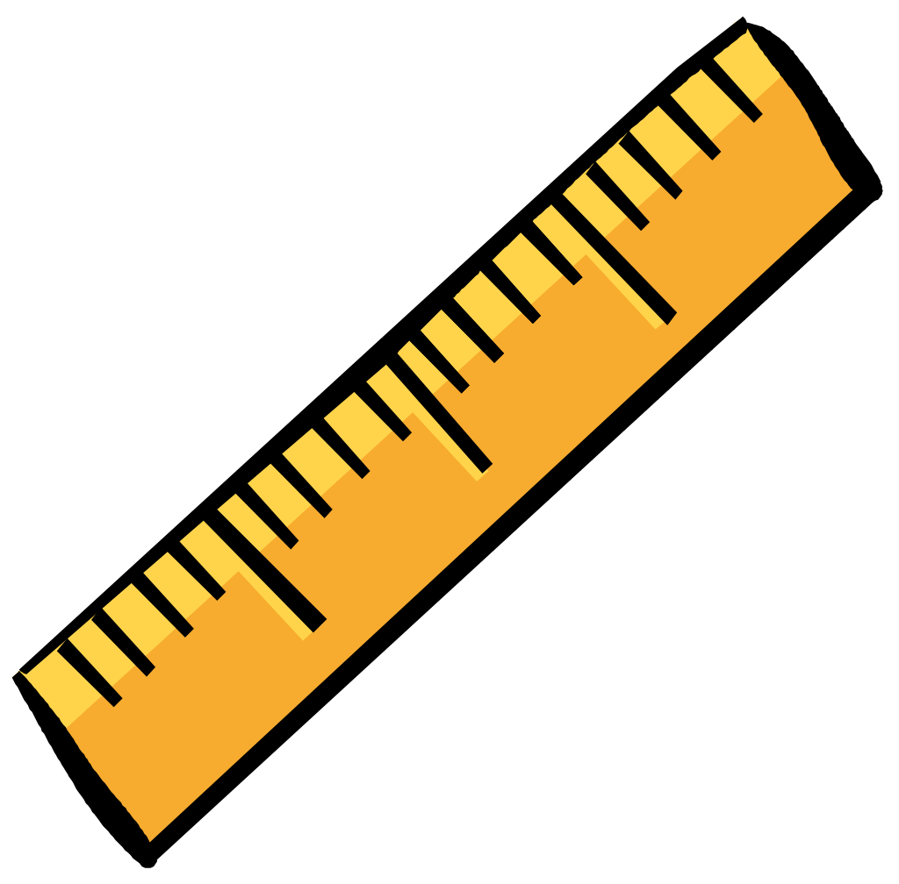rt.
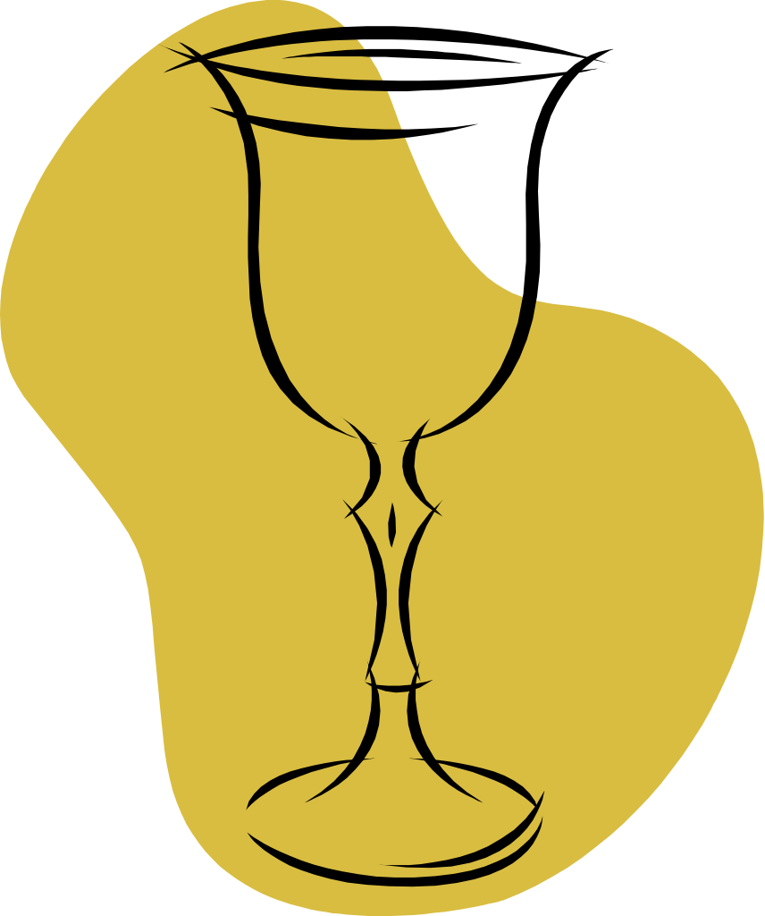

Before adding any water, measure where the water will start to fill the bottom of the container. Example: 0mL = 3.2cm

Water starts here:

2. Data: Decide on a logical amount of water to use. Pour water into one of the glasses and measure the height of the water from the table top. Record your measurements in your data table. Continue to add the same amount of water and record the total amount and total height above the table for each of your chosen container, until it is full.

You may use different amounts for each glass. The idea is to be able to see any
variations in the shape of the container so use a small enough increment for this.

- Analysis: Make one graph for all of your data. Look at the graph on 1st page if you need help with labels, etc. Why are you making a line graph? Would a bar graph work?

- Conclusion: Study the shapes of each of the glasses and the graphs they produced. Consider how differences in the glasses show up as differences in the graphs. Reassess the pairings you made on the front side in light of what you learned from gathering the data. Discuss possibility for error. Make a generalization about graphs and what they actually tell us.

ASSESSMENT
- Find a partner you have not worked with today.

- Each of you will draw a container. (Don’t make it too convoluted!)

3. On a separate paper, sketch a height vs. volume graph corresponding to
the container you drew.

- Exchange only the graphs.

- Looking only at the sketch of the graph, draw a container
suggested by that graph.

- When you and your partner finish, compare your drawings and the graph it should correspond to.

7. Are the drawings similar? If not, work to understand and resolve your
differences. (Determine who is reading the graph correctly and work together so that the
person making mistakes now understands.)

