Building a model Atomic Force Microscope (AFM)

Materials:
-Box or other opaque box
-Wooden probe (skewer)
-Ruler
-Marking pen
-Items for inside box
-Tape or glue (optional)
-Graph paper

PREPARE PROBE:
- Put wooden probe through lid (or graph paper tape over box) until it touches the box bottom.

- Mark the probe where it first emerges from the box and mark this 0.0 cm.

- Remove the probe and use the ruler and marker to draw marks every 0.2 cm from 0.0 to 4.0 cm. Be sure these markings increase towards the bottom of the stirrer (not the top).

PREPARE THE BOX:
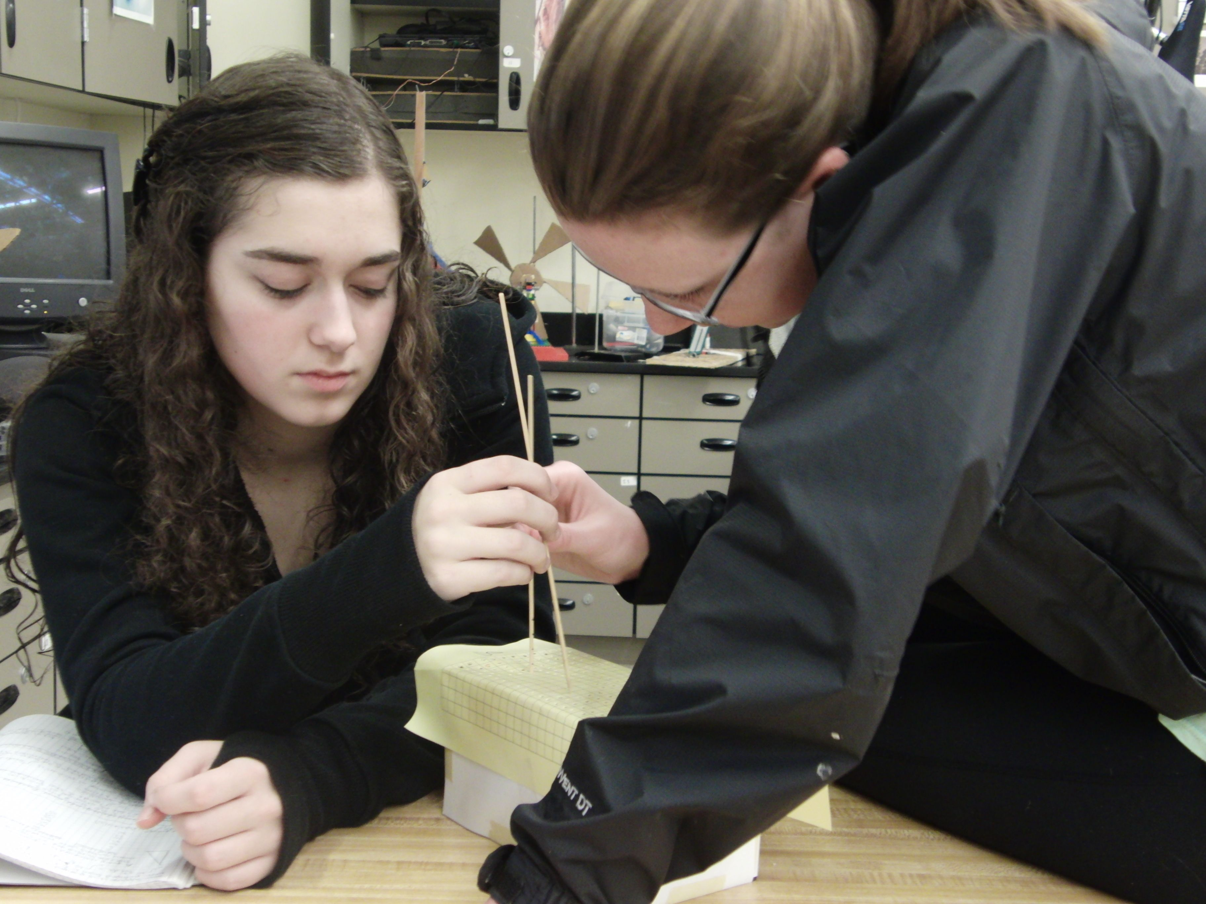
- Place various shapes in the bottom of the box so that they don’t move (glue). Suggestions: playdough (recipe below) or clay forms, wood blocks, hardware supplies. For softer items, remind students to pay attention to resistance on the probe. If students do have softer items (playdough), noise (probe sticking in too far) will be an issue and a good discussion topic.

- Cover the top of the box with graph paper. It helps to label the graph paper with letters and numbers, just like an excel spreadsheet is laid out. *Before covering, sketch or take pictures, so students will be able to guess at the right shape without taking off the graph paper.

- Tape on or make sure students do not take off the top.

*Play dough gives fairly low-res shapes, but they were relatively quick to set up. Shapes: a log, several balls of different sizes, an X, a hill, a valley, etc.
You may want to have the boxes filled with shapes and covered with graph paper before students arrive in class. Cover the top of the box with graph paper for more stability. If you have a computer at each lab station, have students enter their data directly into Excel, and have a 3D surface graph take shape as they entered measurements.
Many students will realize they’d like to change resolution “midstream”, but it’s not clear how to do this easily once a measurement grid is already established in Excel.
Students have about an 80% success rate at correctly identifying their unknown. Concepts of resolution and proxy variable were made very obvious through this work.

Playdough Recipe
2 cups flour
1 cup salt
2 tablespoons cream of tarter
2 cups of water
1 tablespoons vegetable oil
food coloring (color all shapes the same color, in case some sticks to probe)
Mix all ingredients in a saucepan. Cook over medium heat, stirring until dough forms into ball. Knead and allowed to cool. Store in clean, 1 gallon Ziploc bag. Refrigerate.

