MOLECULAR NETWORKS
Part I: Halobacteria and their Environment

Background

In the image below, taken from Google Earth, you will notice a number of saltwater crystallization ponds adjacent to San Francisco Bay. The most obvious and quite beautiful feature of these ponds is the variety of distinct colors that are found in each. One of the factors influencing the color of these ponds derives from the action of salt loving (halophilic) bacteria. Through a series of experiments and other activities this week, you will become acquainted with the biology of halobacteria. More specifically, you will develop an understanding of the how the environment can influence particular gene expression and the network of proteins that ultimately affect the phenotypic color of these halobacteria. In this initial introduction, you will experimentally manipulate bacterial access to light and oxygen.

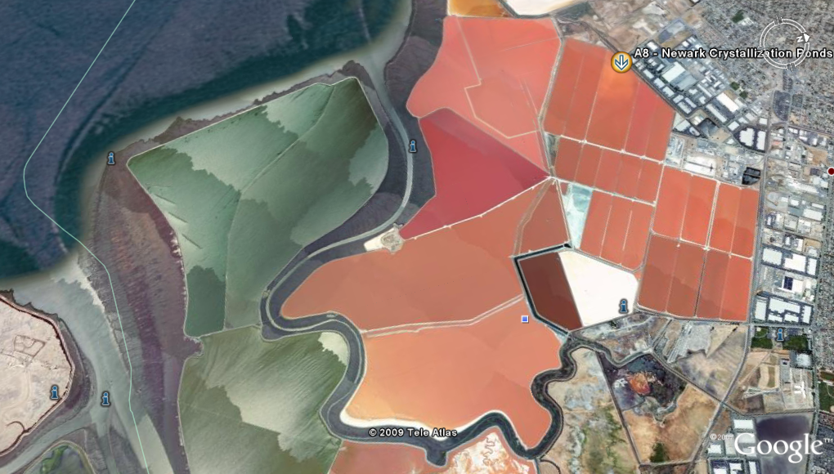

My inspiration for this image came from my observation of a Google Earth linked poster of the South Bay Salt Pond Restoration Project (http://www.southbayrestoration.org/). When you have the time I highly suggest that you take some time to view the images and click the KMZ file link to take a Google Earth tour of the images in the poster. It is an impressive visual experience.

Acknowledgements

My interest in teaching about systems biology was initially inspired by the book The Music of Life by Denis Nobel, and this activity was modified from those developed by the Baliga Laboratory at the Institute for Systems Biology in conjunction with the Bellevue School District.

Guiding Question

What environmental conditions cause Halobacterium to turn on or off the gene coding
for the protein, Bacteriorhodopsin?

Materials

Flask with initial Halobacteria culture
4 125 mL flasks
2 Falcon tubes with Halobacteria culture medium
_ cuvettes
Beral Pipettes
Microcentrifuge tubes
Permanent Labeling Marker
Electrical Tape
Stoppers

Spectrophotometer
Lamp with Full Spectrum Bulb
Kim Wipes
Distilled Water

Procedure: Day One

Culture Setup

1. Cover two of your flasks entirely in electrical tape so that no light could potentially get to the sample.
2. Label the two flasks you have covered, “dark with 0₂” and “dark without 0₂.” Label the remaining two uncovered flasks “light with 0₂“ and “light without 0₂.”
3. Using a clean graduated cylinder measure out and pour _ mL of the culture medium into each of the four flasks.
4. Gentle swirl your stock halobacteria culture flask to create a more homogeneous solution, and then using a pipette transfer 75 mL of the Halobacteria culture to each of your prepared experimental flasks.
5. Use the two holed stoppers to close up the “with 0₂” flasks and use the two non-holed stoppers to close up the “without 0₂“ flasks.
6. Measure out _ feet of clear plastic tubing, attach one end to the aquarium pump aerator, and place the other end through the hold stoppers so that the tubing will bubble air through those cultures.

Determining the Optical Density of the Cultures

1. Pour a _ mL sample from each of your prepared cultures into separate clean cuvettes, and arrange the cuvettes in a test tube rack in an order that you won’t forget (or label the rack with temporary tape).
2. Make sure the spectrophotometer has been warming up and set the wavelength at 600 nm.
3. Place the prepared blank cuvette in the spectrophotometer and use the _ to set the absorbance to zero.
4. Then, clean each sample cuvette with a kim wipe, insert them, and read and record their abosorbance.
5. When finished pour each sample back into the appropriate experimental flask, and clean the cuvettes by rising them out three times with warm tap water and a final time with distilled water.

Procedure: Day Two (Day 2)

After at least 48 hours, obtain your samples from the incubator. Record the time and date the incubation stopped.

Determine the Optical Density of your Cultures

1. Make sure the spectrophotometer has been warming up and using clean cuvettes, and a reference blank, determine the optical density of your experimental samples using the same methods as before. Make sure to swirl the cultures before pouring off samples so that the cultures are homogeneous.

Creating Cell Pellets

1. Use a pipette to transfer 1.5 mL from each culture into an appropriately labeled microcentrifuge tube.
2. Place your samples in the microcentrifuge so that they are balanced symmetrically. If you need another microcentrifuge tube for that purpose, fill one with 1.5 mL of water to do so.
3. Run the microcentrifuge for 15 minutes.
4. When finished spinning, remove each microcentrifuge tube, and use a clean pipette to remove the liquid above the cell pellet at the bottom of each tube. Observe and record the color of your pellets using the color chart below, and observe and record the relative size of each pellet as well.

A B C D E F G H I J K L M N O
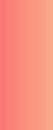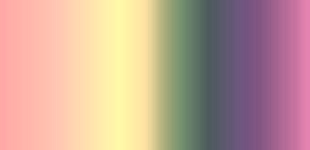

Part I: HALOBACTERIAL GROWTH

Name: _____________________________

Lab-Preparation Questions

Read the American Scientist article Extreme Microbes by Shiladitya DasSarma, and answer the following questions.

1. Explain how halobacteria are unique and discuss how they are related to other forms of life.

2. Explain how halobacteria can, as a group, be considered diverse metabolically and ecologically.

3. What protein of interest was discovered in these bacteria? Diagram and describe the function of this protein in relationship to ATP synthase.

4. What is curious about the characteristics of all the proteins found in halobacteria? How might this unique protein profile be adaptive in the environment in which halobacteria thrive?

Next, read more information about bacteriorhodopsin at David Goodsell’s Molecules of the Month at the Protein Data Bank by surfing to the first website below or downloading a pdf of the same information at the second.

- http://www.pdb.org/pdb/static.do?p=education_discussion/molecule_of_the_month/pdb27_1.html
- http://www.pdb.org/pdb/education_discussion/molecule_of_the_month/download/Bacteriorhodopson.pdf

1. Describe the structure of bacteriorhodopsin.

2. Explain how bacteriorhodopsin used sunlight to generate a proton gradient in general and more specifically after reading to the end of the document.

3. Name and describe the other three types of bacteriorhodopsin found in halobacteria.

4. Do we have any proteins similar to bacteriorhodopsin? Explain.

5. Based on the knowledge you have gained about halobacteria, how would you hypothesize the color of your different samples vary?

Lab Observations and Results

 | Initial Optical Density | Final Optical Density
Light with Oxygen
Light without Oxygen
Dark with Oxygen
Dark without Oxygen

Observations of Color and Cell Pellet Size

Light with Oxygen
Light without Oxygen
Dark with Oxygen
Dark without Oxygen

Questions

1. Which halobacteria culture has the greatest expression of bacteriorhodopsin? Explain your reasoning.

2. Does it appear that light affects the expression of bacteriorhodopsin? Explain with reference to specific results.

3. Does it appear that oxygen affects the expression of bacteriorhodopsin? Explain with reference to specific results.

4. Besides the expression of bacteriorhodopsin does it appear that light or oxygen influences anything else? Explain.

5. Can you now make hypotheses about the different colors of the salt ponds shown in the introductory image? Give an example of a few hypotheses that you think are reasonable.

