INTRODUCTION TO NETWORKS:
CELL PHONE SIMULATION

Name: __________________________

Background

A Network is defined as a system of distinct members that are associated or related through the particular relationships that connect them. The members of a network are referred to as nodes and are most commonly represented by circles, while the relationships between members are referred to as edges and are represented by the arrows that connect them. Depending on the relationship being represented between the members in the network the edges may be diagrams with arrow at one or both ends.
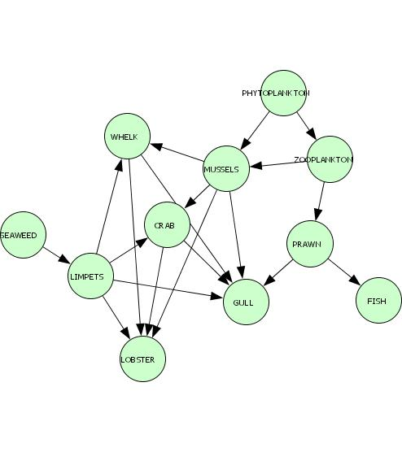
In order to develop the skills for understanding biological networks, which are often quite complex, you will be creating and analyzing network that is increasingly becoming common place in today’s society, a cell phone network.

Objective

1. You will become familiar with the terminology associated with the construction of networks, and apply that information to the construction and analysis of a simulated cell phone network.

Acknowledgements

My interest to teach about systems biology was initially inspired by the book The Music of Life by Denis Nobel, and this activity was modified from those developed by the Baliga Laboratory at the Institute for Systems Biology in conjunction with the Bellevue School District.
Procedure

General Instructions & Information

- You have each been assigned your own cell phone, which contains a certain number of names in your phone book, and a particular number/letter combination (Example: 1A). Your card also contains information on roaming capabilities, etc… This information will be used in tomorrow’s activity.

- You can only call the people in your phone book. You cannot add or delete names from your phone book (none of the phones have caller ID, so you only know the numbers in your phone book).

- Your goal is to create ONE accurate network, including everyone in the classroom (35 people!), showing who can call who.

- You may wish to create rough drafts in pencil, but I would like a nice looking final draft in pen. (You may use a second piece of paper if you need to)

Part I – Identifying the Name of the People

- Find out the names of everyone in your phonebook, and write these in on the lines provided on your card. (Example: 1A John Doe). You may need to wander around the room to do this.

Part II – Beginning your Network with your Numbered Group

- Find the table that is labeled with your number (if you are 3B, go to table 3).

- Together, create a network diagram showing who can call whom (see the example below). Use circles (nodes) to represent people. Inside the circle include both the number/letter combination and the student’s name. Use arrows (edges) to show where calls can go. Remember that your paper will need to fit 35 nodes, so do not draw them too large!
1A
Jasmine
1D
Josh

Part III – Collect Information from Others with your Letter Group

- Next, when instructed, you will take a pen and go meet with everyone in the room who shares the same letter as you (If you are 5C, go meet all the other C’s at the station labeled “C”). At this station, you will find an “information collecting sheet” – use one!

- Collect everyone else’s phone book information from your group. For example, if you are in group A then you will write down all of the people that 1A can call, all of the people 2A can call, etc. until all the information has been recorded.

Part IV – Complete your Network with your Numbered Groups

- You will then return to your original group (1, 2, 3, etc) and share the information gathered. You should expand your network to include the information for all of the students in the class.

- When you have completed your network, clean up, and use your network diagram to answer the activity questions that follow.

Questions

Pre-activity Homework

1. Diagram a simple network and label its component parts.

2. What are the nodes in the network shown in the background?

3. What relationships is being represented by the edges in the network shown in the background?

Activity Questions

1. The circles in your network are called nodes. How many nodes are in your network?

2. The lines connecting the circles are called edges. How many edges (both incoming and outgoing – counted separately) are connected to 6E?

3. This network of nodes and edges shows us how information may be passed around the classroom. With this in mind, if 1C hears an interesting rumor, and this rumor gets passed around via cell phones, will everyone hear about it? Explain in some detail.

4. If 4B is removed from the network, will it affect who in the class hears the rumor from 1C? If so, who will it affect?

5. If 4D is removed from the network, will it affect who in the class hears the rumor from 1C? If so, who will it affect?

6. If the teacher wanted to confiscate a student phone (other than 1C’s) in order to stop this rumor from spreading throughout the class, whose phone would be the best to take?

7. List 3 different possible routes for a message to get from 2C to 7B.

Homework Questions

1. Create one challenge questions involving this cell phone network (make it as tough as you’d like). You will present this question tomorrow for another group to solve. Be sure to use number/letter labels in the question you create.

2. For each of the following prompts diagram a network with the number of nodes given and only one edge between each node. Then for each diagram determine the total number of edges in the diagram.
Total Edges
Two nodes ____

Three nodes ____

Four nodes ____

Five nodes ____

Six nodes ____

3. Use your internet skills to determine how many different functional proteins are found within a common cell?

4. Assuming that each protein is a node and that they can each interact through a single edge, can you easily determine how many total edges are contained within such a network? What modern technology would aid in making such calculations?

Name: ___________________________
NETWORK BIOINFORMATICS:
AN INTRODUCTION TO CYTOSCAPE

Background

As you have determined for yourself, networks become exponentially complex as the number of nodes and edges increase. This is often referred to as a combinatorial explosion.
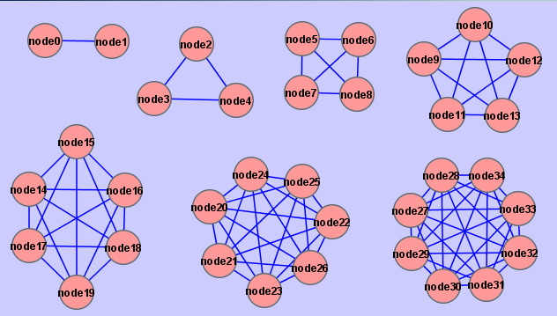

You most likely predicted that the diagram and analysis of such complex networks can efficiently be completed with computers. The biological field spawned by these and other large data sets is called bioinformatics.

Today you will analyze the cell phone network that you created yesterday using a simulated version of Cytoscape, bioinformatics software that fosters the analysis of such complex systems. In practice it is used to analyze networks of interacting proteins found in cells.

Objectives

1. You will become familiar with the software Cytoscape through a simulator. More specifically, you will learn how to use this software to select nodes, knockout and reactivate nodes based on a number of properties of the network, and efficiently trace the flow of information through the network.

Procedure

1. In a group of 2, surf to the following url. Read through the second paragraph and “click here” when instructed. Select “run” or “keep” so the Cytoscape simulator will load or enter your download folder. Open the file or wait until it loads. You will see the cell phone network we created previously. Referencing the network you created, answer question 1 in Part I.

https://see.systemsbiology.net/resources/cell-phone-simulation/
2. Next, use the Simulation drop down menu to familiarize yourself with the following tasks. As you complete and understand each task check them off. If you have difficulty understanding the drop down menu, use the Cytoscape Manual provided.

____ Select a Node
____ Knock out and Reactivate a Node
____ Knock out and Reactivate Nodes and Edges by Carrier and Property
____ Use the Phone Tree Option
____ Reset Graph
____ Use the Shortest Path Option

3. Now that you understand how Cytoscape can be used to manipulate and analyze the cell phone network, use the software to complete questions 1-7 in Part II and 1-8 in Part III.

Questions

Part I

1. How does your hand drawn network compare to the network on Cytoscape®? How is it different?

Part II

Your teacher just decided to give a pop quiz in biology tomorrow. Student 5C heard her mention this in the hall today after school. Answer the following questions assuming that 5C passes the message on to everyone in his/her phonebook then everyone who hears the message passes it on to everyone in their phone book, etc... (you can use the “phone tree” function for this).

1. Will the whole class know about the quiz by tomorrow? (hint: leave the “statistics” window open to answer the next 3 questions)

2. Which person(s) will receive the most phone calls about the quiz? How many calls does this person receive?

3. Which person(s) will make the most phone calls about the quiz? How many calls does this person make?

4. Which person(s) will make the fewest phone calls about the quiz? How many calls does this person make?

5. If one phone call takes 30 seconds to make, how long will it take for the first message to get from 5C to 2A? (show your work)

6. If student 4D’s phone runs out of batteries and he/she can’t make or receive any calls, how many students will find out about the pop quiz?

7. If student 3E is grounded and can’t use his/her phone, how many students will find out about the pop quiz?

Part III – Using Phone Attributes

1. Sprint PCS’s cell phone towers are struck down by a meteorite. Will this change who can call who? Are any groups now isolated from each other? (give examples: can group 6 contact group 1?)

2. Sprint PCS rebuilds its cell phone towers, but one week later AT&T Wireless is bought out and all of its customers temporarily lose their service. Which outage has a bigger impact on our overall cell phone network: Sprint or AT&T Wireless? Explain.

3. Not all of the phones in our classroom network have analog roam capabilities. If our class goes on a field trip to rural Montana, where only the phones with roaming capability will work, will this change who can call who in our network? Explain.

4. List the students to whom 5C will be able to pass a message.

5. Will students in group 7 be able to pass a message to students in group 2?

6. Will students in group 7 be able to pass a message to students in group 5?

7. On this field trip, student 3E takes a picture of a cool rock formation and sends it to everyone he/she can (and they, in turn, send it to everyone they can). How many students will receive the picture? Realize that not all phones can take/send/receive photos.

8. Student 2D receives a funny email and forwards it to everyone in his/her phone book (and they, in turn, forward it to everyone in their phone books). Which students will receive the email forward? Realize that not all of the phones have email capabilities.

